

**Programming Method**

**Module Title**

**Global Wild Swimming and Camping Website**

**Dynamic Website**

**Assignment Title**

**Autumn 2023**

**Examination Cycle**

**SWAM HTET**

**Candidate Name**

**P00202308**

**Candidate No**

**KMD Computer Centre (Yangon)**

**Centre Name**

**19 July 2023**

**Submission Date:**

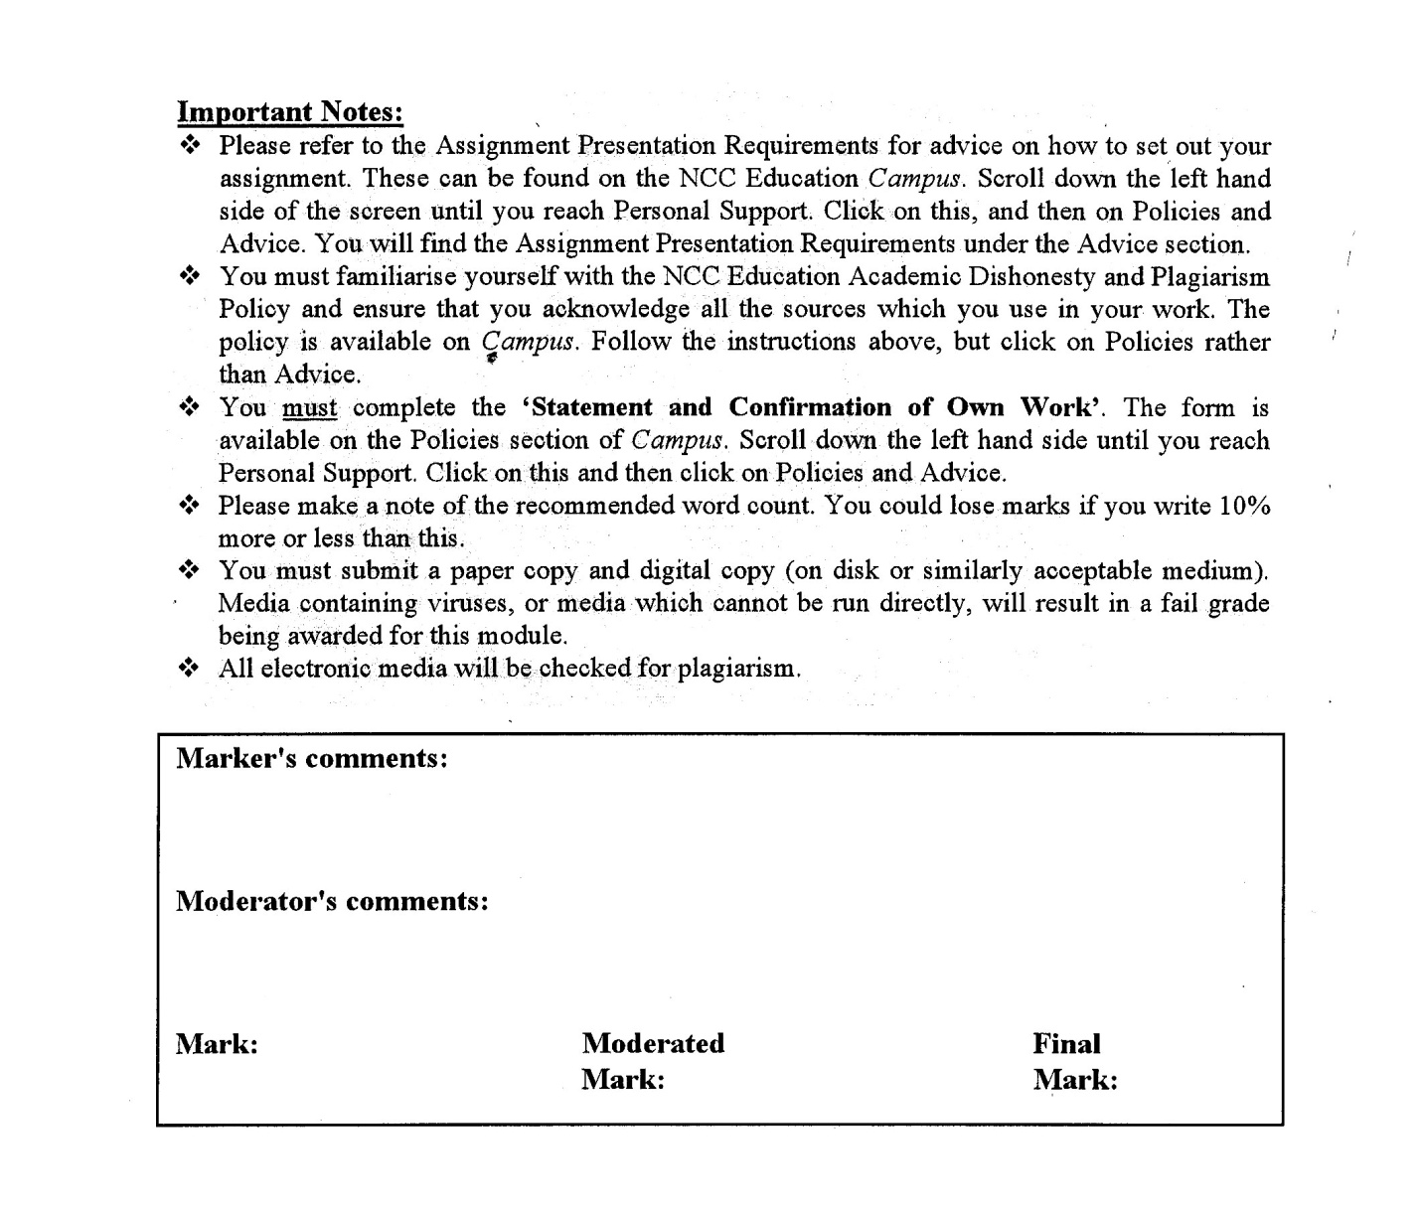



**Statement and Confirmation of Own Work**

**Programmed/Qualification Name: L5DC**

*All NCC Education assessed assignments submitted by students must have this statement as the cover page or it will not be accepted for marking. Please ensure that this statement is either firmly attached to the cover of the assignment or electronically inserted into the front of the assignment.*

**Student declaration**

I have read and understood NCC Education’s Policy on Academic Dishonesty and Plagiarism.

I can confirm the following details:

**Student ID/Registration number : P00202308**

**Name : SWAM HTET  
Centre Name : KMD Computer Centre (Yangon)**

**Module Name : Dynamic Website  
Module Leader : AYE AYE KYAW**

**Number of words : [ 1129 ] words**

I confirm that this is my own work and that I have not plagiarised any part of it. I have also noted the assessment criteria and pass mark for assignments.

**Due Date : 19 July 2023  
Student Signature : SWAM**

**Submitted Date : 19 July 2023**

Contents

Task 1 4

Homepage(index.php) 4

Information (information.php) 16

Login Page (login.php) 25

Register (create_acount.php) 27

Search Camp (search_camp.php) 31

Profile (camp_profile.php) 32

Review Page(all_review.php) 37

User Page (all_user.php) 40

Booking Page (all_booking.php) 42

Contact Page( all_contact.php) 44

Camp Register page(camp_register.php) 50

Privacy Policy Page(policy.php) 53

Rss(rss.php) 56

Task 2 57

External CSS File 57

Databases 80

Task 3 90

Critical Evaluation 90

Functionality to the website 90

HTML 91

CSS 91

Evaluation the GWSC website 91

Task 4 93

Process of the website development 93

Tools 93

Lesson Learnt (Learning Experience) 93

Future (Improvements/Different Process) 93

References: 94

Candidate Checklist 95

# Task 1

### Homepage(index.php)

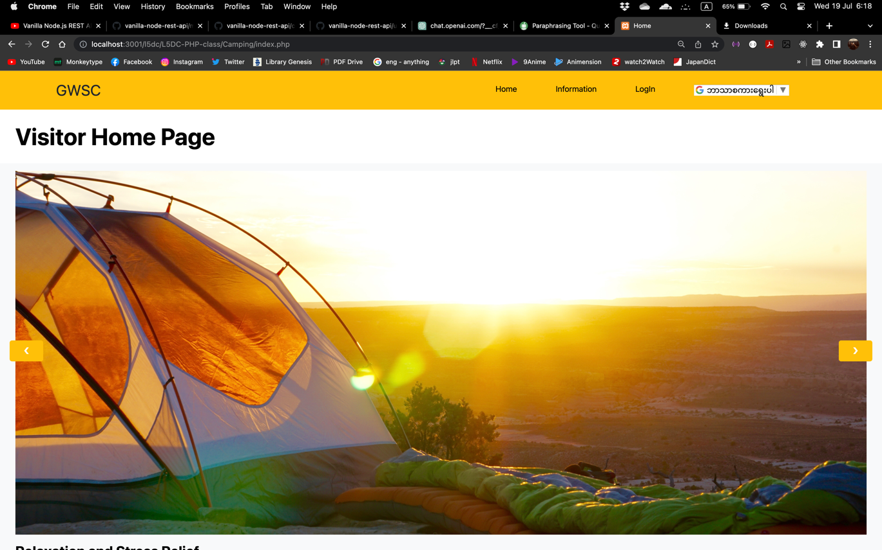

Figure home page 1in Chrome Browser

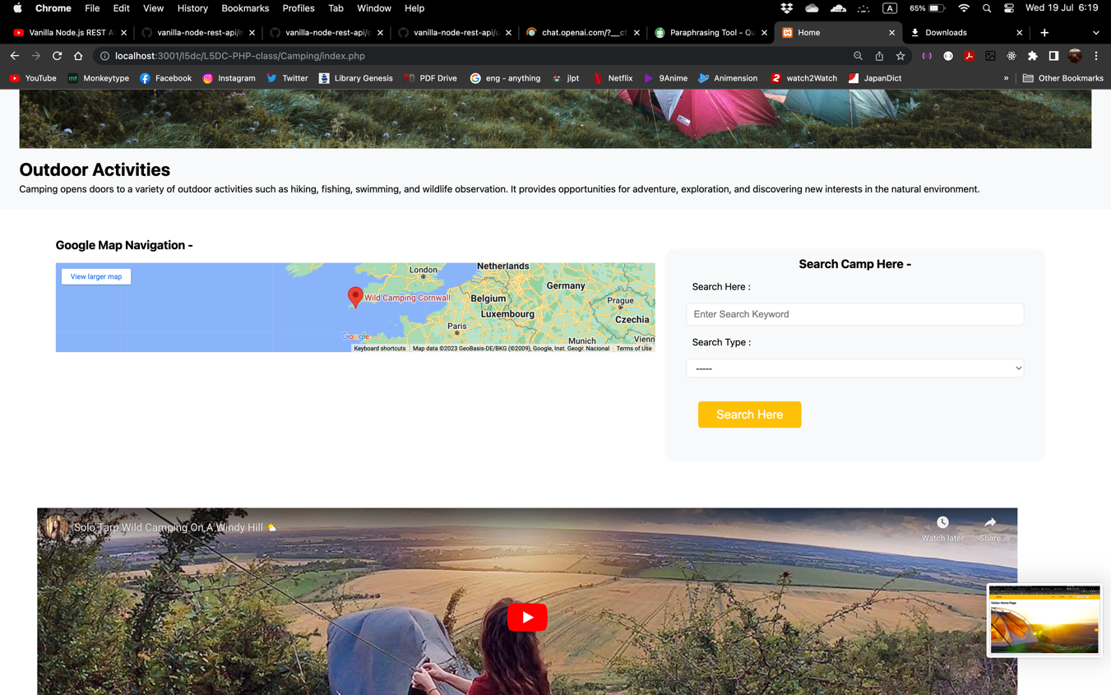

Figure home page 2 in Chrome Browser

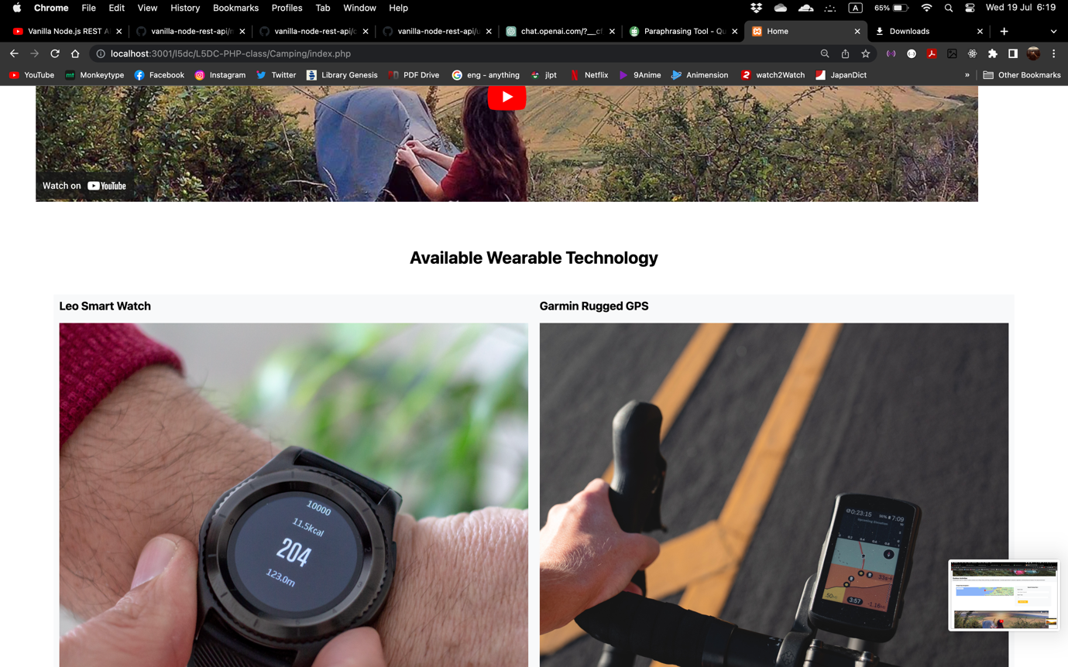

Figure home page 3 in Chrome Browser

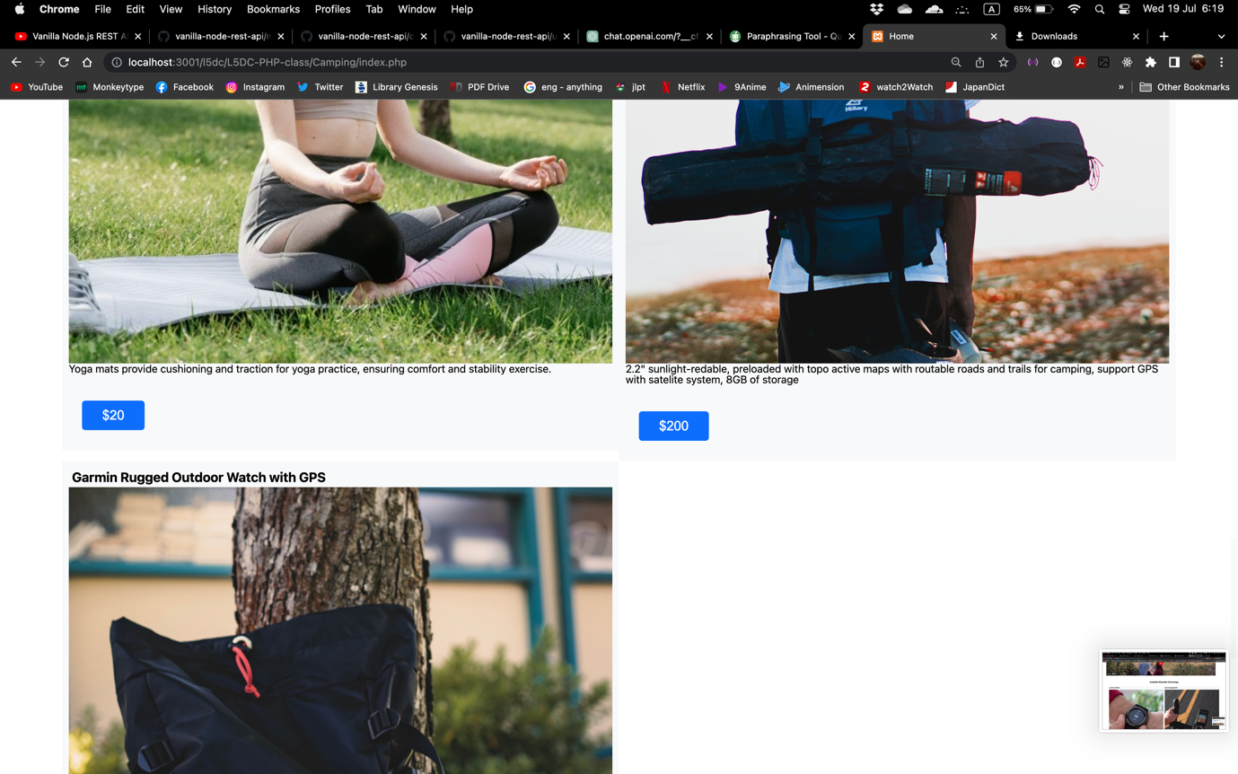

Figure home page 4 in Chrome Browser

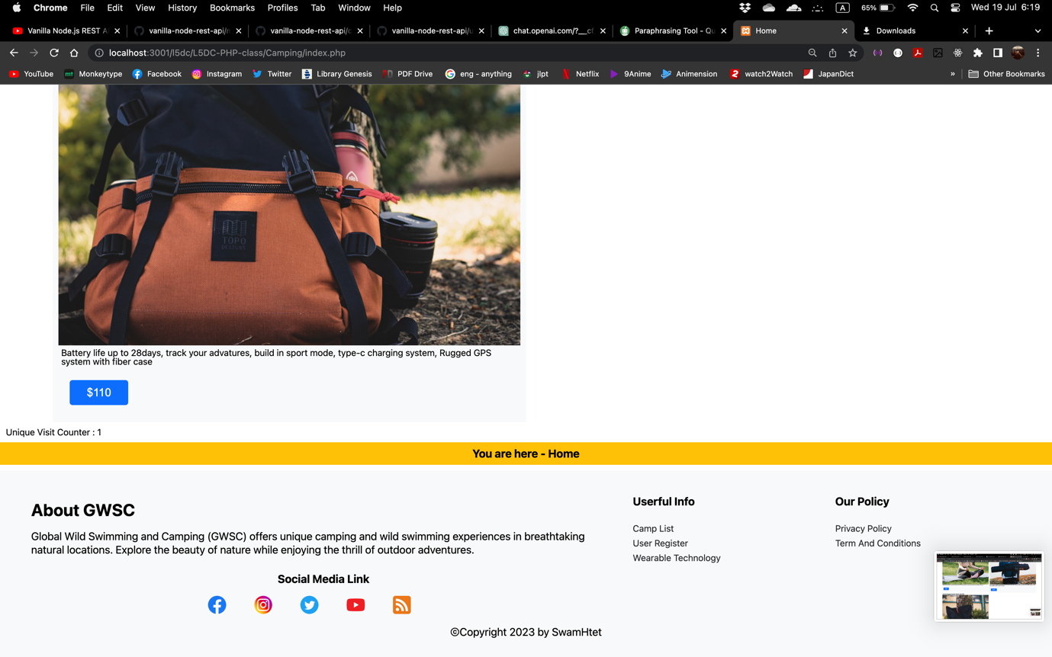

Figure home page 5 in Chrome Browser

Home page in Firefox Browser

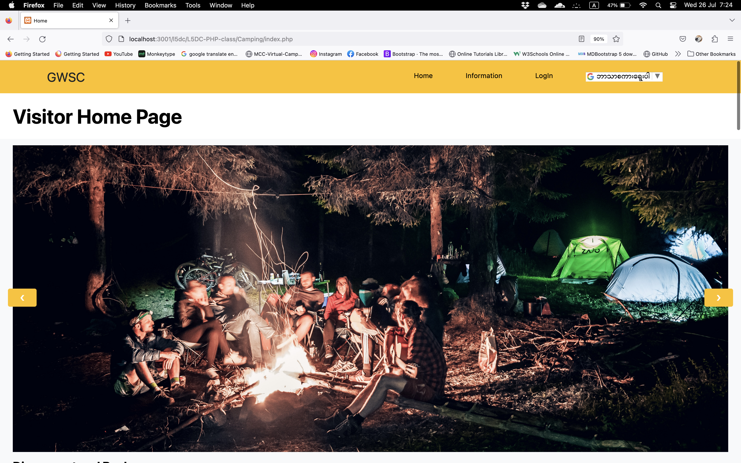

Figure home page 1 in Firefox Browser

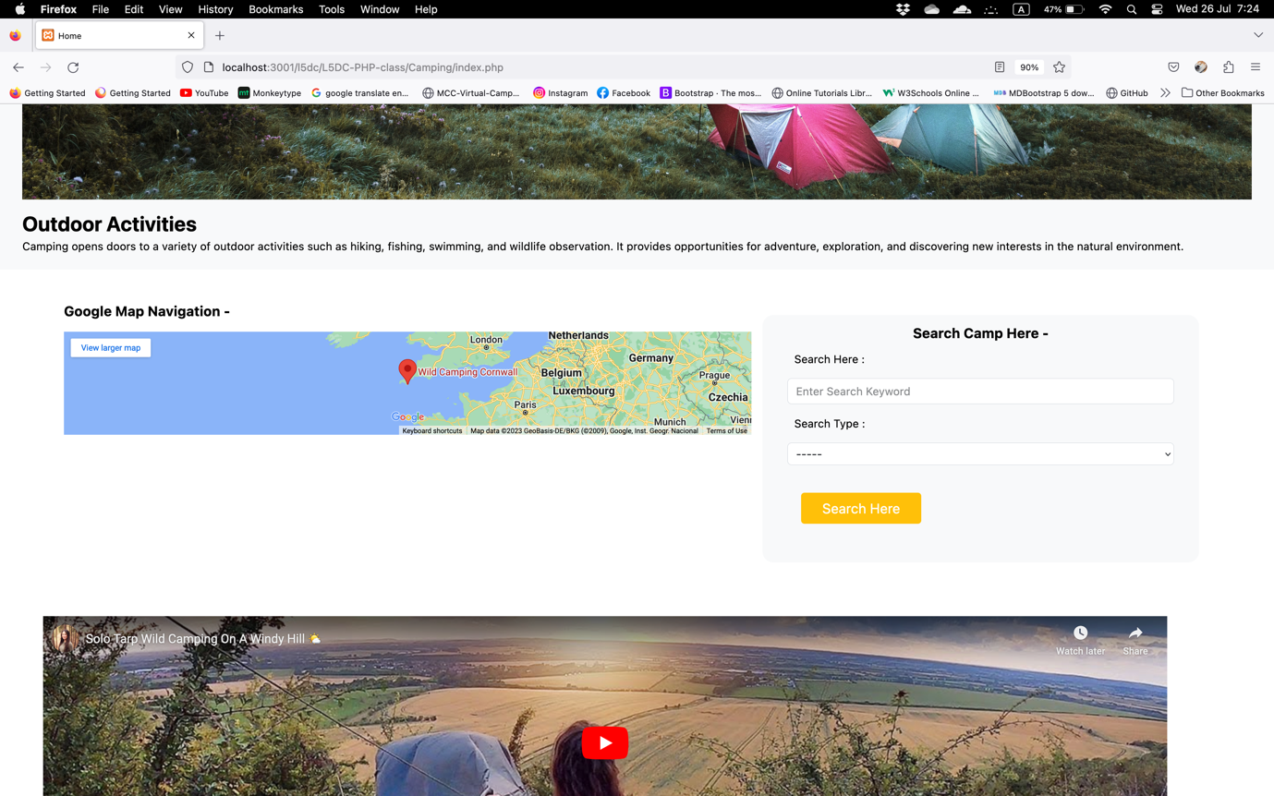

Figure home page 2 in Firefox Browser

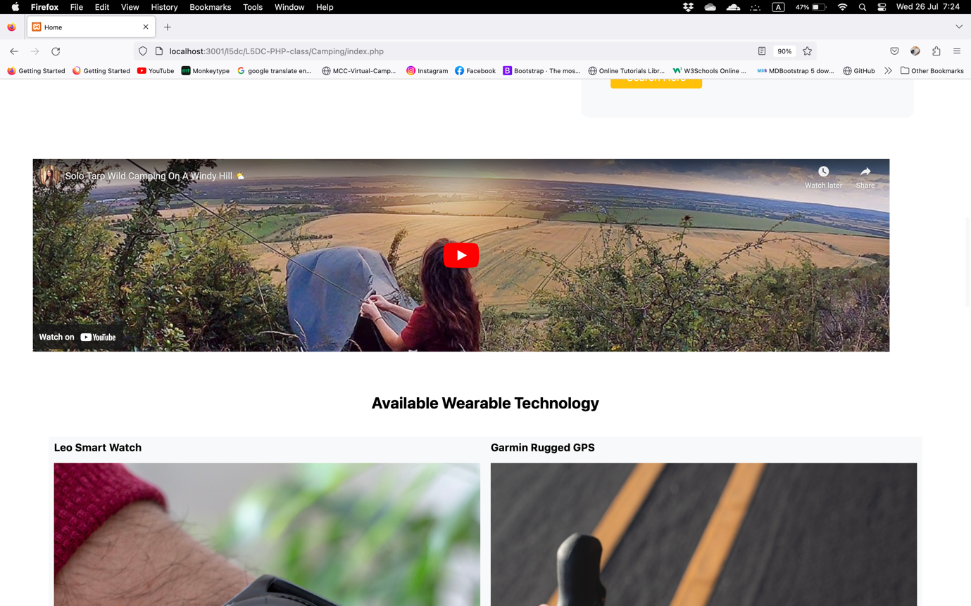

Figure home page 3 in Firefox Browser

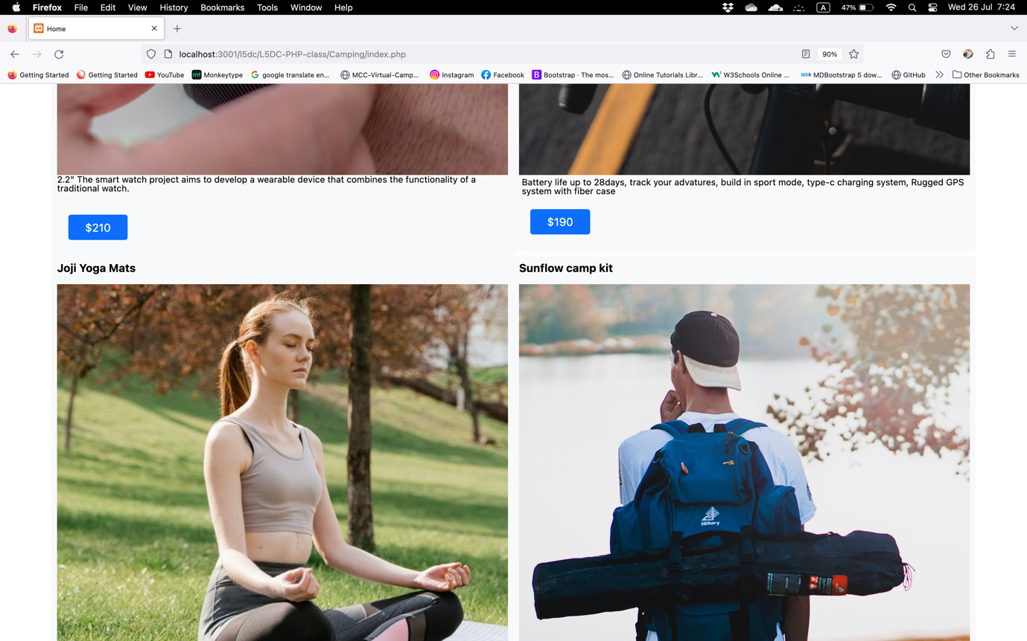

Figure Home page 5 in Firefox Browser

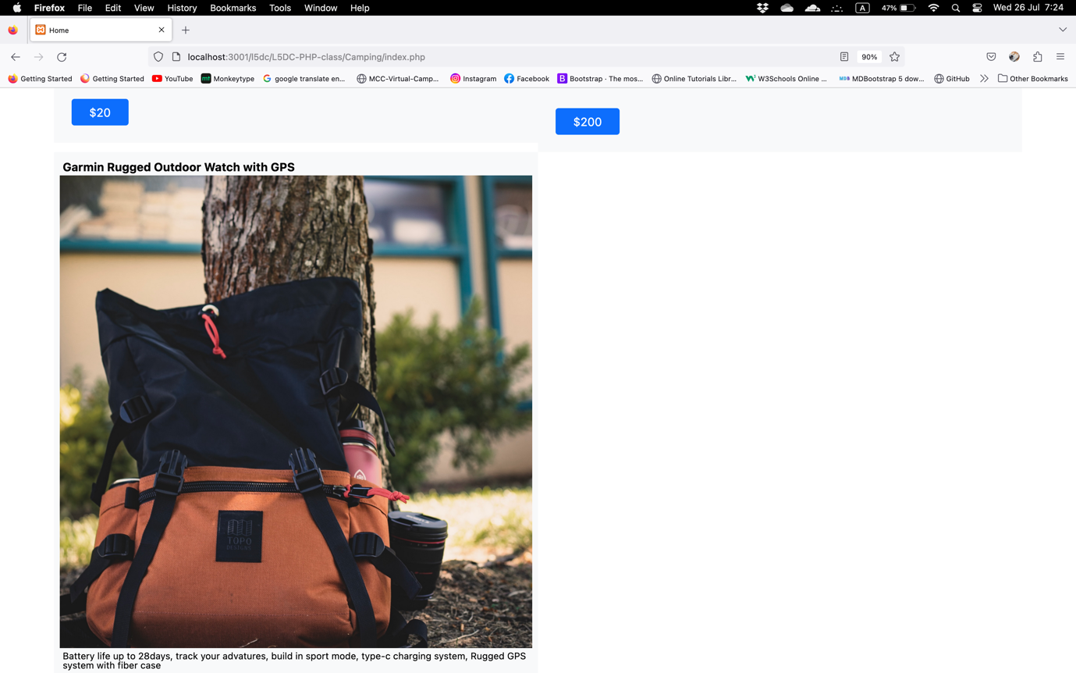

Figure home page 6 in Firefox Browser

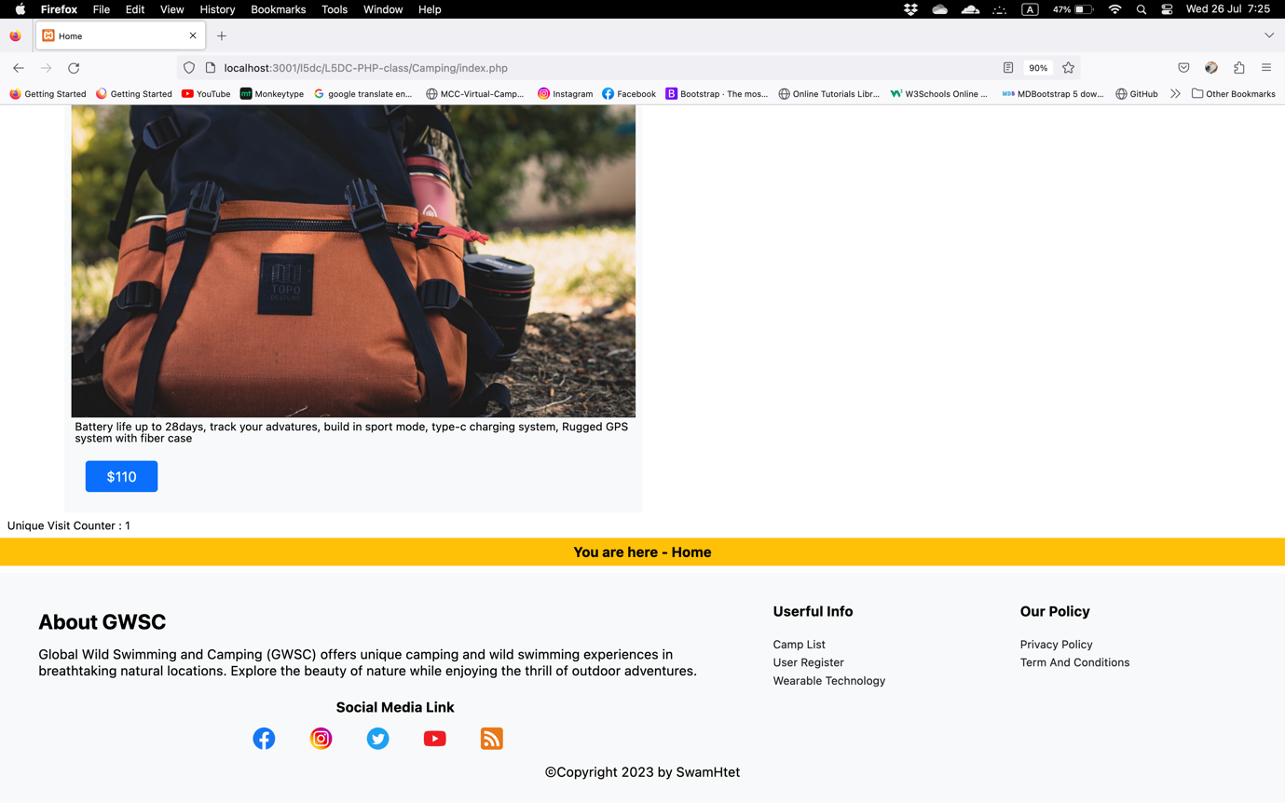

Figure home page 7 in Firefox Browser

**Navigation bar for different user levels**

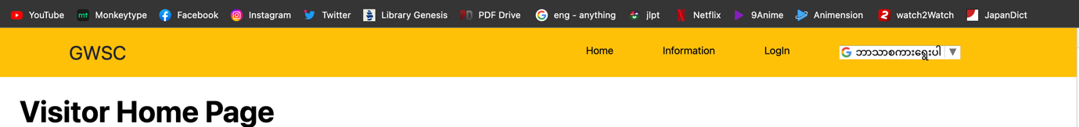

Figure navigation bar for visitor

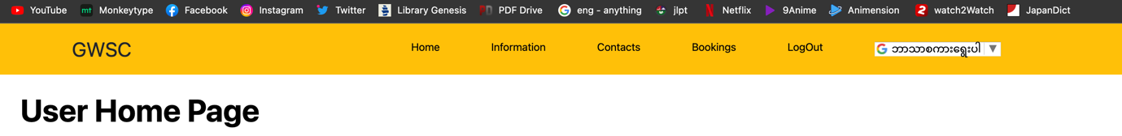

Figure navigation bar for user

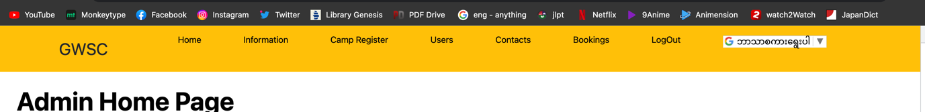

Figure navigation bar for admin

**Responsive Navigation bar for tablet**

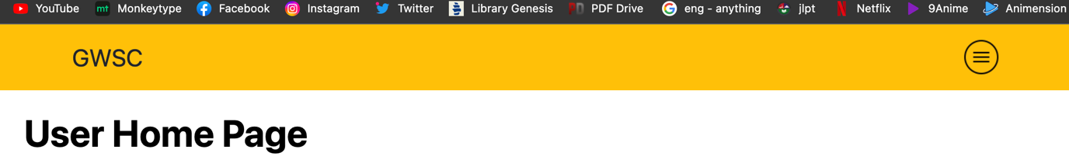

Figure navigation bar for tablet 1

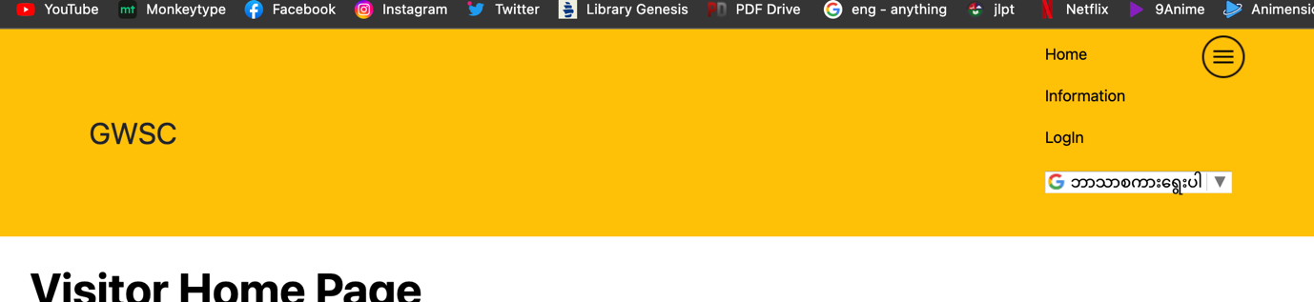

Figure responsive navigation bar for table 2

**Responsive Navigation bar for Mobile**

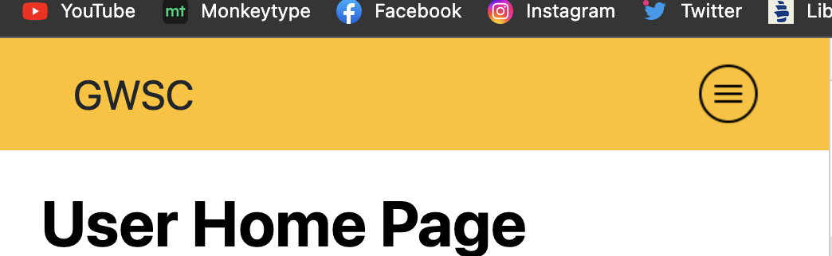

Figure responsive navigation bar for mobile 1

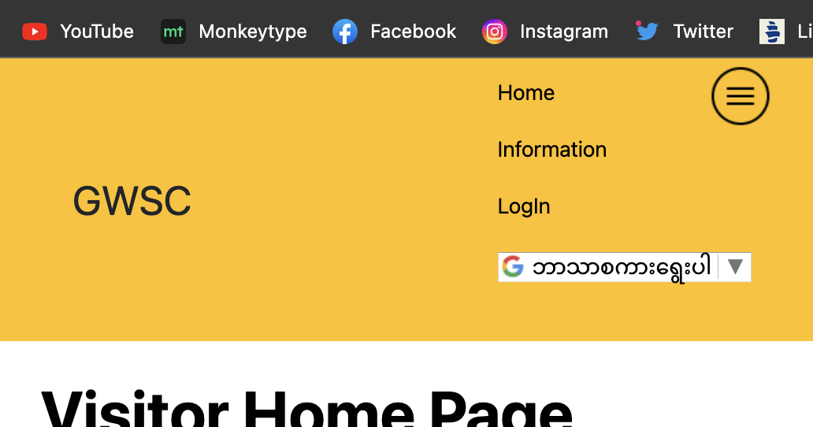

Figure responsive navigation bar for mobile 2

#### Slideshow

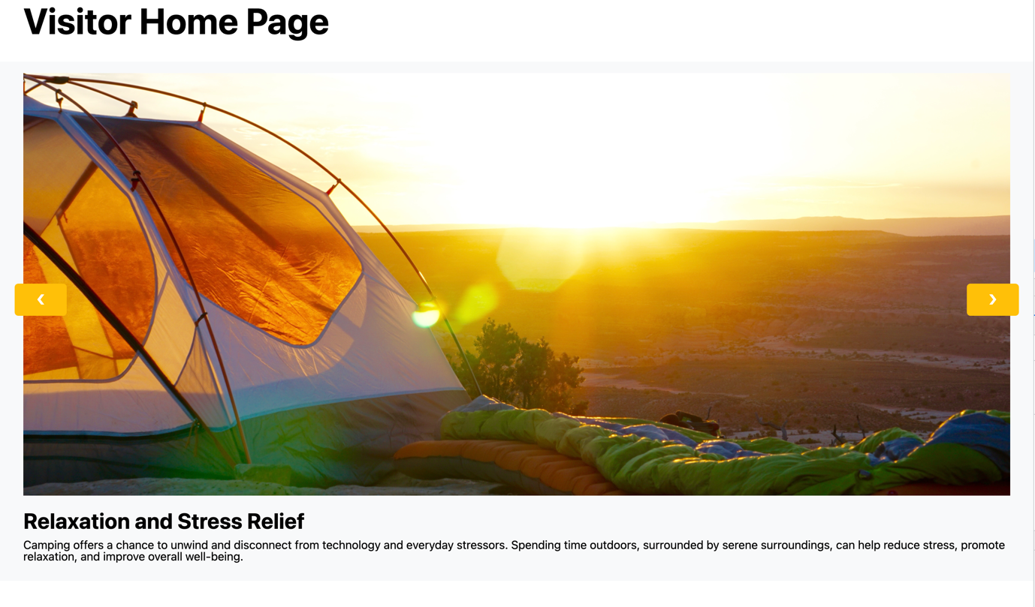

Figure slide show

#### Google Map Navigation of GWSC

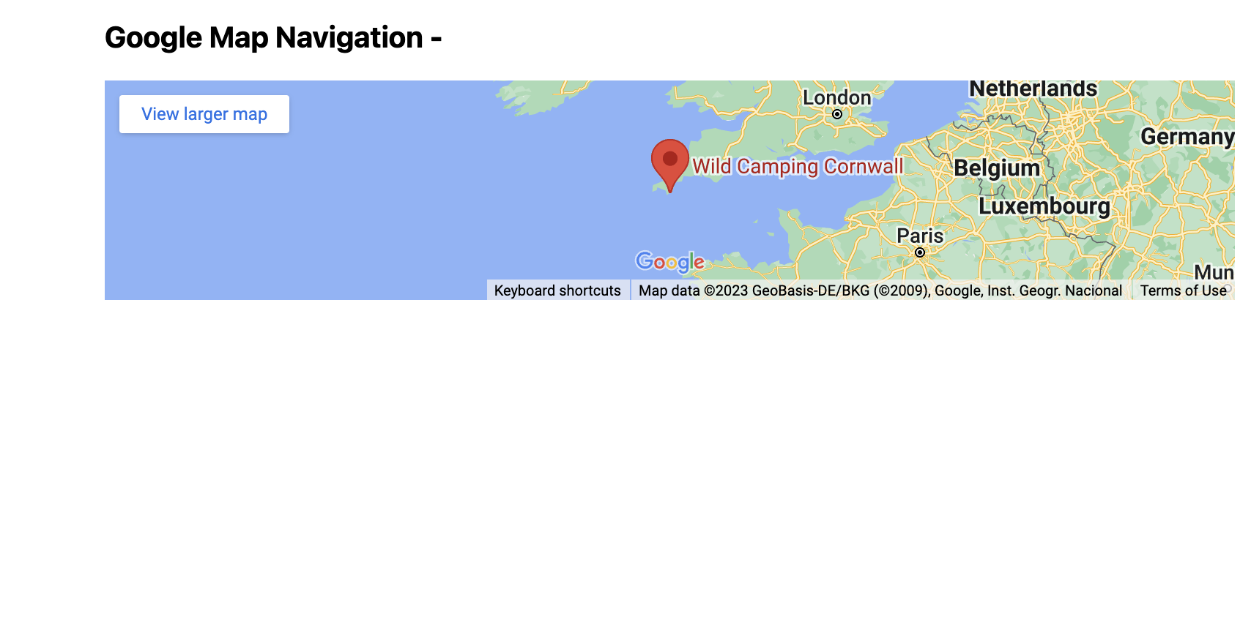

Figure google map navigation

#### Search Bar at the home page

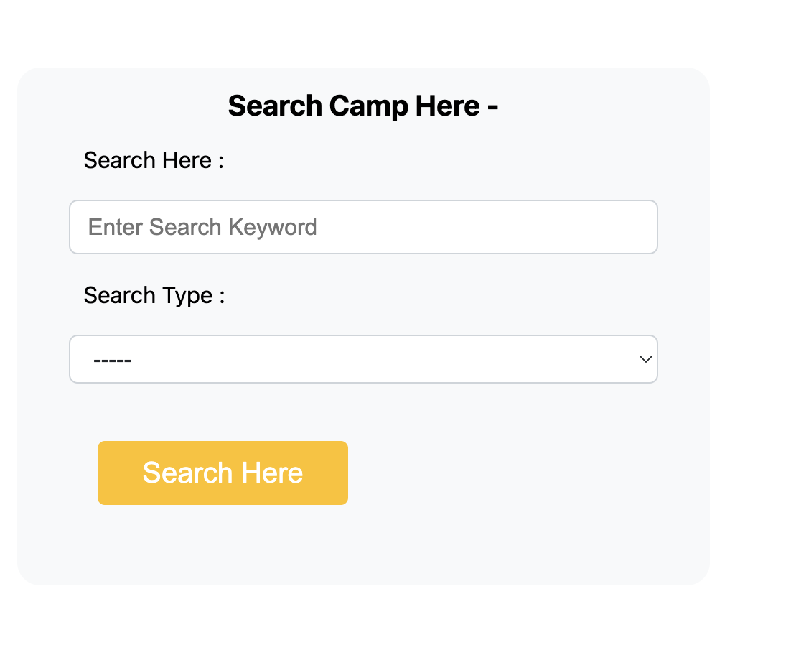

Figure search bar in the home page

#### YouTube Guide Video

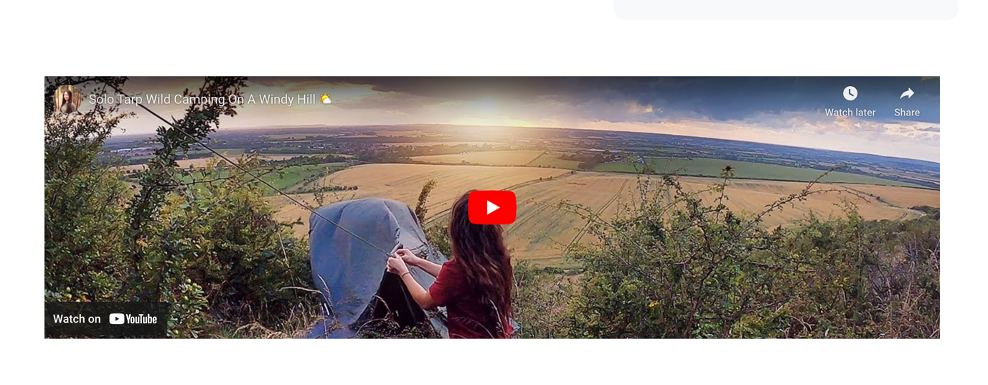

Figure YouTube Video guideline

#### Available Wearable Technology Display

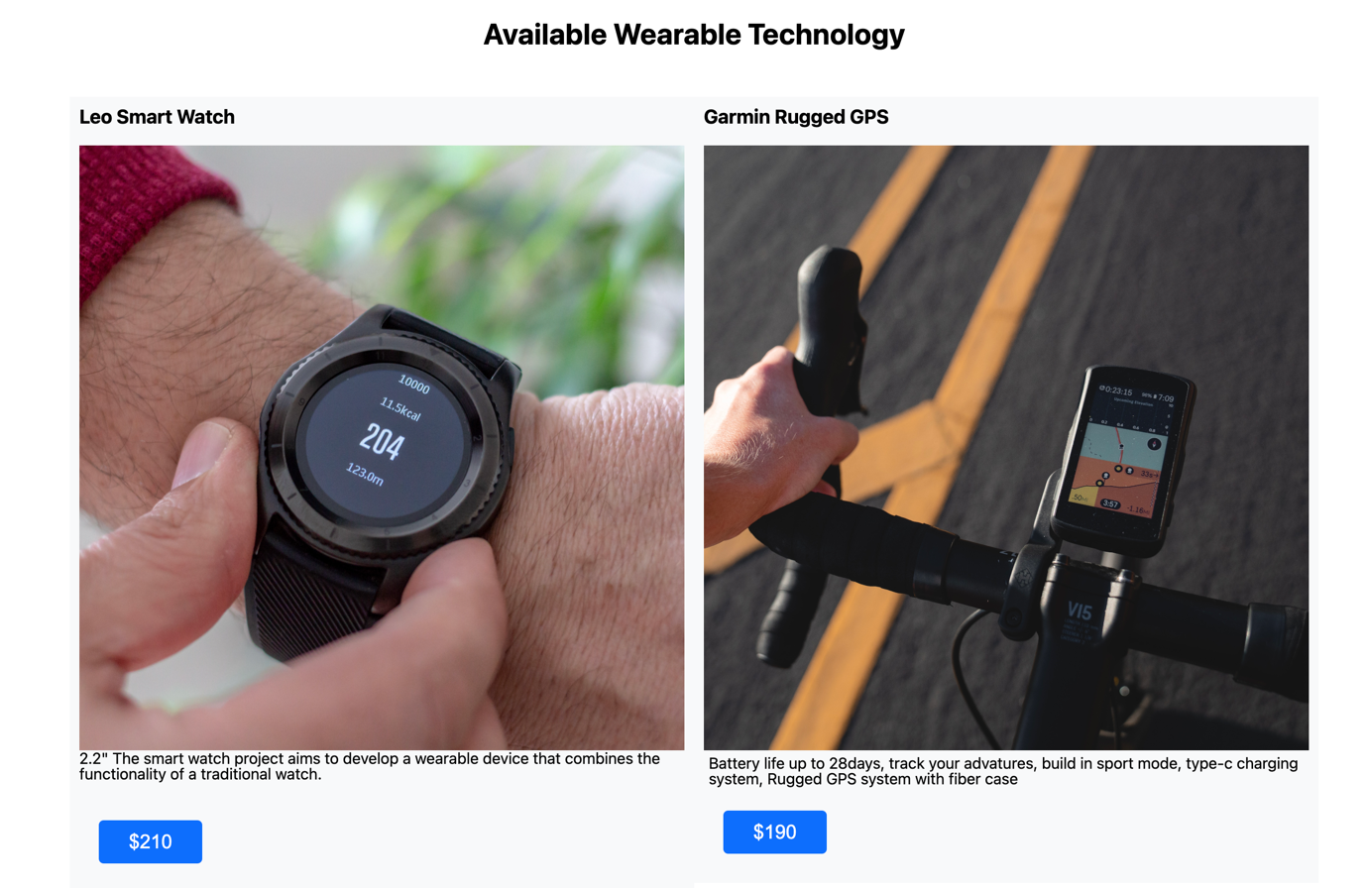

Figure available wearable technology 1

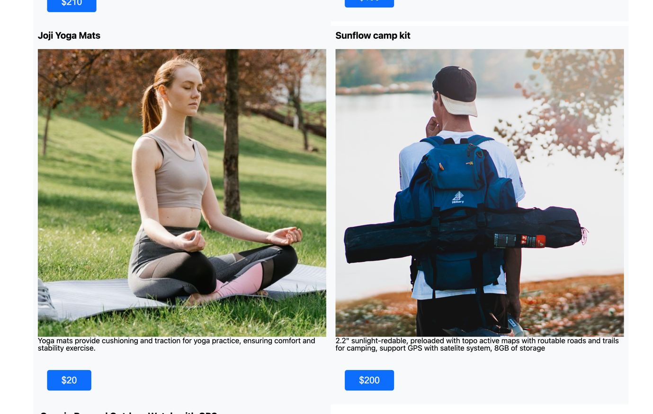

Figure available wearable technology 2

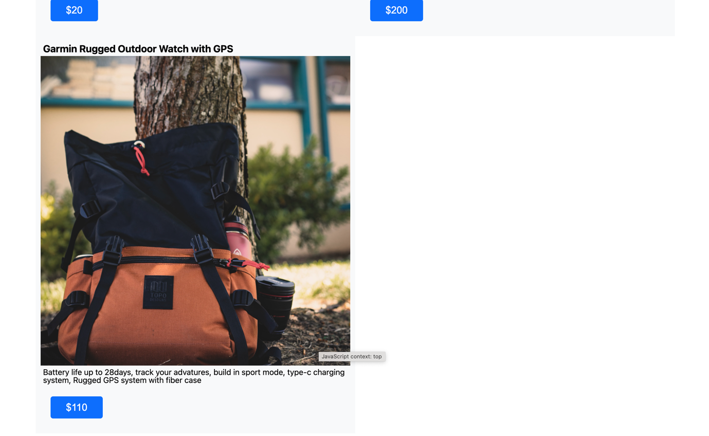

Figure available wearable technology 3

#### Footer

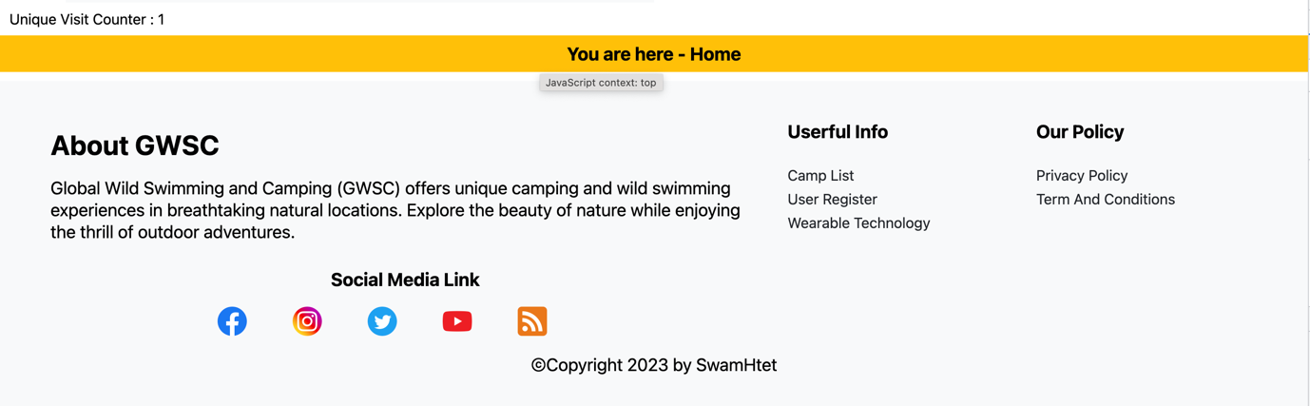

Figure footer

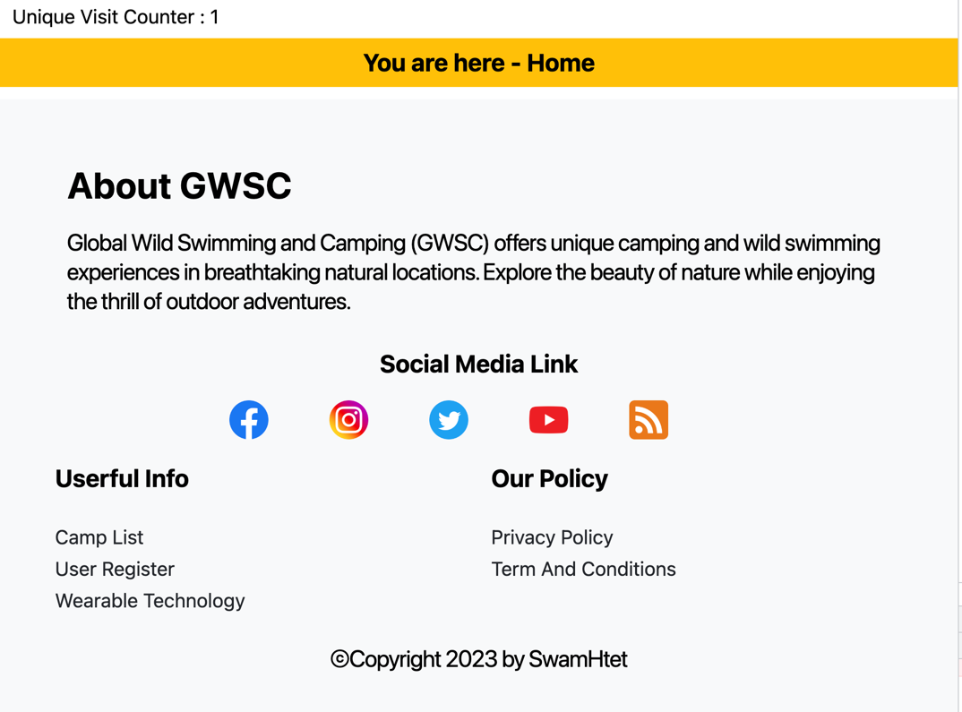

Figure responsive footer for tablet

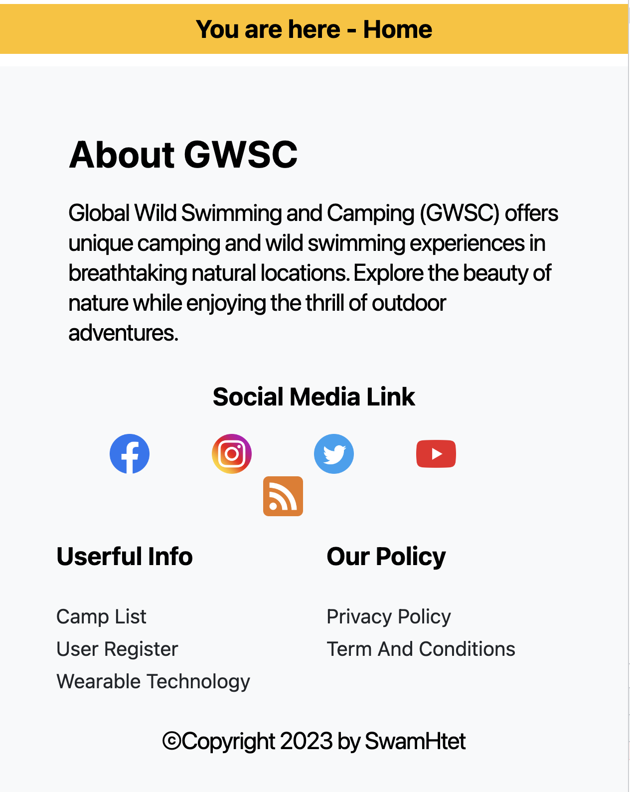

Figure responsive footer for mobile

### Information (information.php)

#### Information page for the visitor

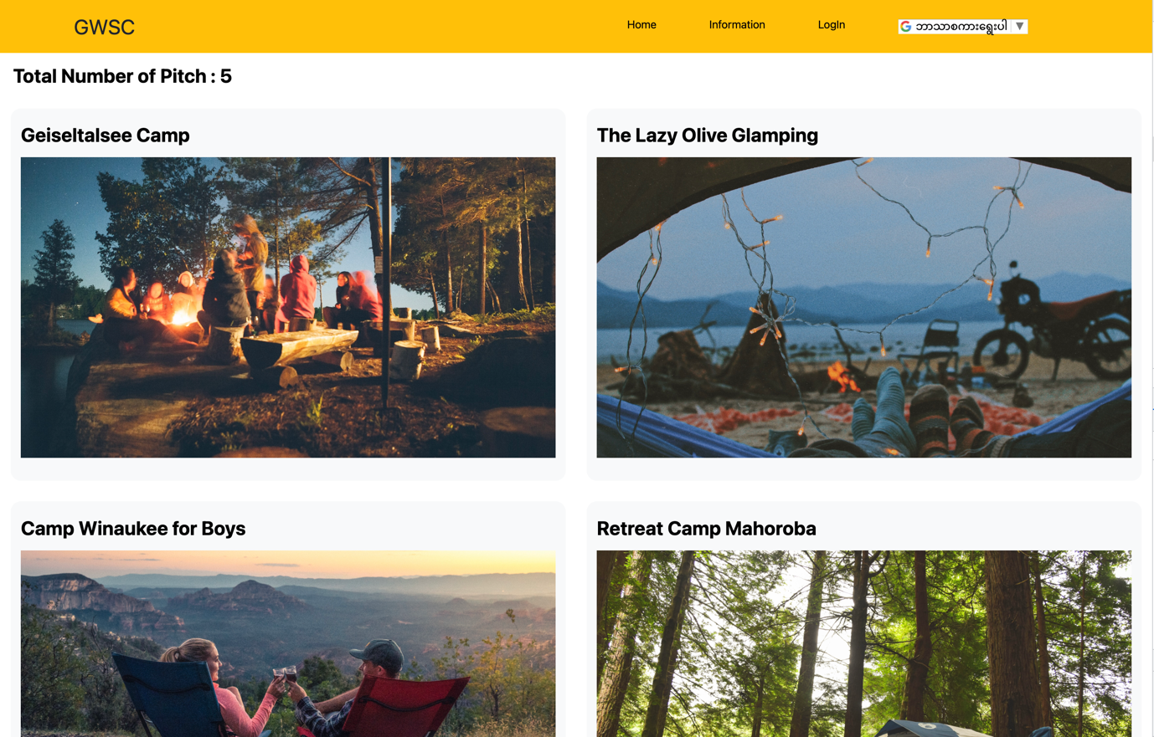

Figure information page for visitor 1 in Chrome Browser

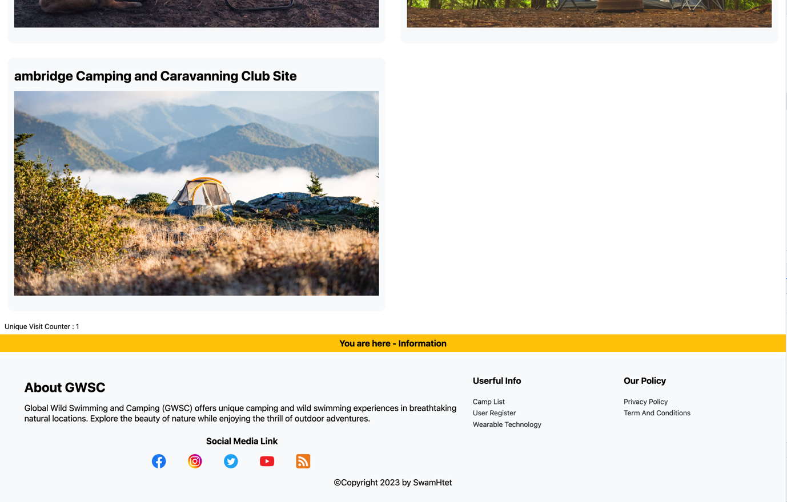

Figure information page for visitor 2 in Chrome Browser

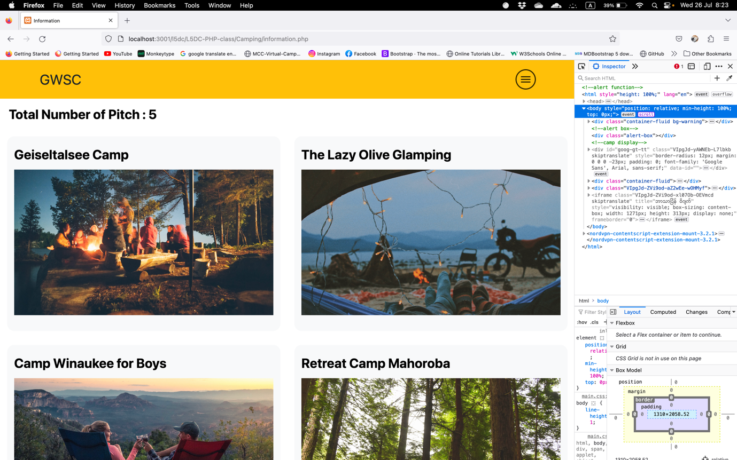

Figure information page for visitor 1 in Firefox Browser

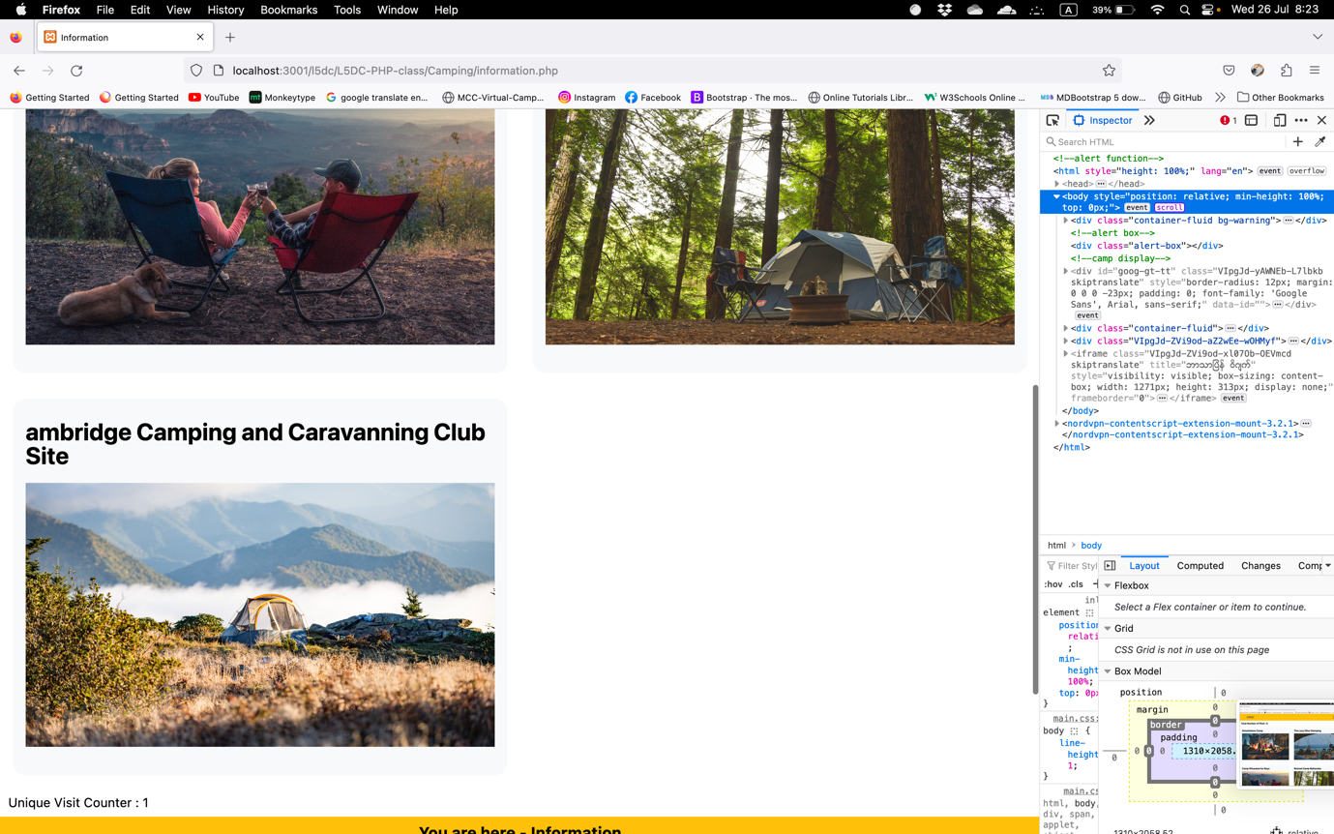

Figure information page for visitor 2 in Firefox Browser

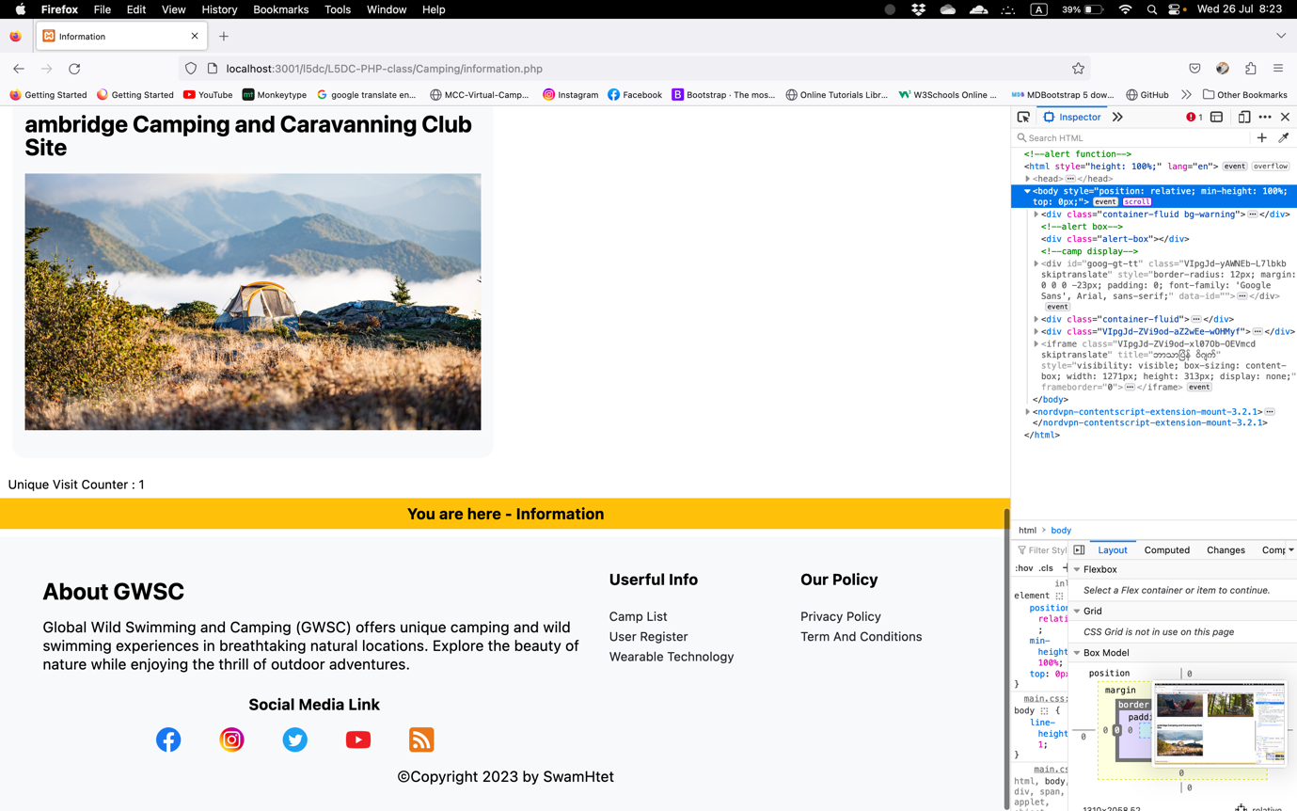

Figure information page for visitor 3 in Firefox Browser

#### Information page for the user

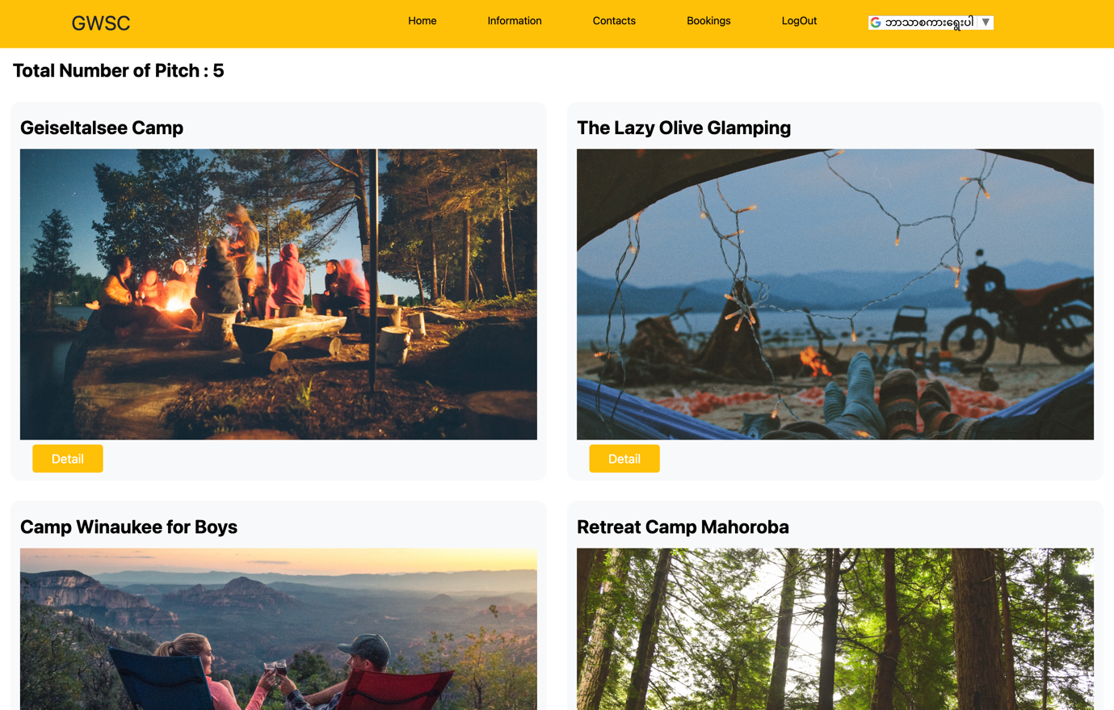

Figure information page for user 1 in Chrome Browser

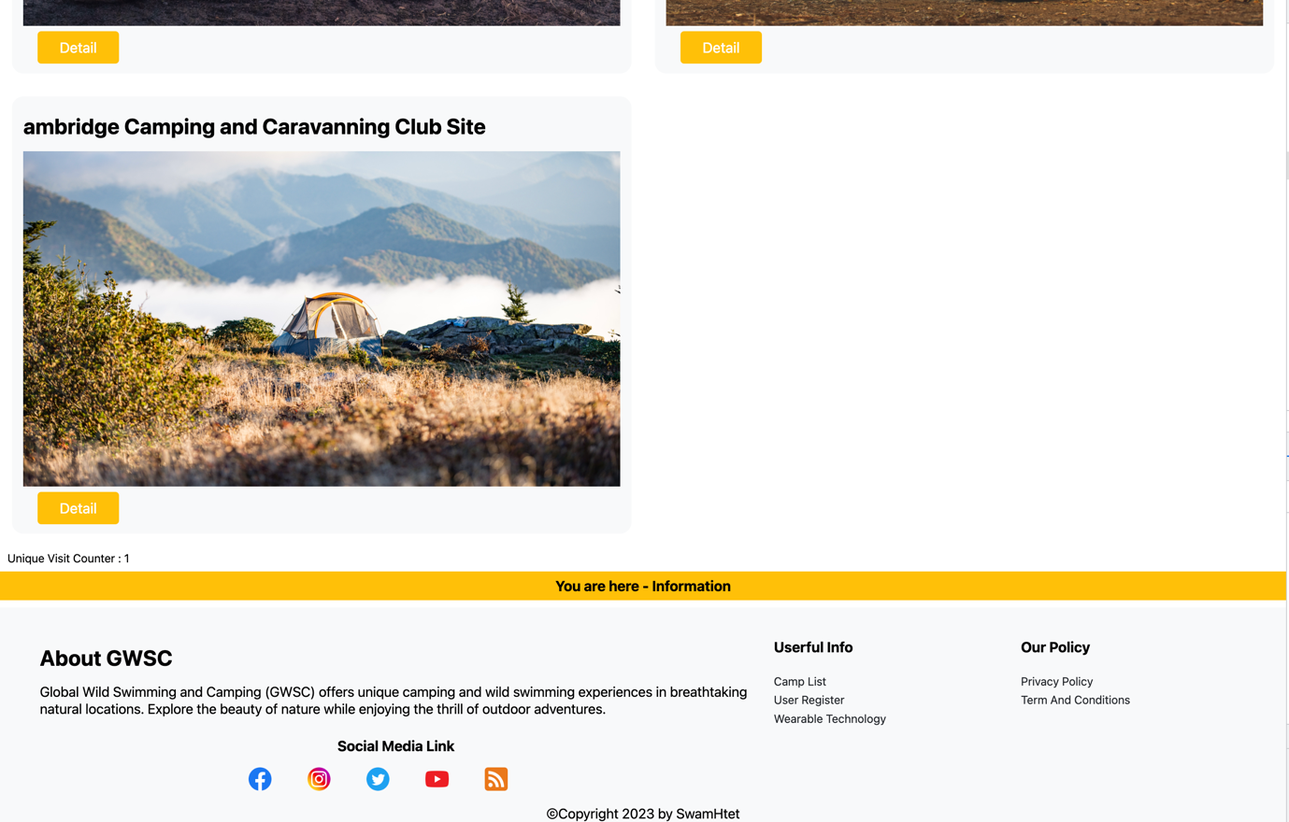

Figure information page for user 2 in Chrome Browser

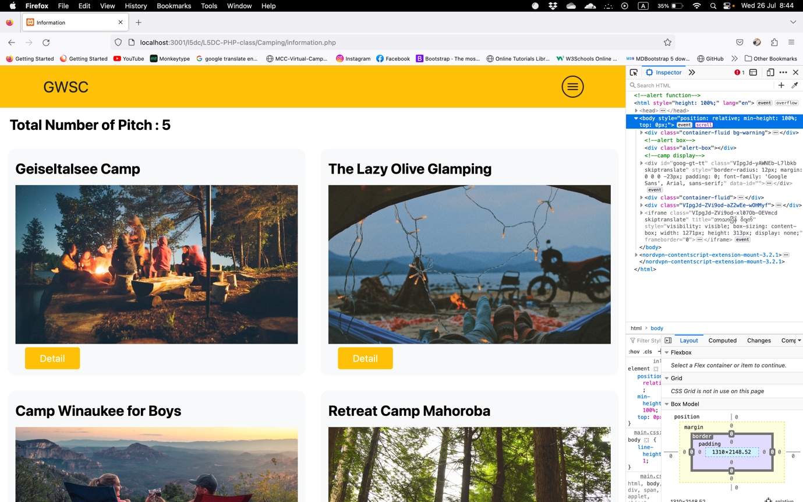

Figure information page for user 1 in Firefox Browser

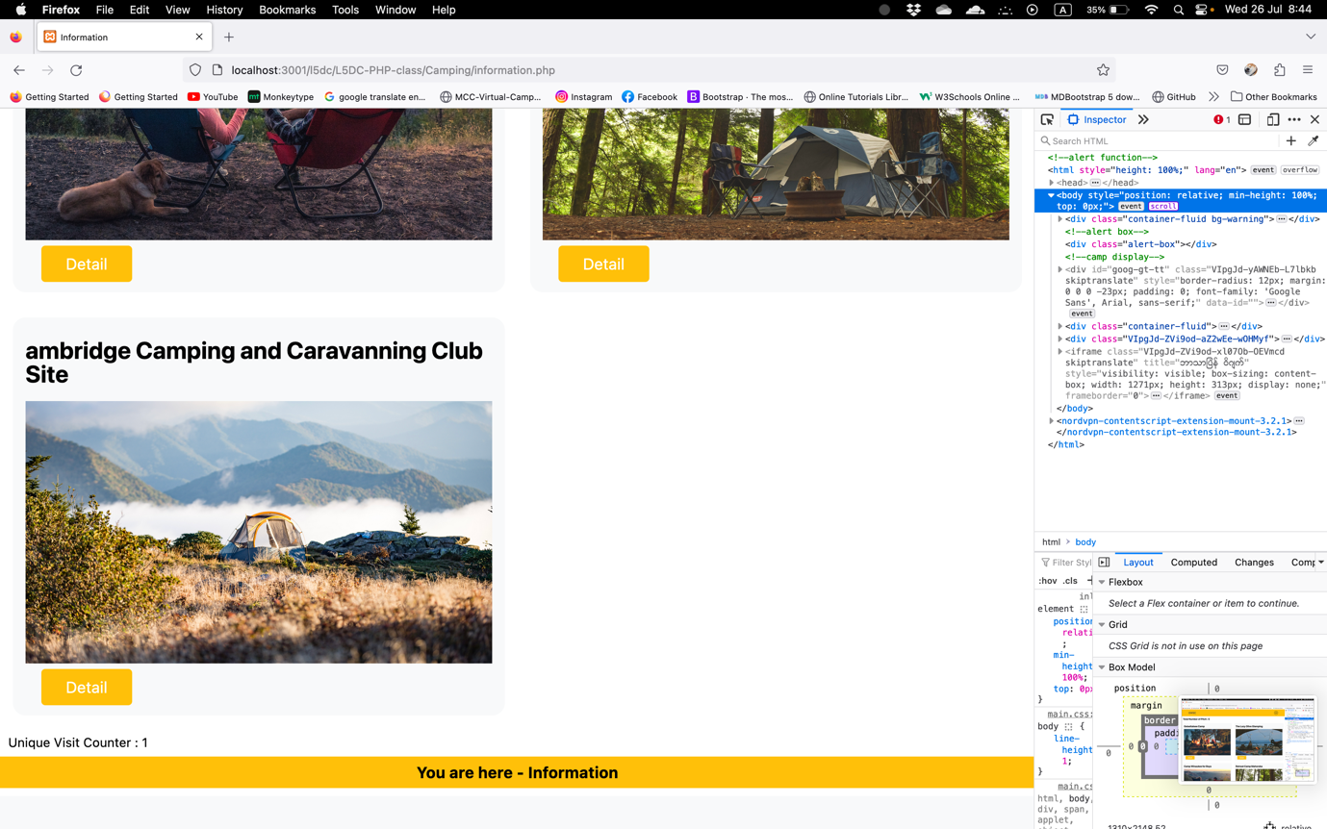

Figure information page for user 2 in Firefox Browser

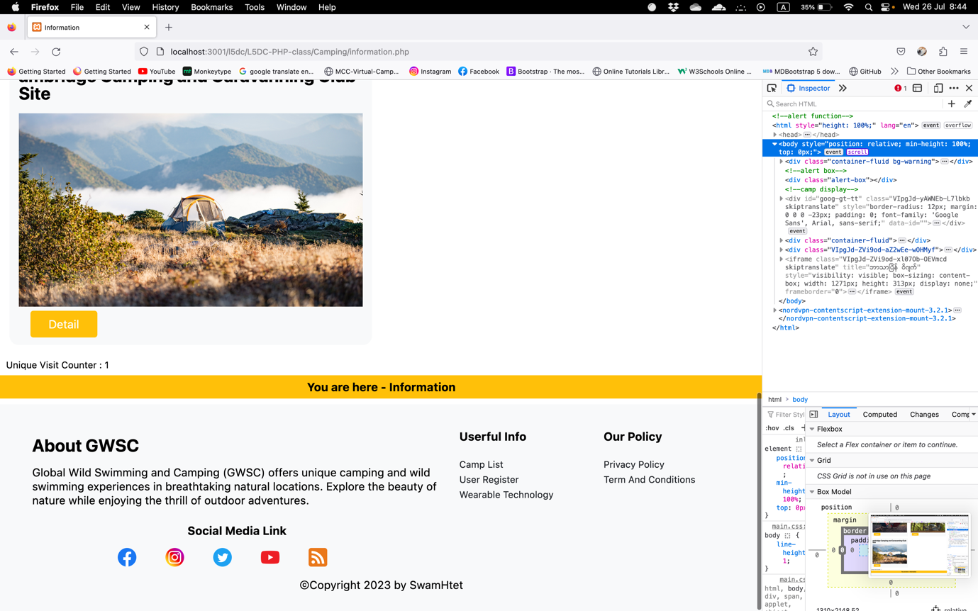

Figure information page for user 3 in Firefox Browser

#### Information page for the admin

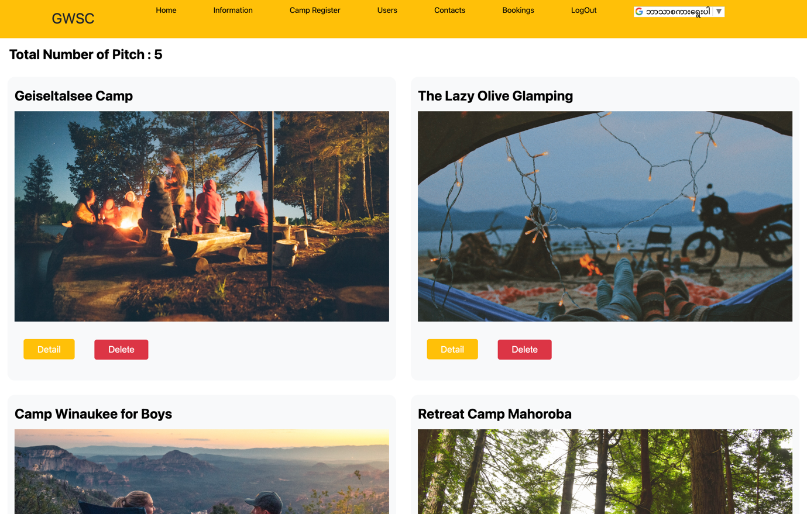

Figure information page for admin 1 in Chrome Browser

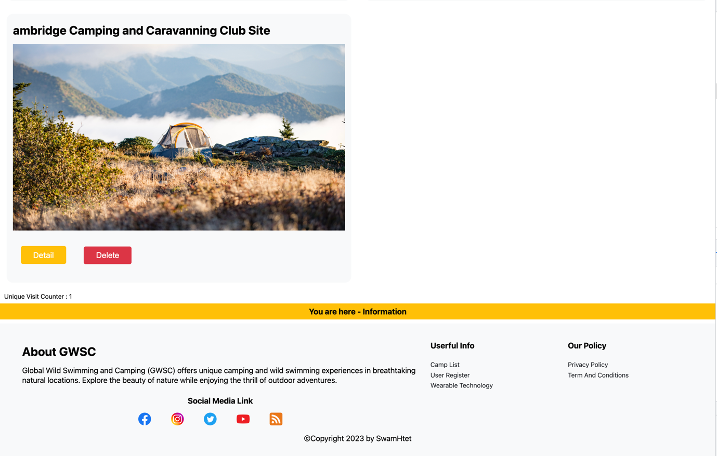

Figure information page for admin 2 in Chrome Browser

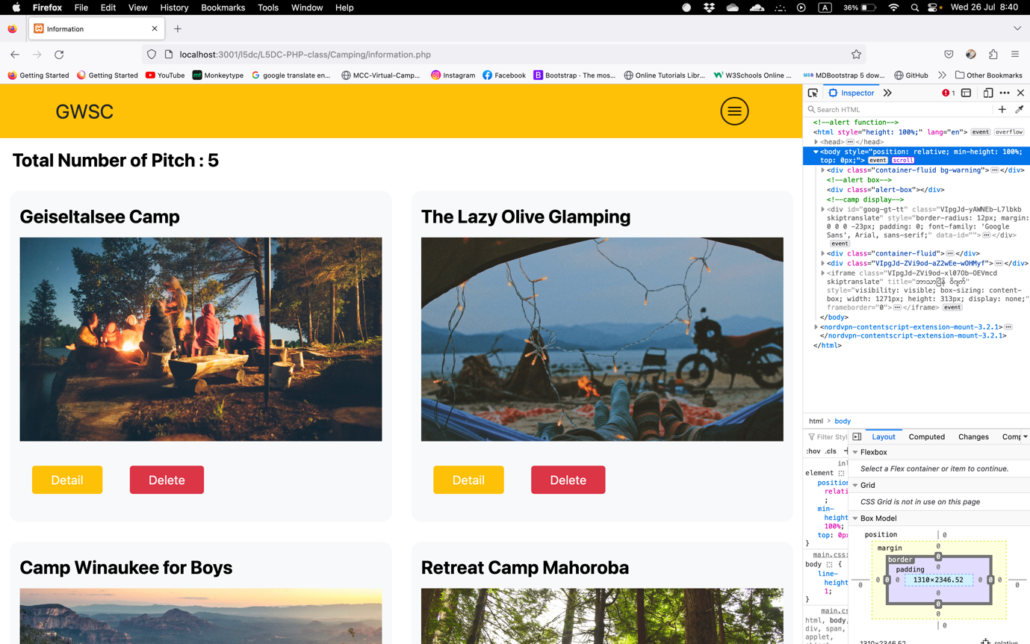

Figure information page for admin 1 in Firefox Browser

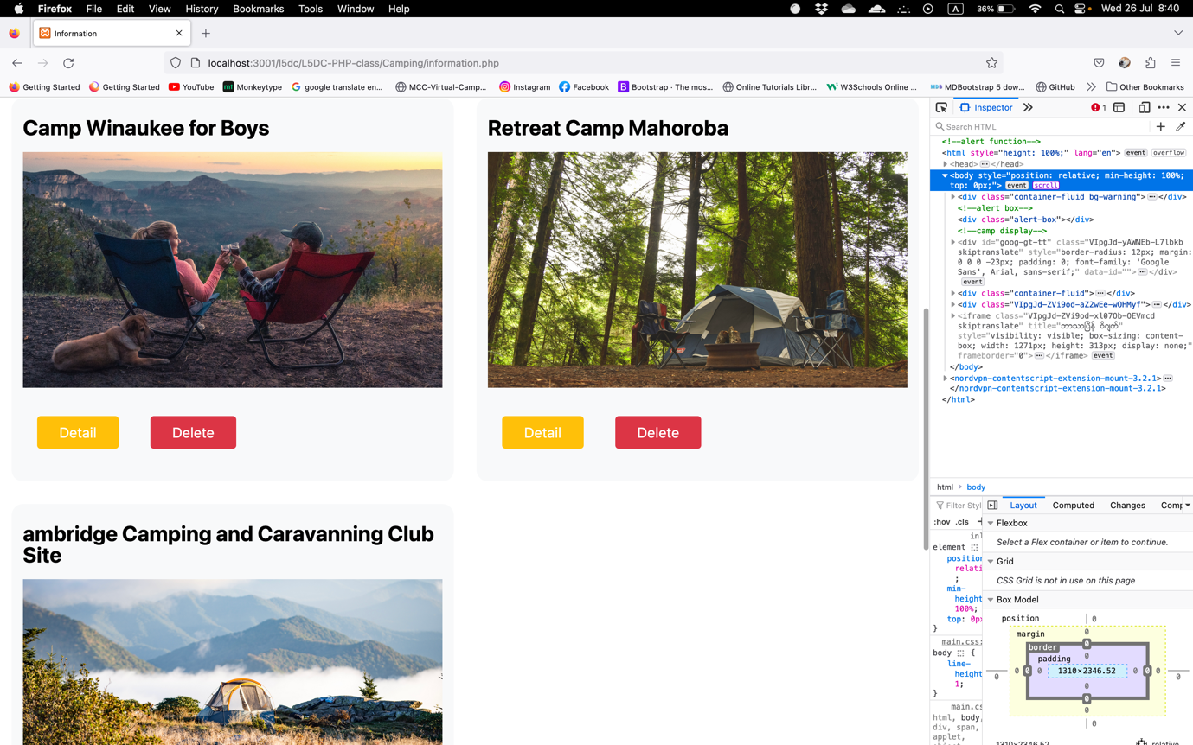

Figure Information page for admin 2 in Firefox Browser

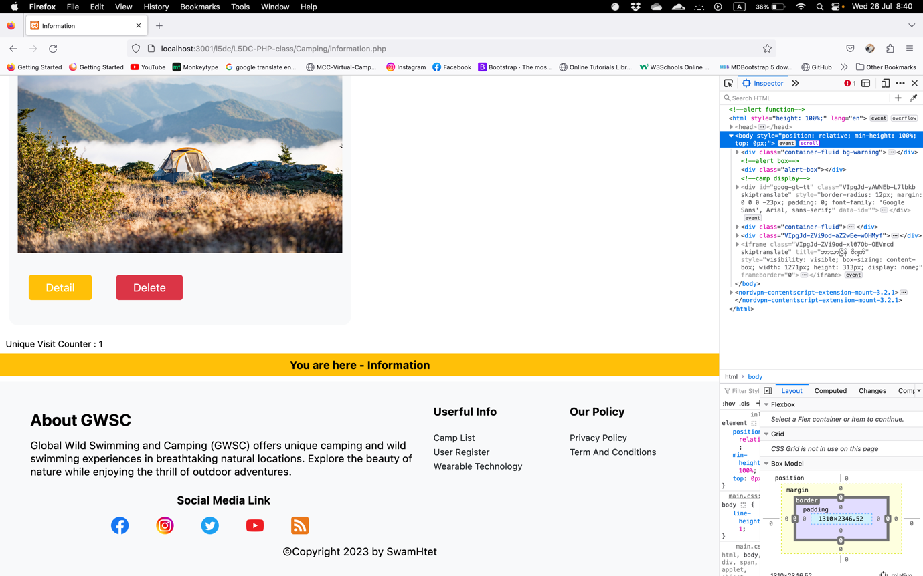

Figure Information Page for admin 3 in Firefox Browser

### Login Page (login.php)

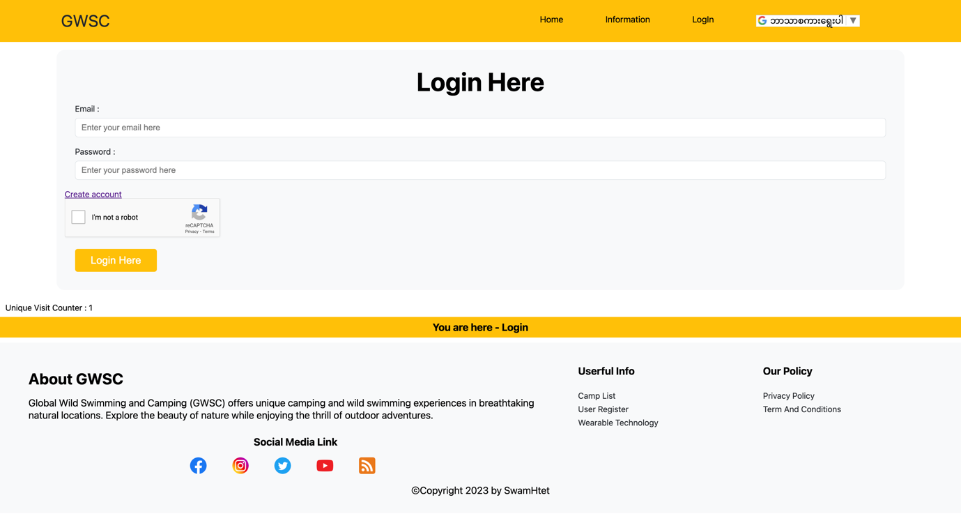Figure login page in Chrome Browser

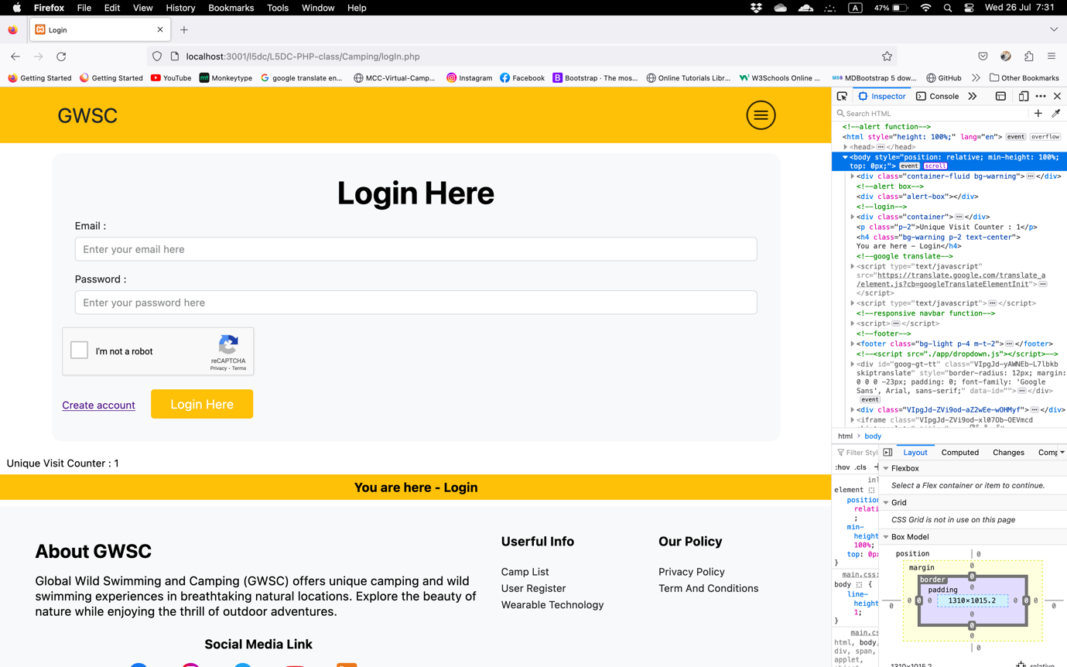

Figure login page in Firefox Browser

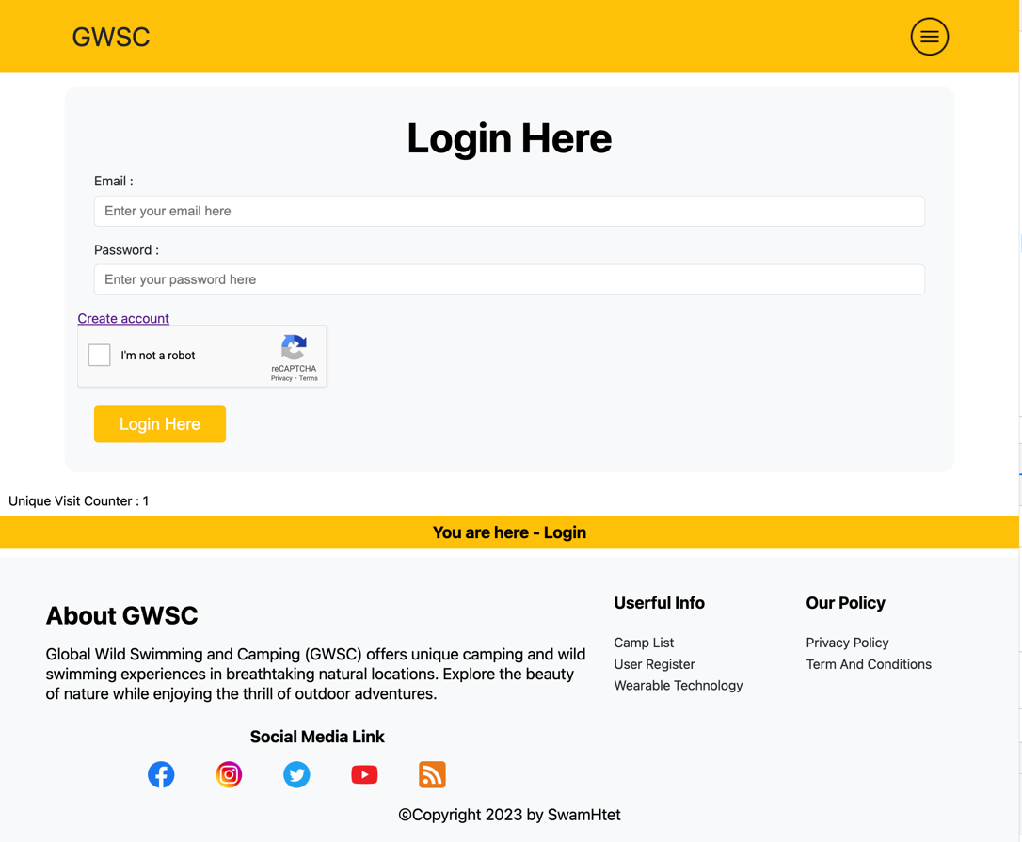

Figure login page for tablet

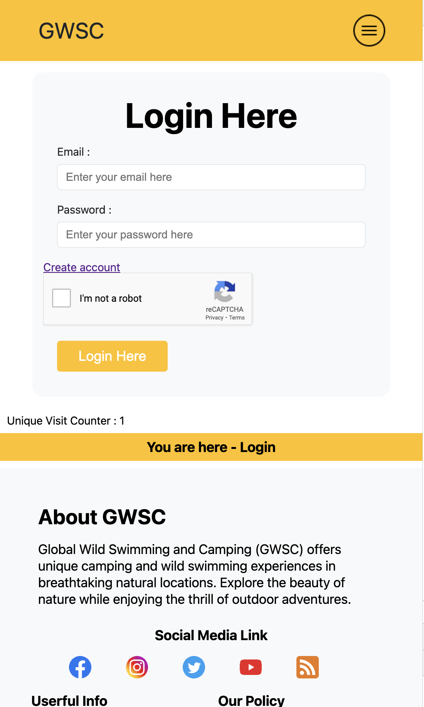

Figure login page for mobile

### Register (create_acount.php)

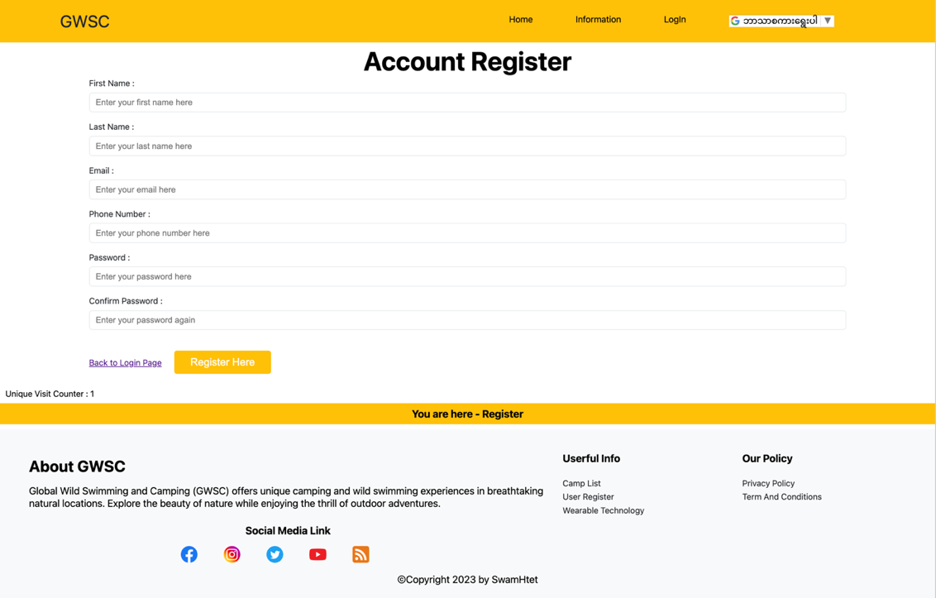

Figure account register in Chrome Browser

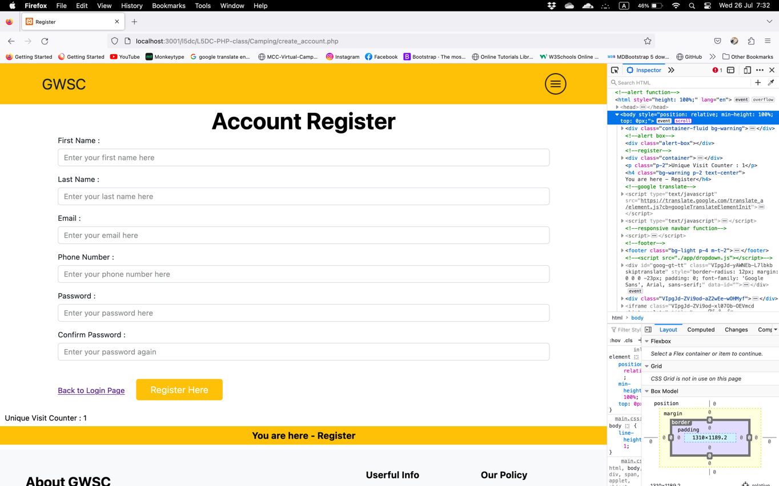

Figure account register in Firefox Browser

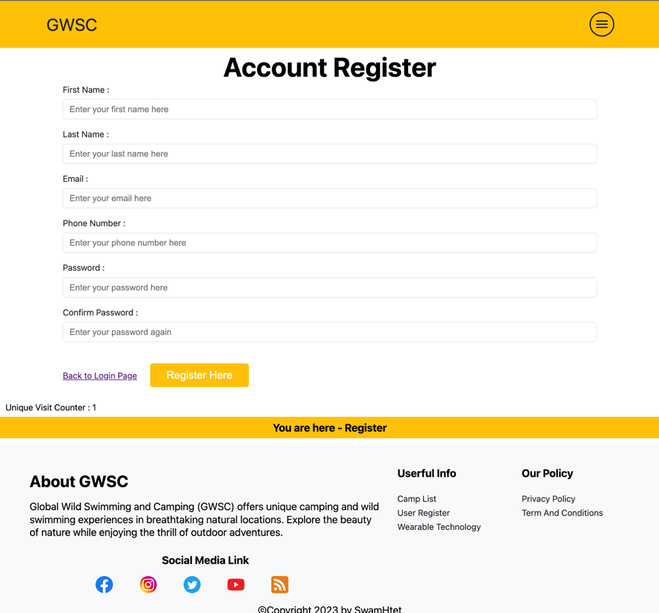

Figure account register for tablet

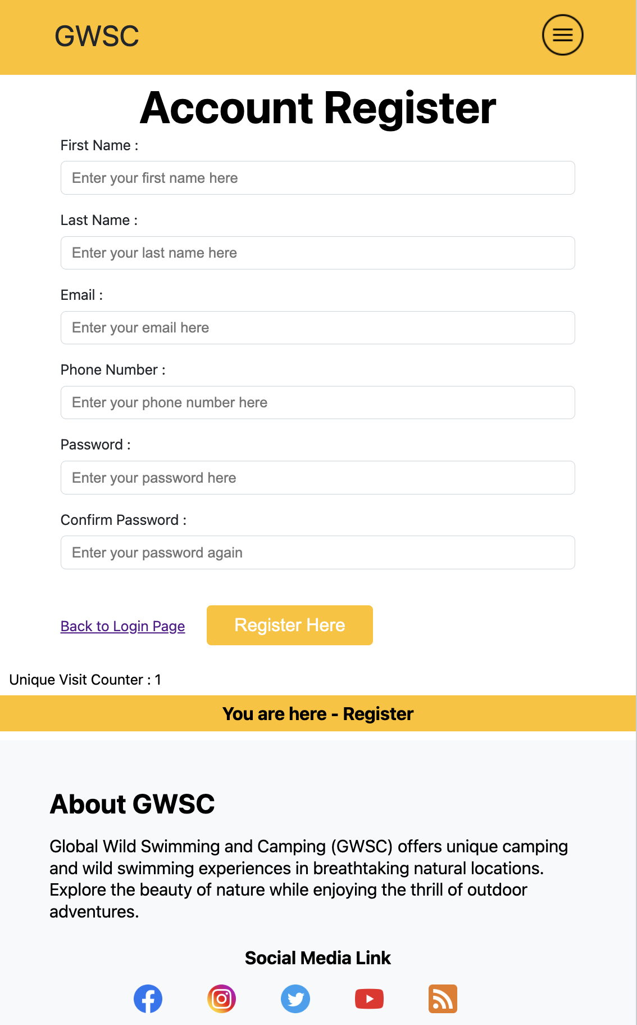

Figure account register for mobile

### Search Camp (search_camp.php)

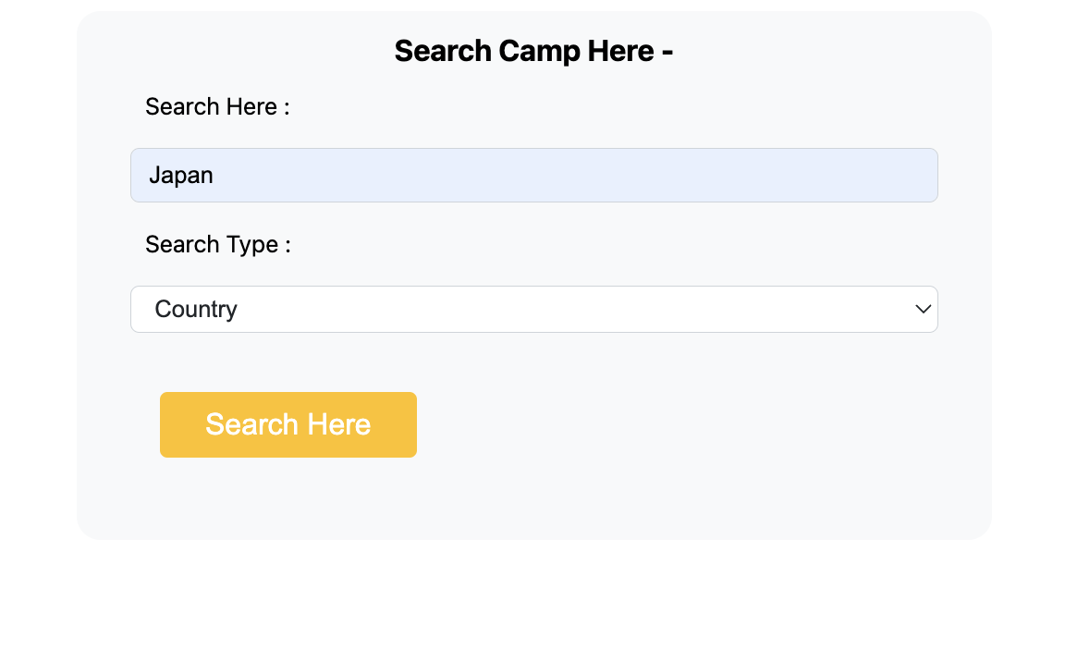

Figure search camp in Japan (Country)

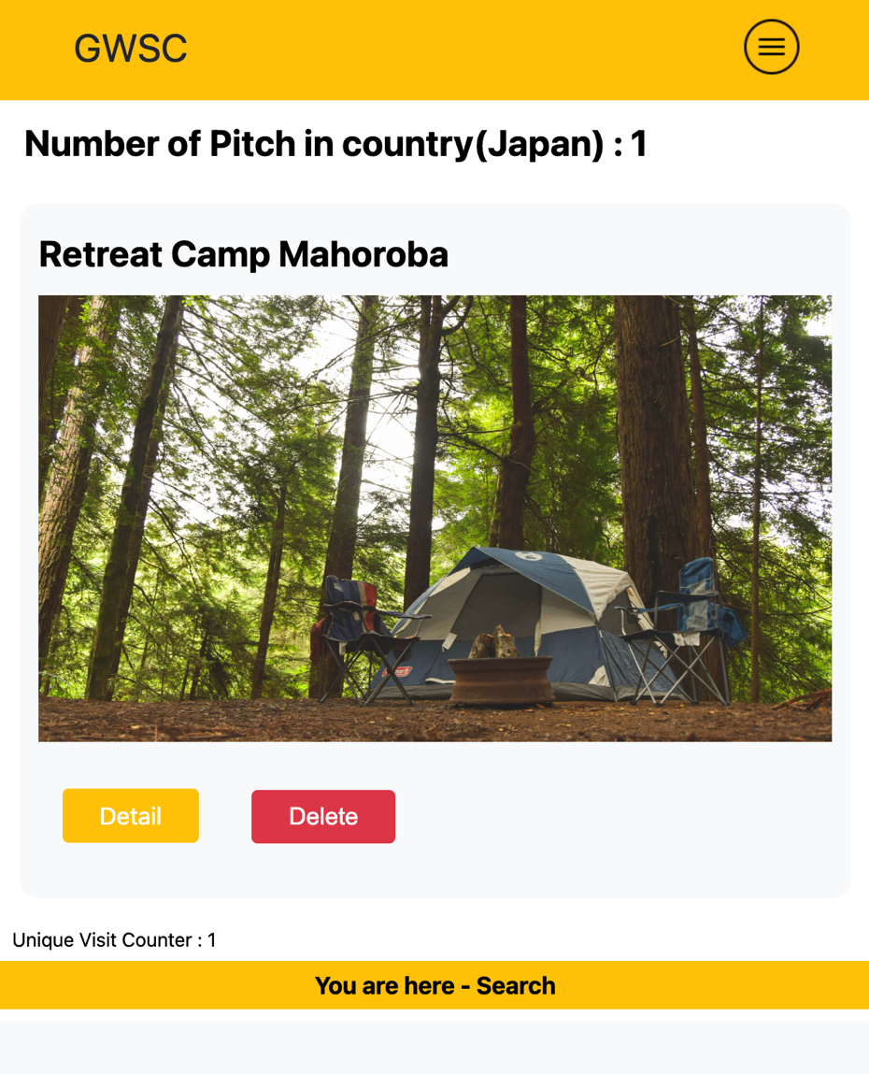

Figure result of Searching

### Profile (camp_profile.php)

#### Profile Page for user

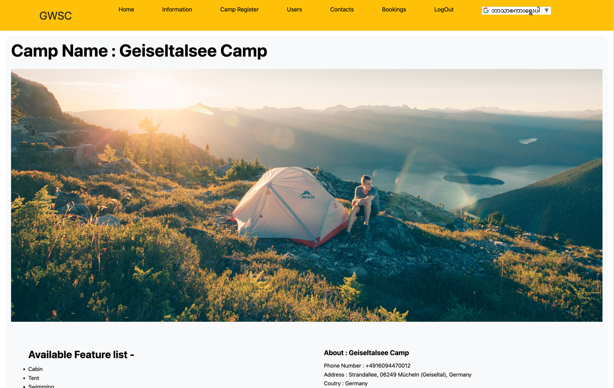

Figure camp profile page for user 1

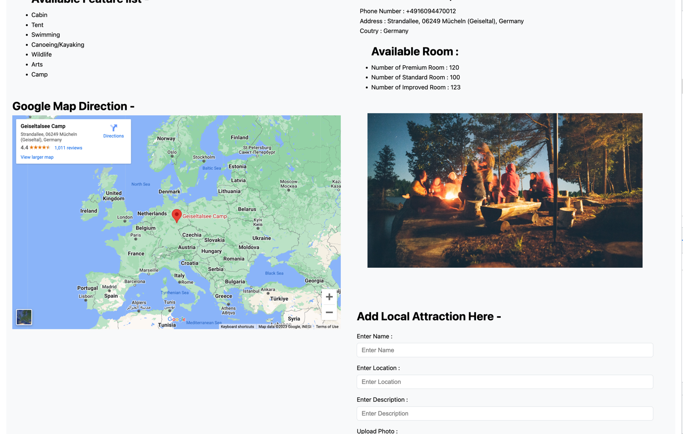

Figure camp profile page for user 2

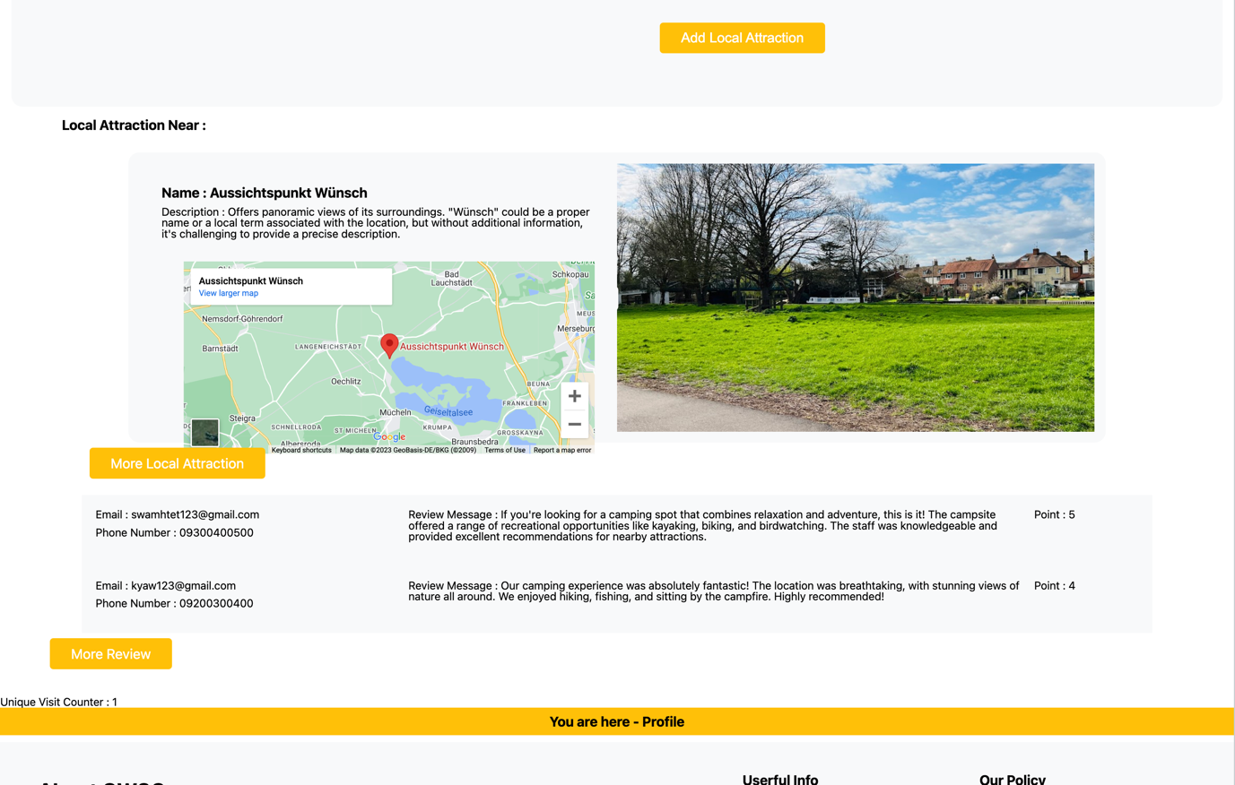

Figure camp profile page for user 3

#### Profile page for admin

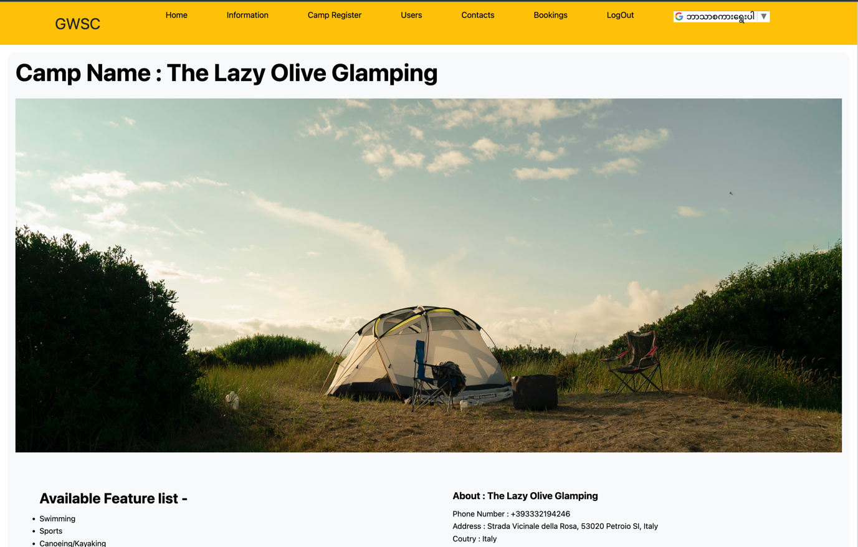

Figure camp profile page for admin 1

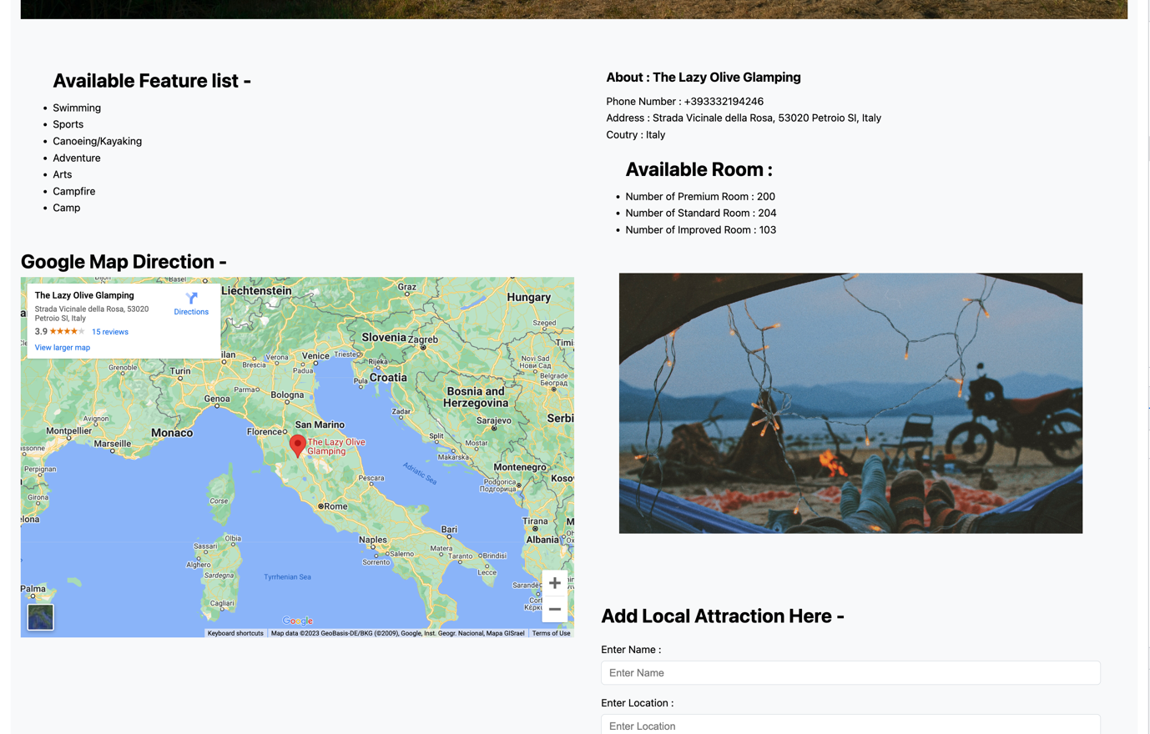

Figure camp profile page for admin 2

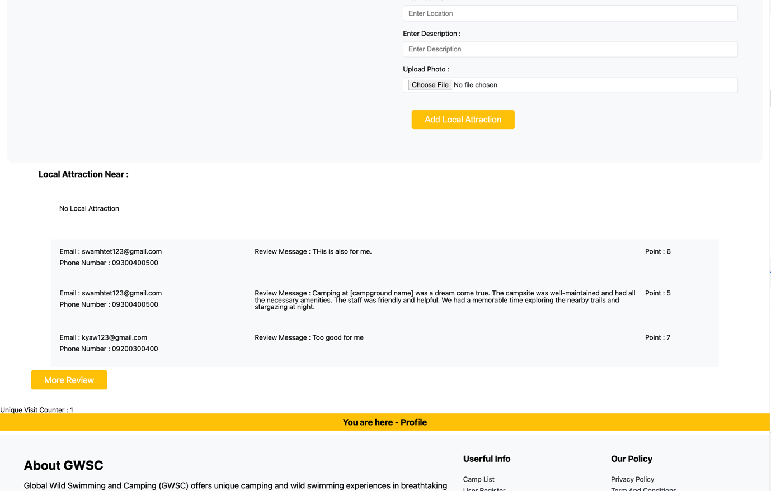

Figure camp profile page for admin 3

#### Available features list in Camp Profile

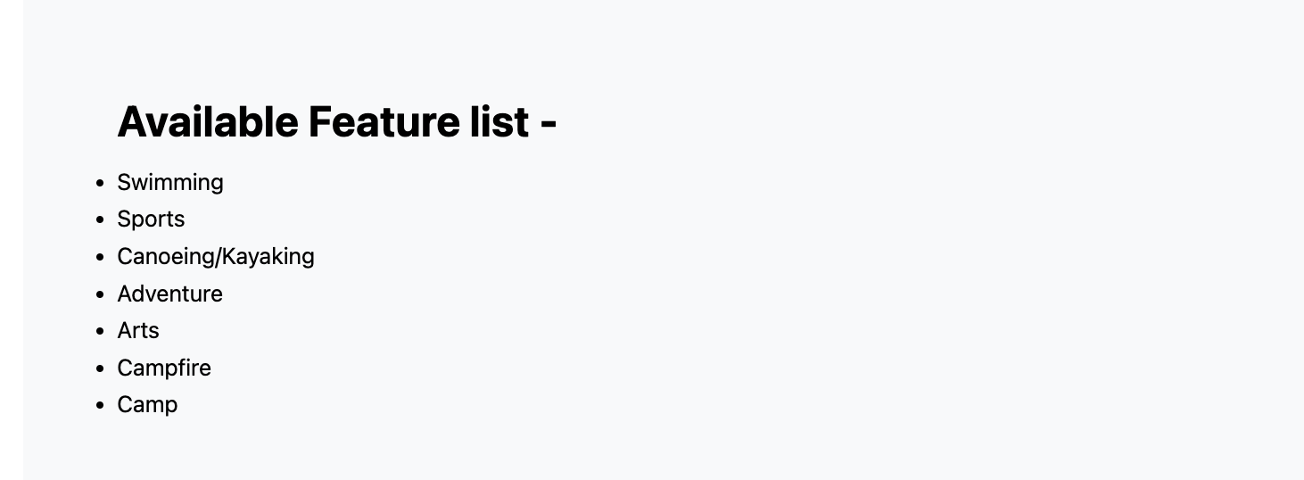

Figure available features of the camp

#### About and Available Room of the camp in camp profile

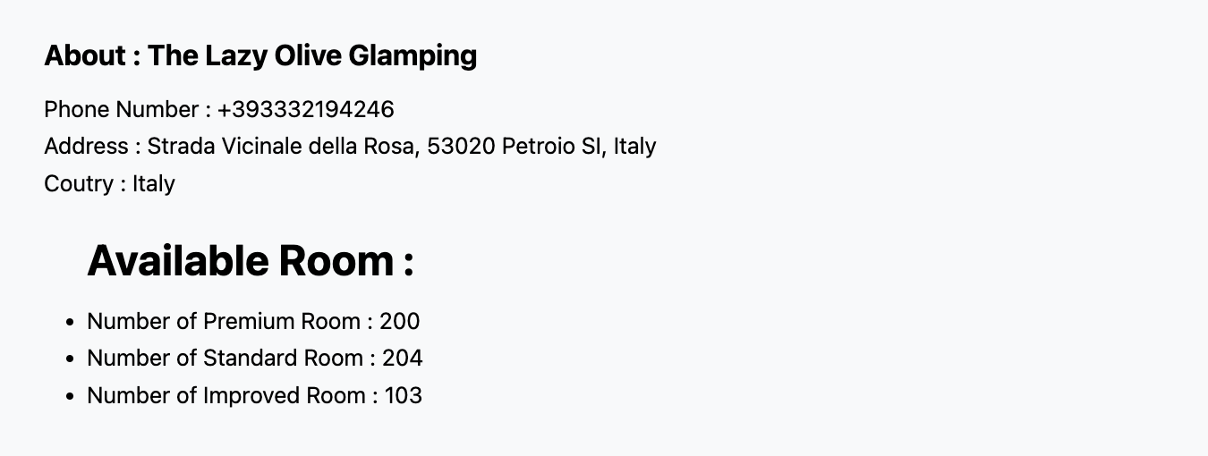

Figure About and available rooms of the camp

#### Google Map Location of the camp

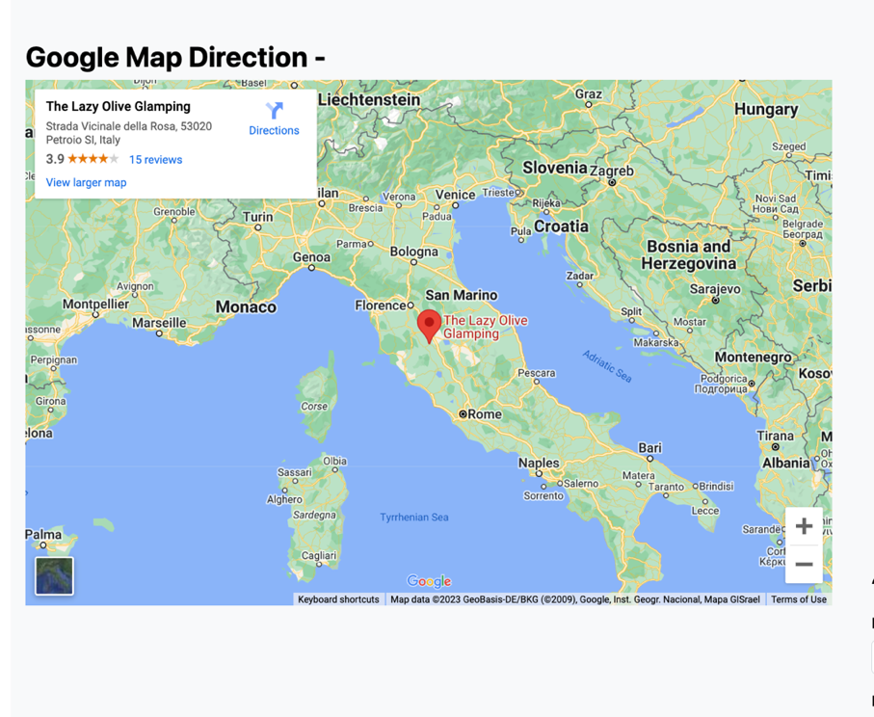

Figure google map location of the camp

#### Adding Local Attraction for the admin

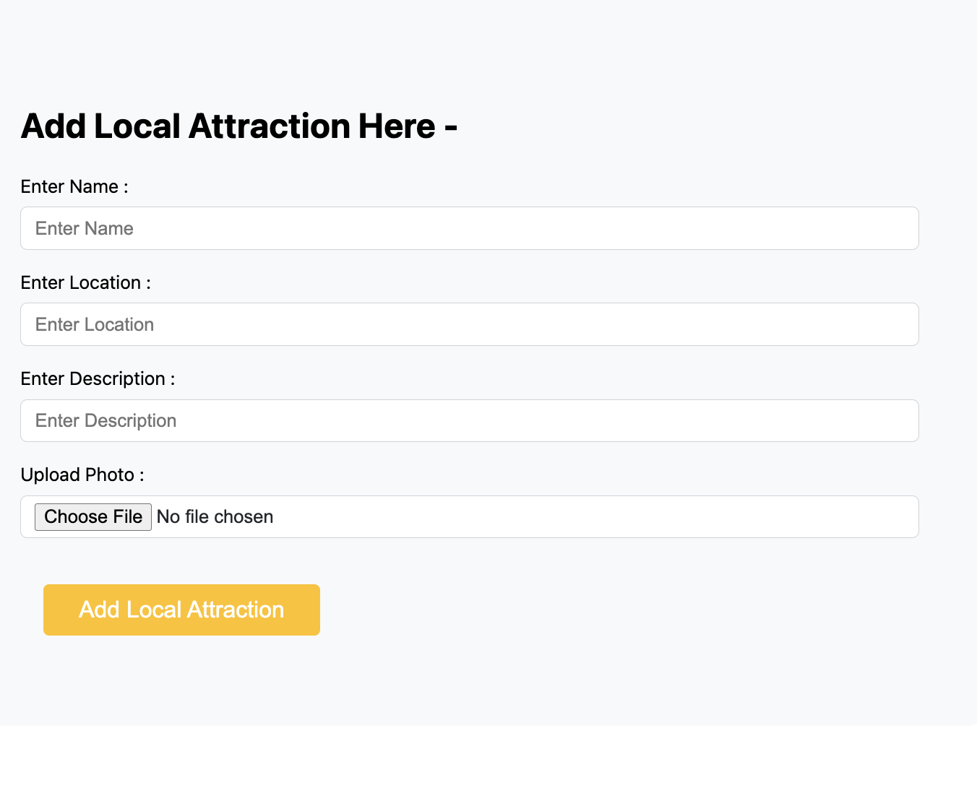

Figure adding local attraction to the camp by admin

#### Checking the top 5 review of the camp at camp profile and click more review to review page

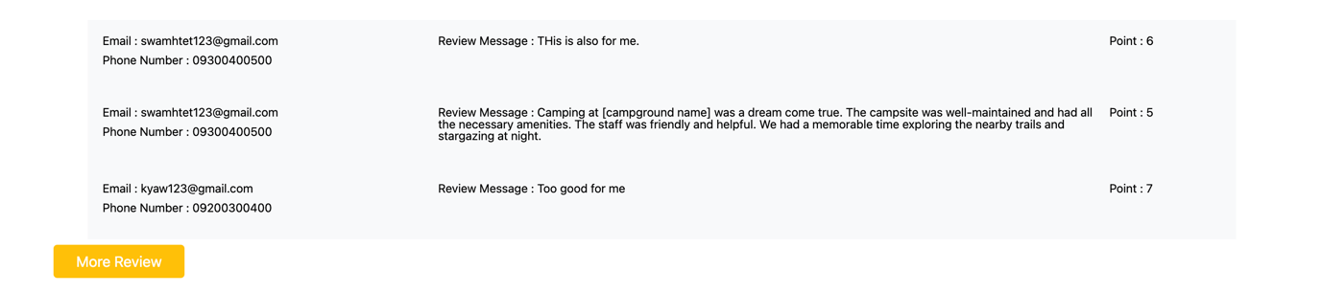

Figure checking top 5 review of the camp and more review button

#### Checking the local attraction of the camp at the camp profile and click more local attraction to local attraction page

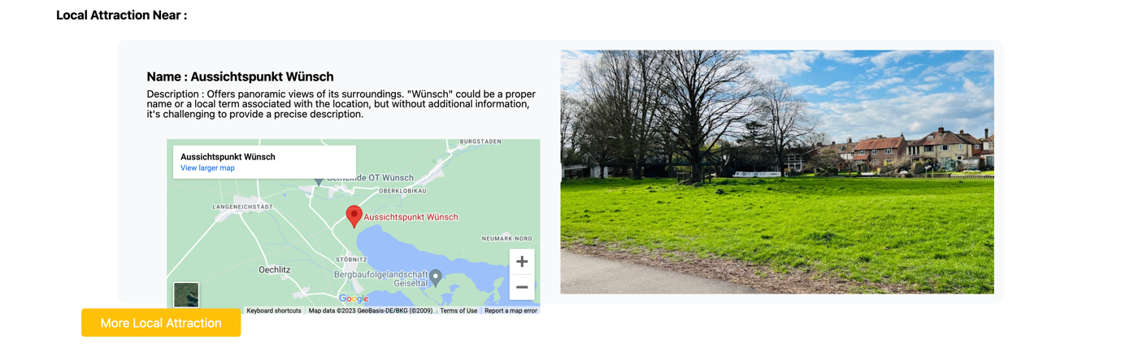

Figure checking the local attraction near the camp and more local attraction button

### Review Page(all_review.php)

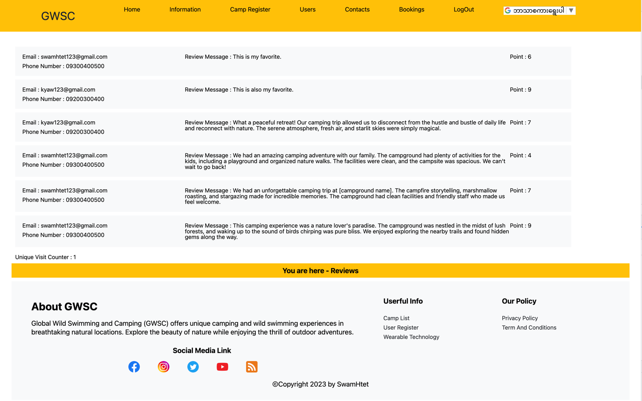

Figure checking the total list of the review of the camp

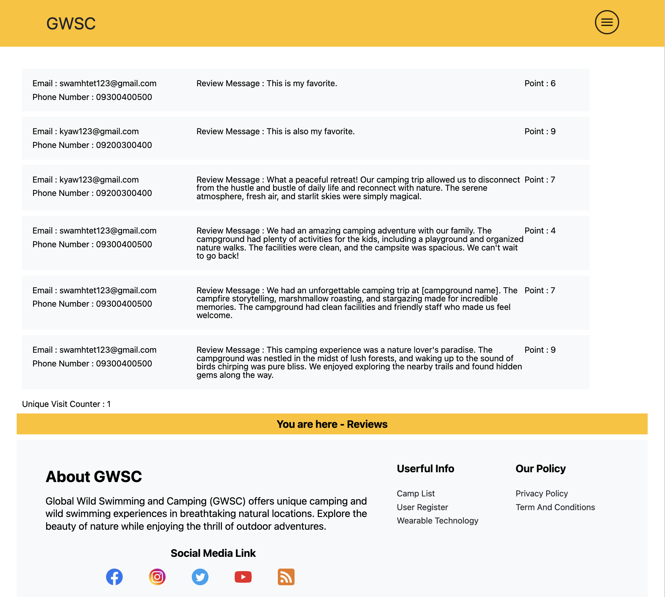

Figure checking the total list of the review of the camp in tablet

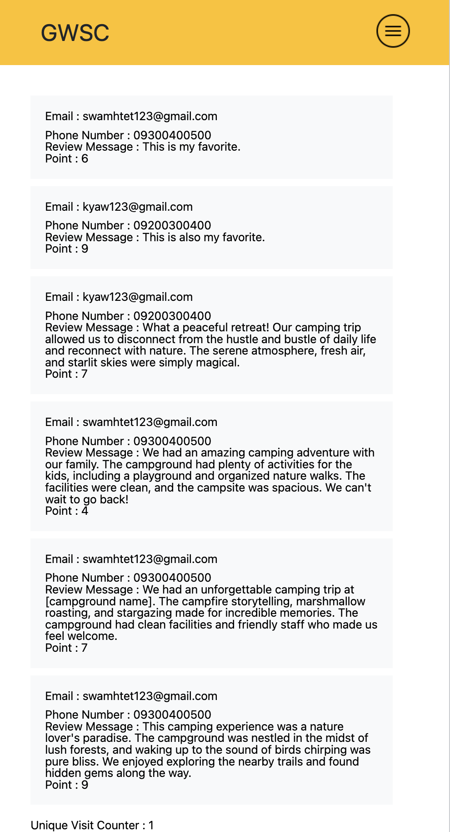

Figure checking the total list of the review of the camp in mobile

### User Page (all_user.php)

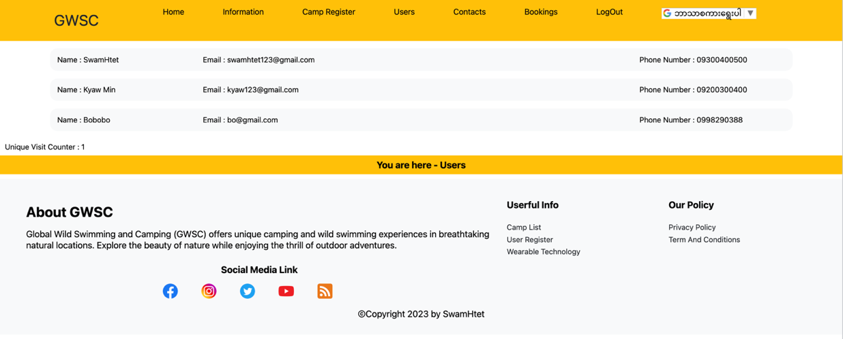

Figure checkin the total list of the user by admin

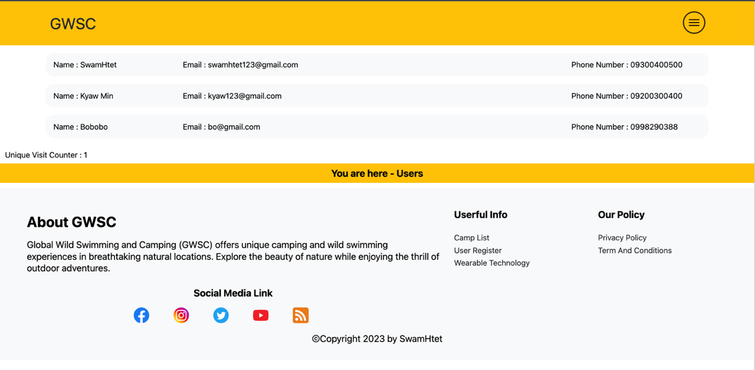

Figure checking the total list of the user by admin in tablet

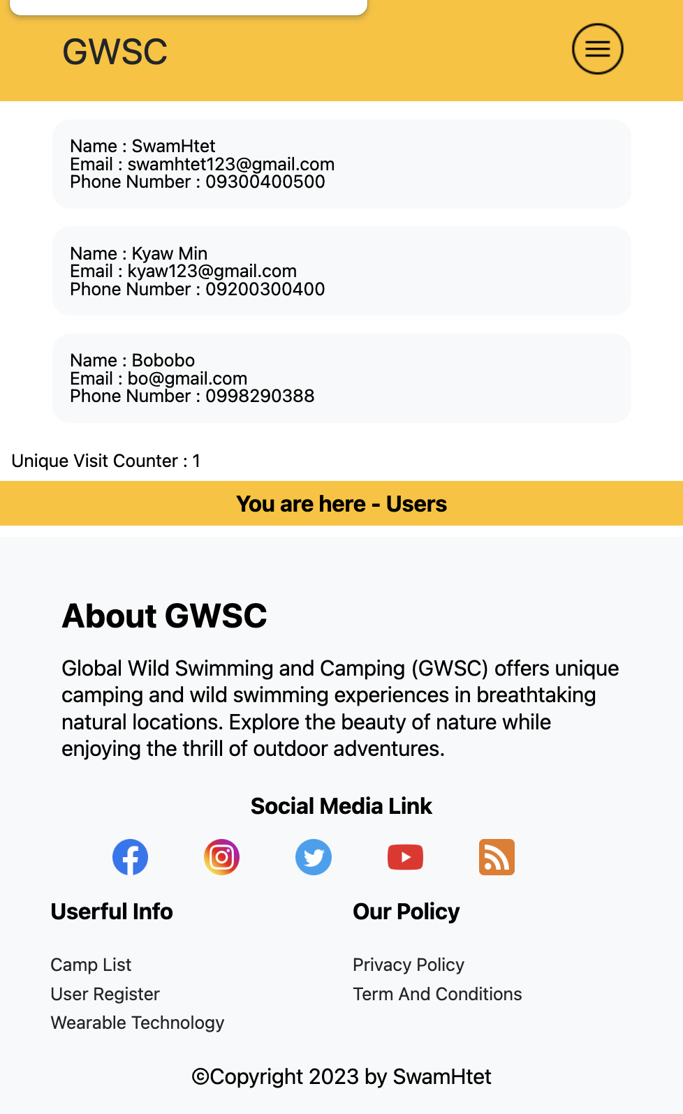

Figure checking the total list of the user by admin in mobile

### Booking Page (all_booking.php)

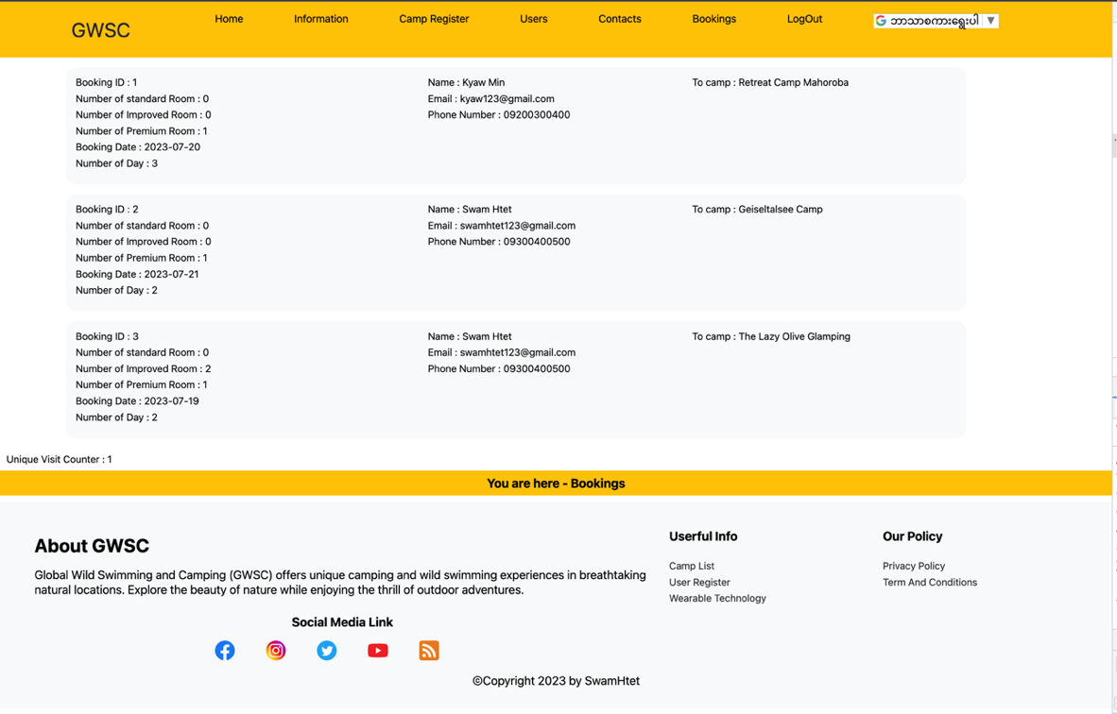

Figure checking the total list of the booking by admin

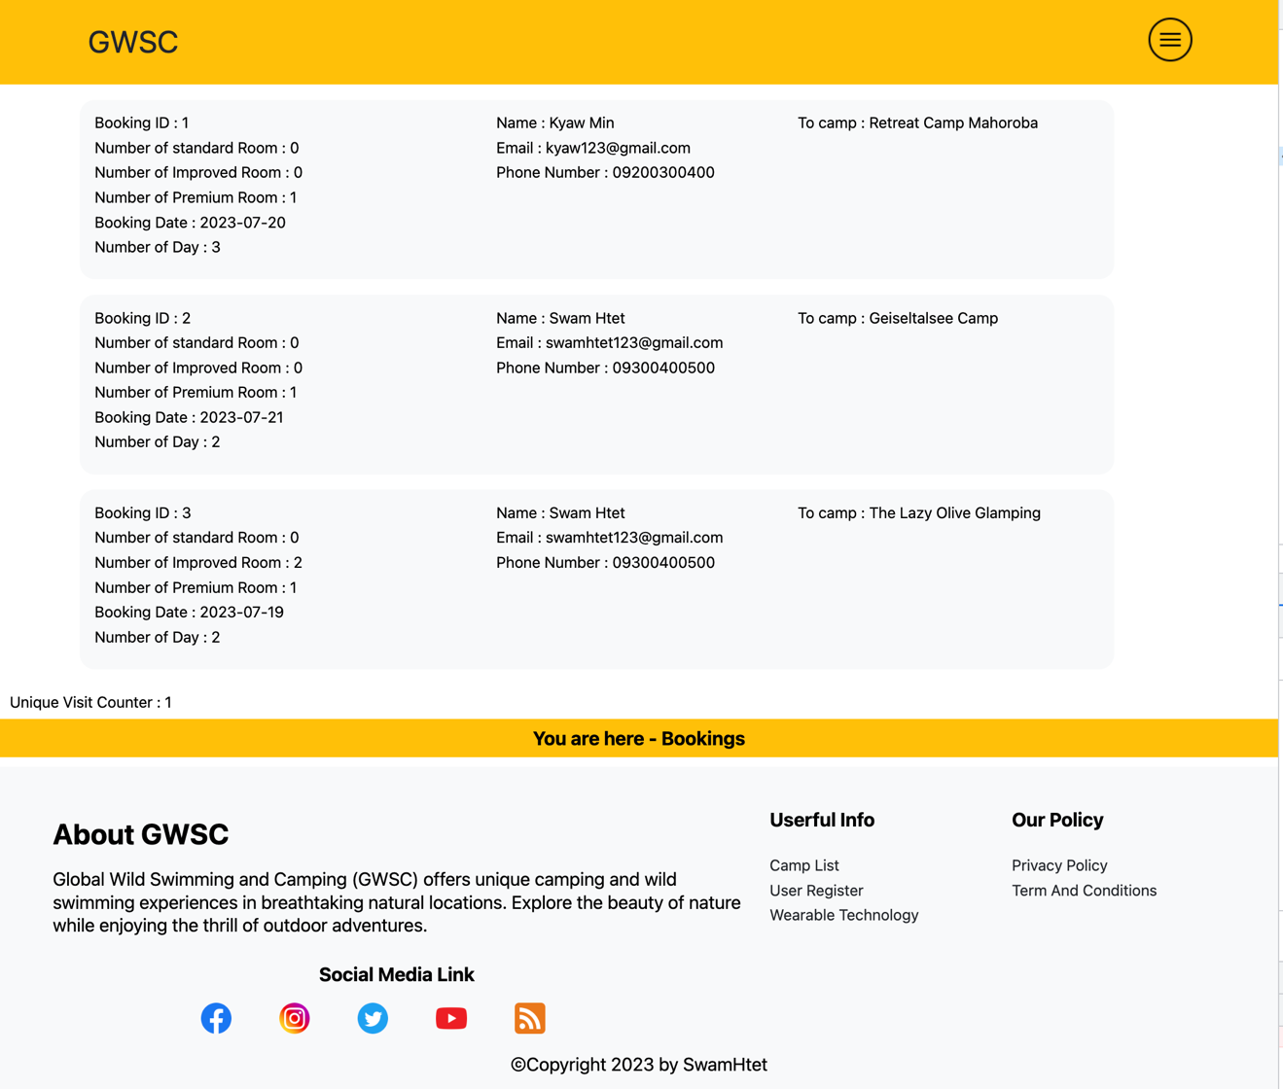

Figure checking the total list of the booking by admin in tablet

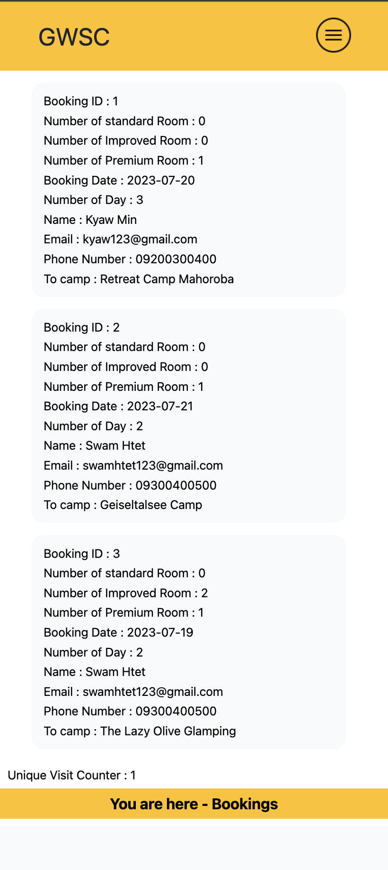

Figure checking the total list of the booking by admin in mobile

### Contact Page( all_contact.php)

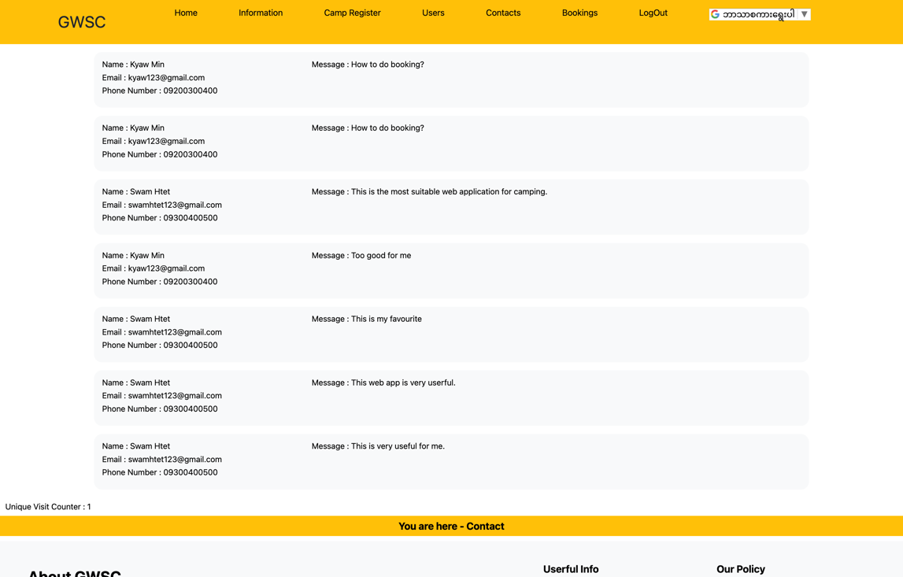

Figure checking the total list of the contact message in Chrome Browser by admin

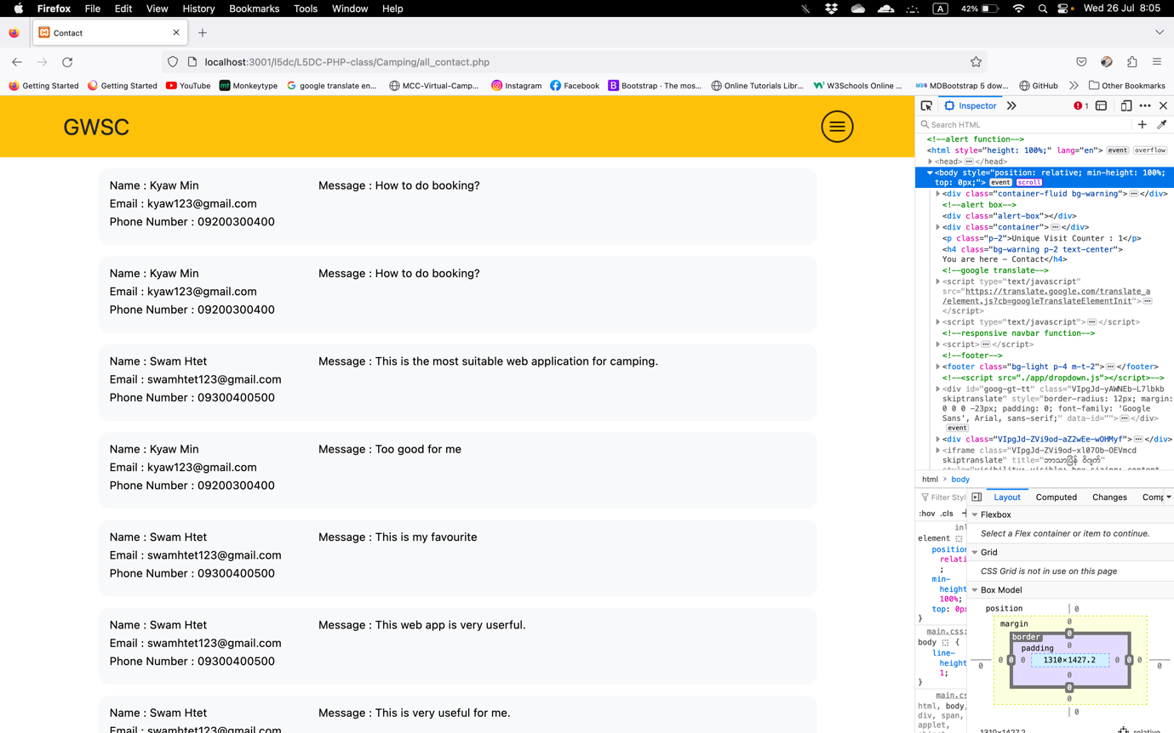

Figure checking the total list of the contact message in Firefox Browser by admin 1

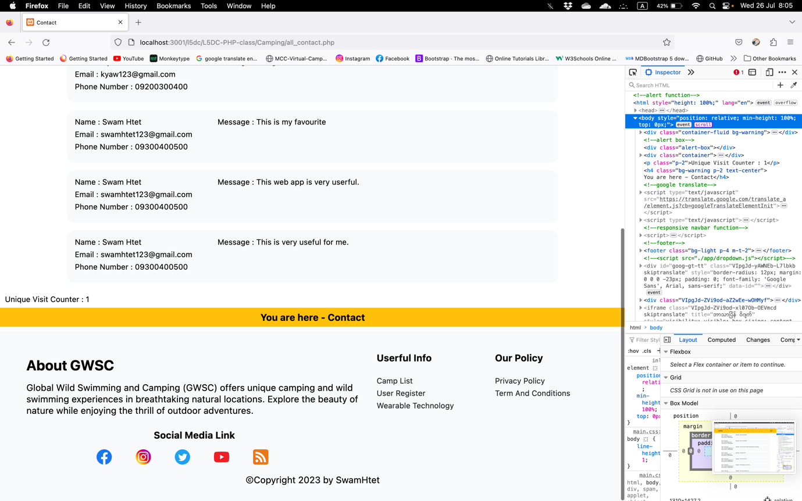

Figure checking the total list of the contact message in Firefox Browser by admin 2

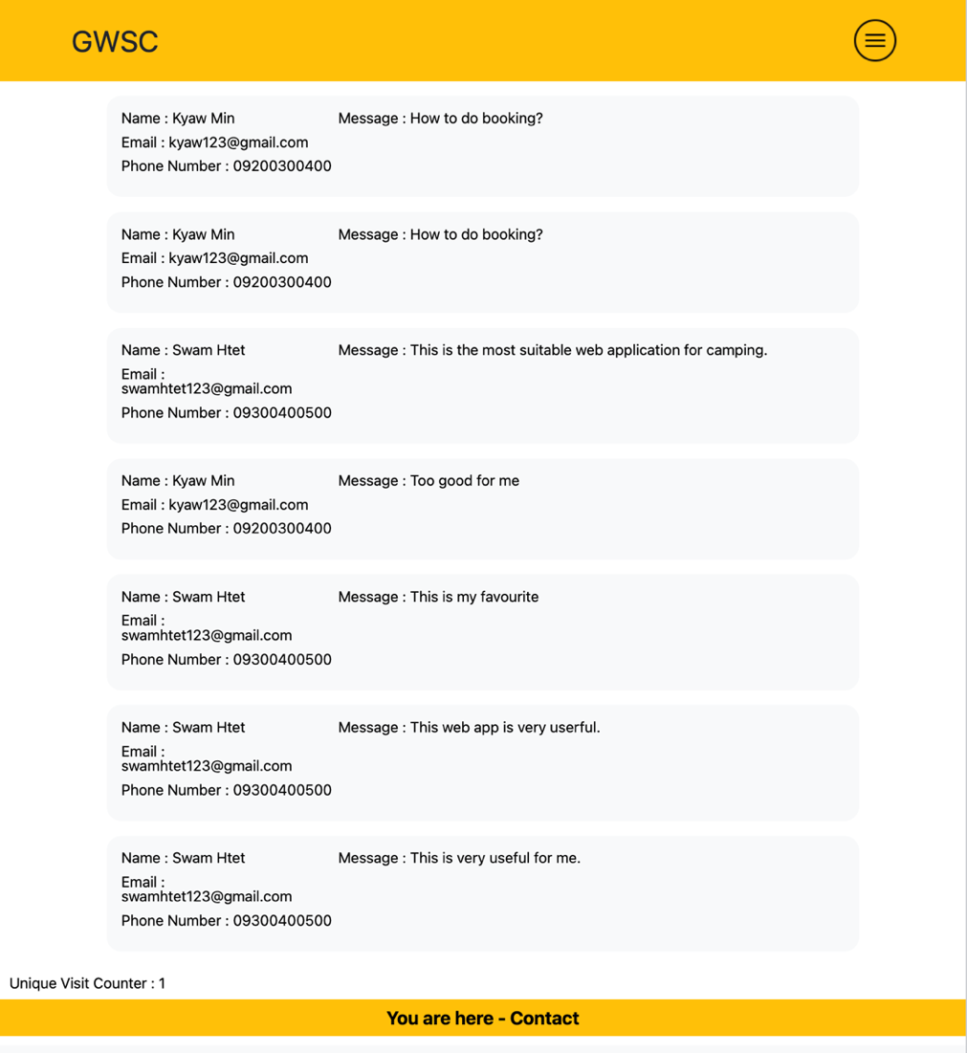

Figure checking the total list of the contact message by admin in tablet

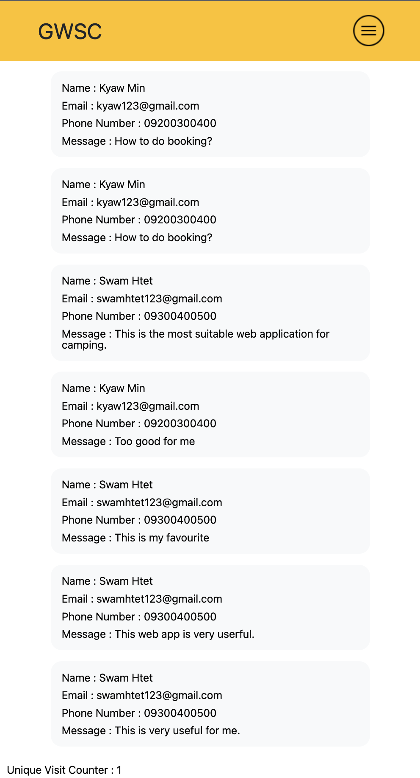

Figure checking the total list of the contact by admin in mobile

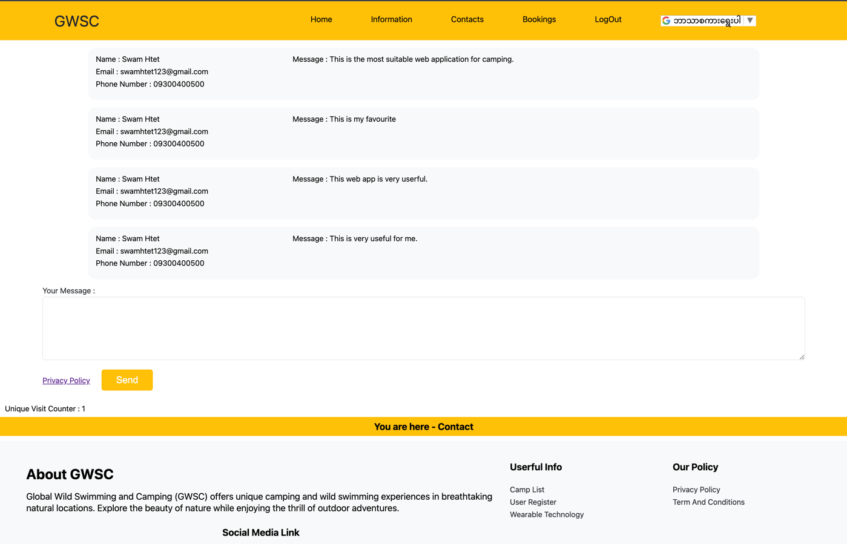

Figure checking the list of the contact by user in Chrome Browser

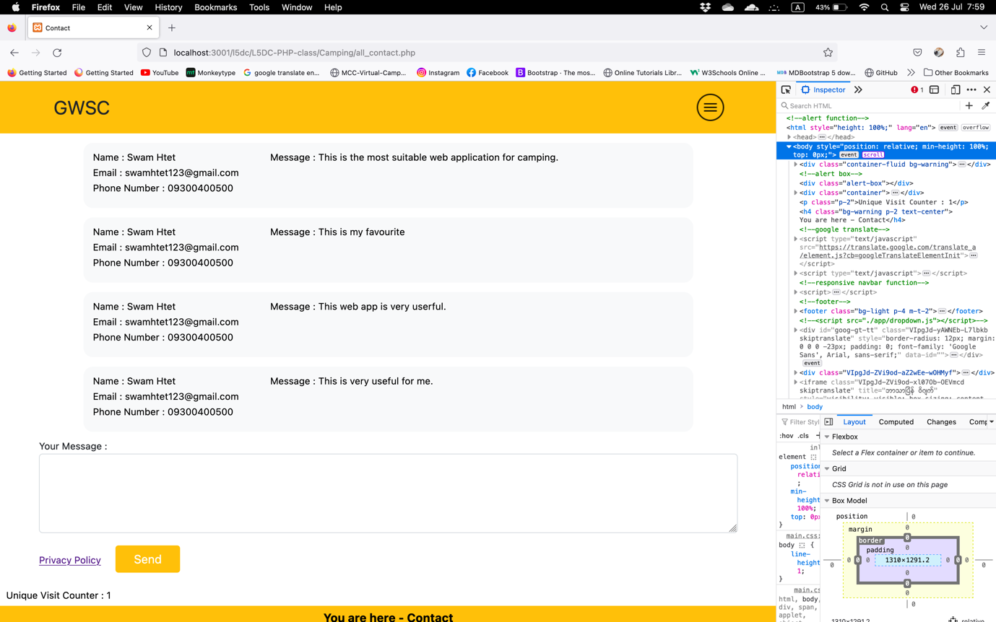

Figure checking the list of contact by user in Firefox Browser

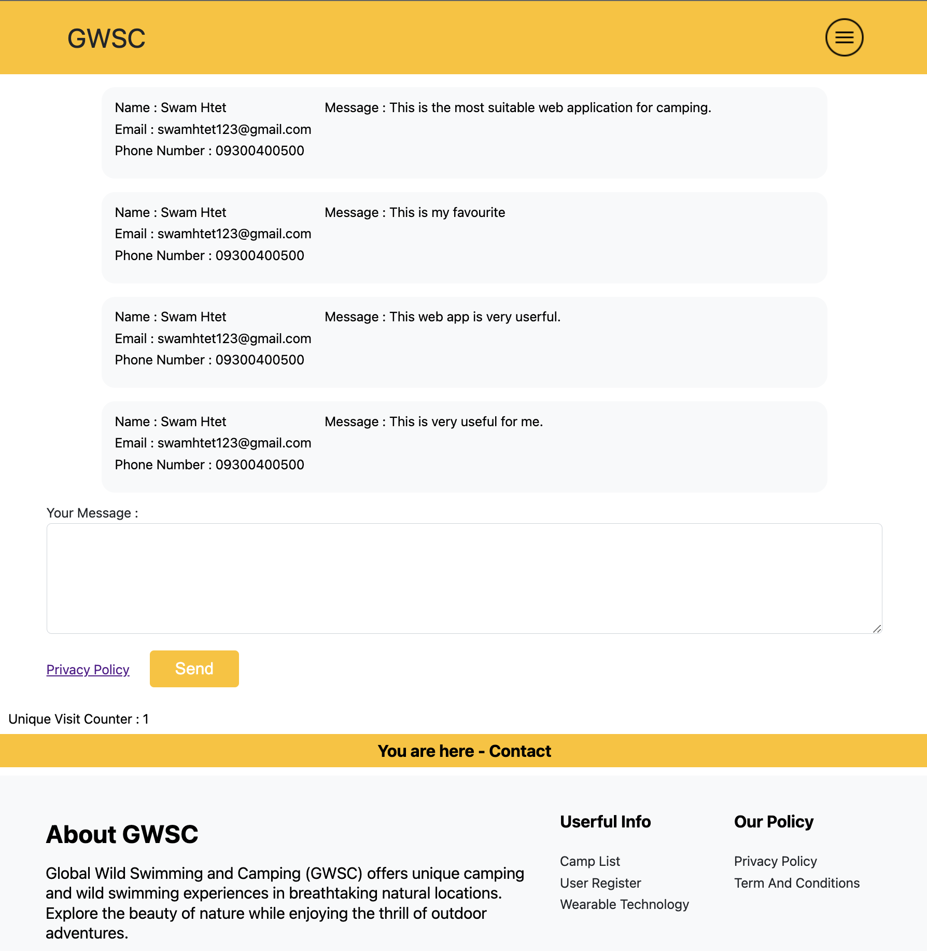

Figure checking the list of the contact by user in tablet

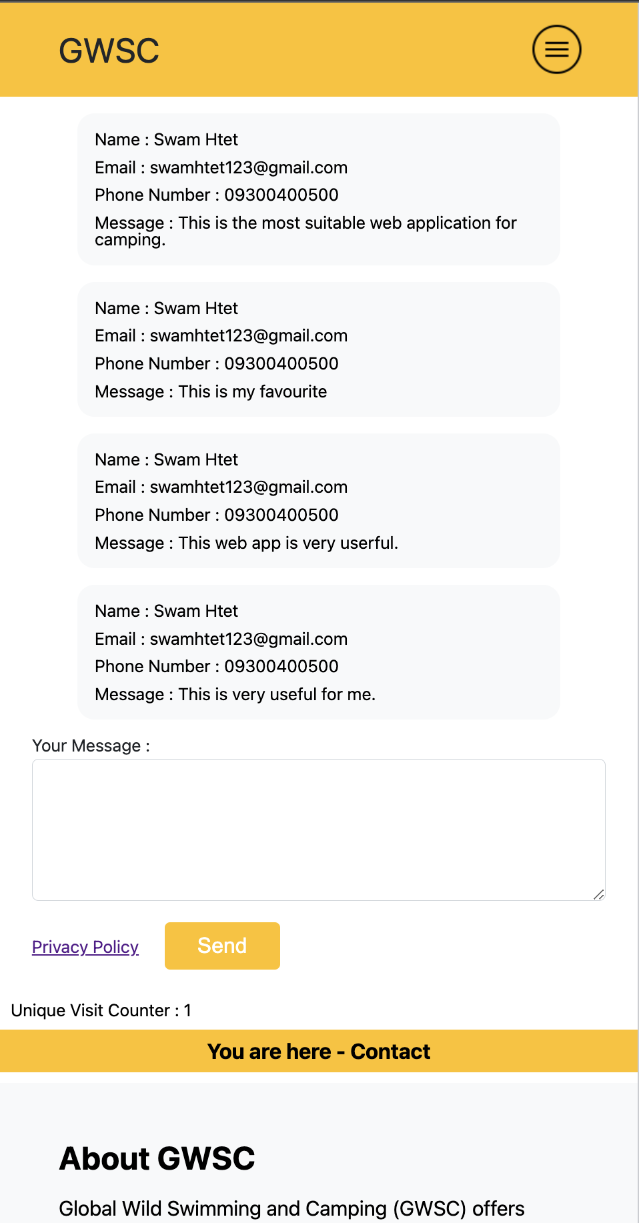

Figure checking the list of the contact by user in mobile

### Camp Register page(camp_register.php)

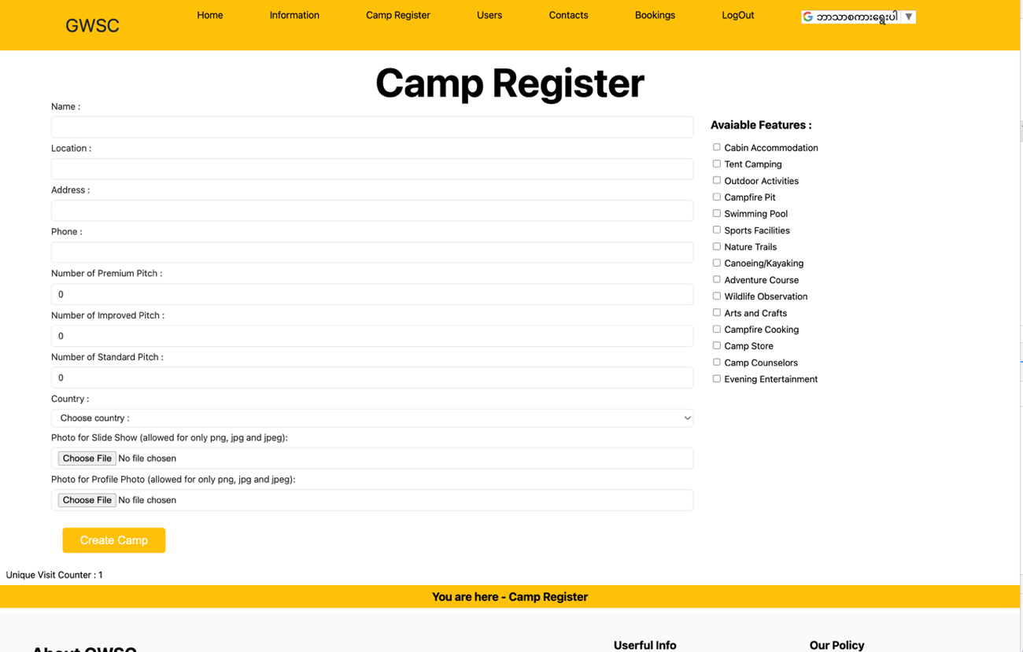

Figure camp register page by admin

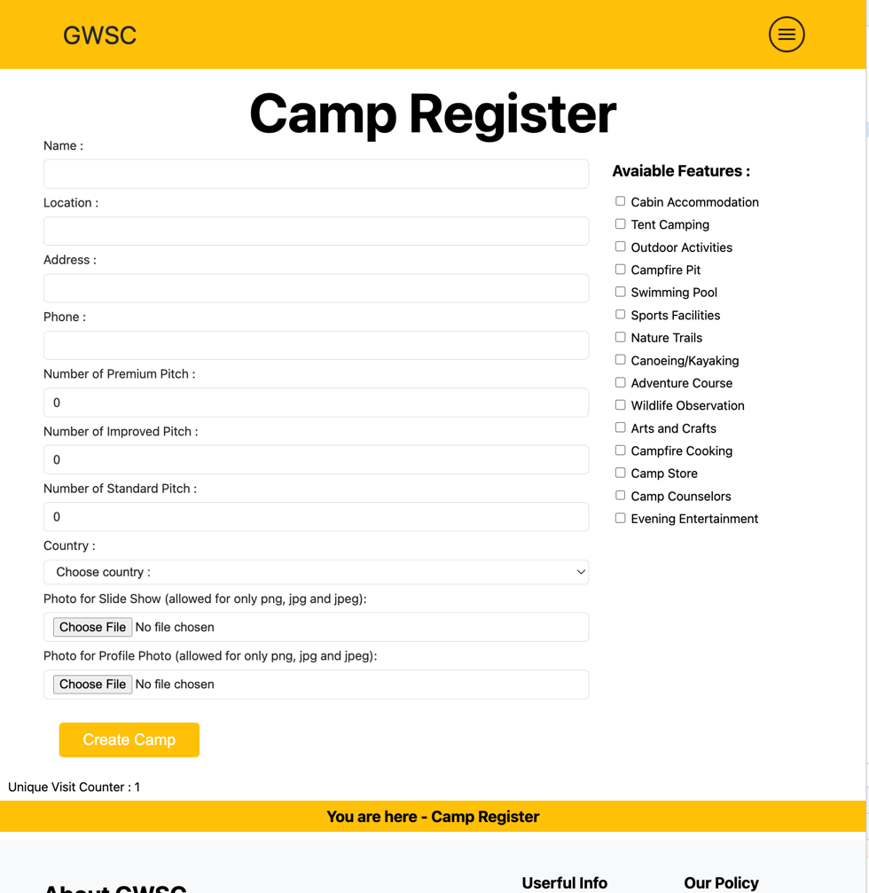

Figure camp register page by admin in tablet

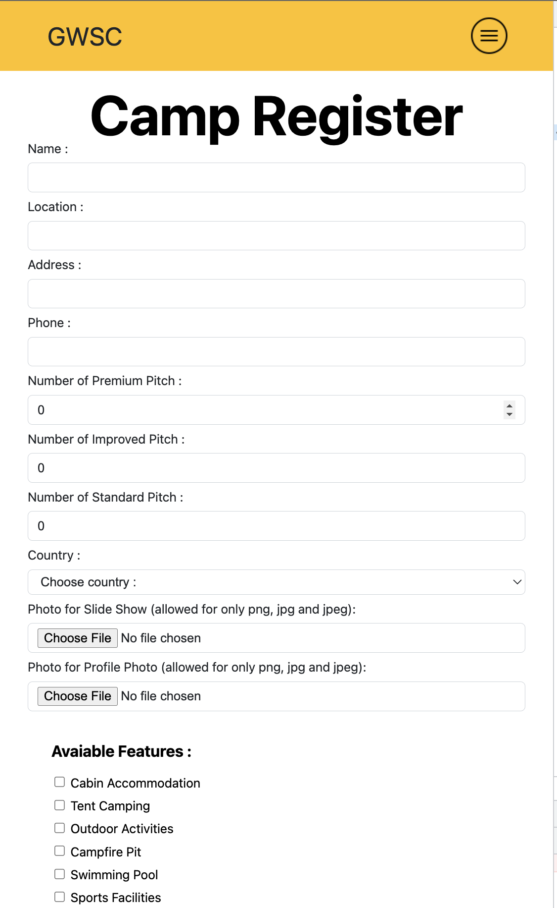

Figure camp register page by admin in mobile 1

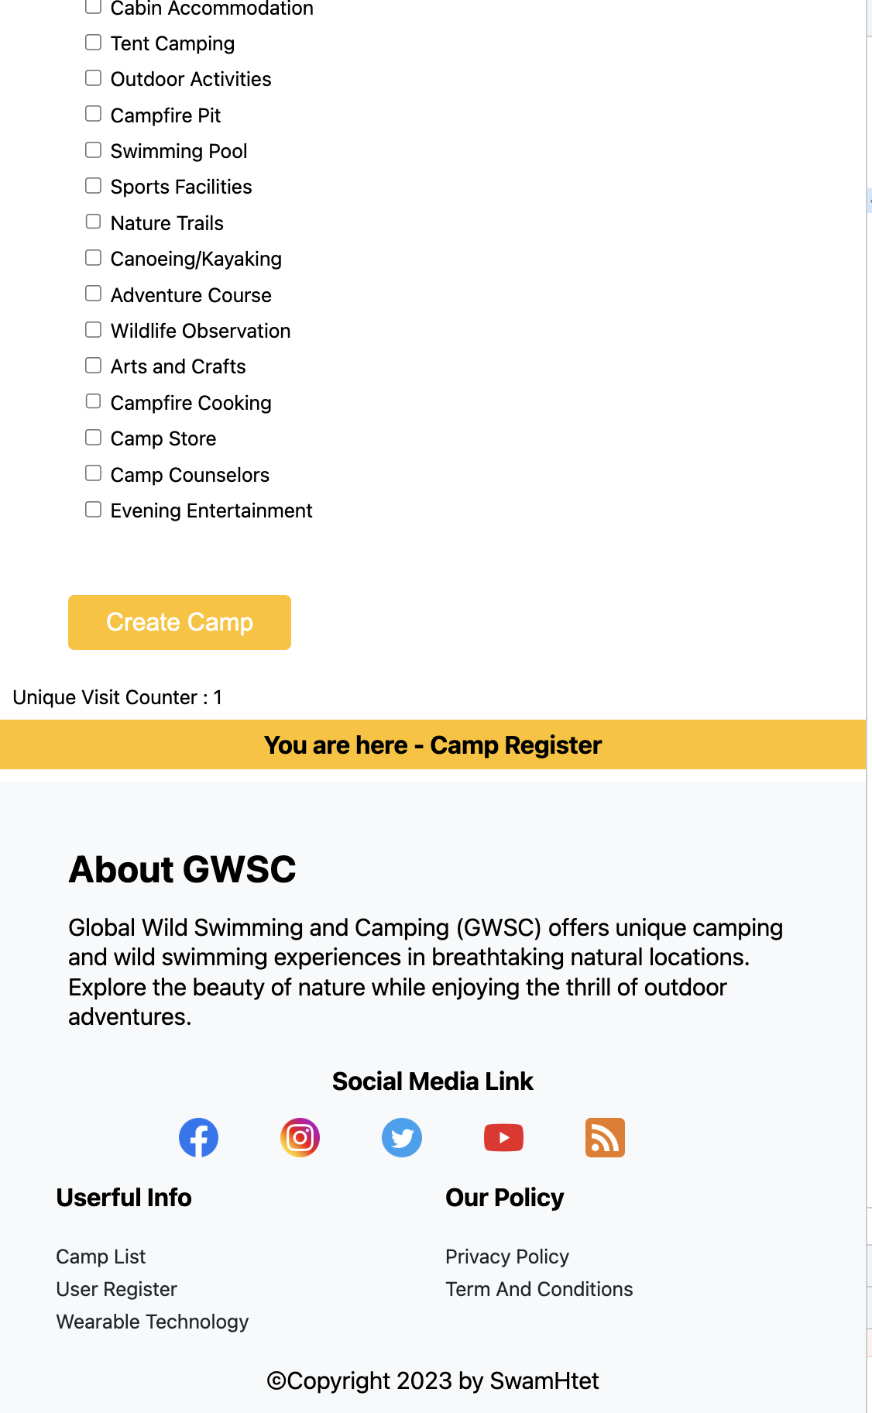

Figure camp register page by admin in mobile 2

### Privacy Policy Page(policy.php)

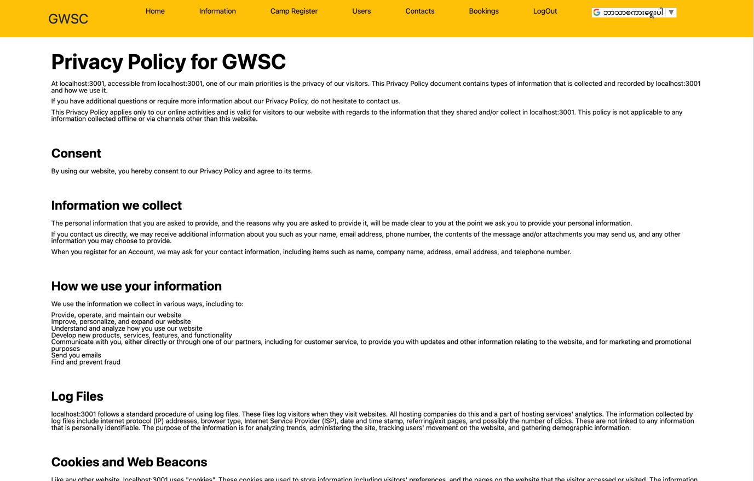

Figure privacy policy page 1 in Chrome Browser

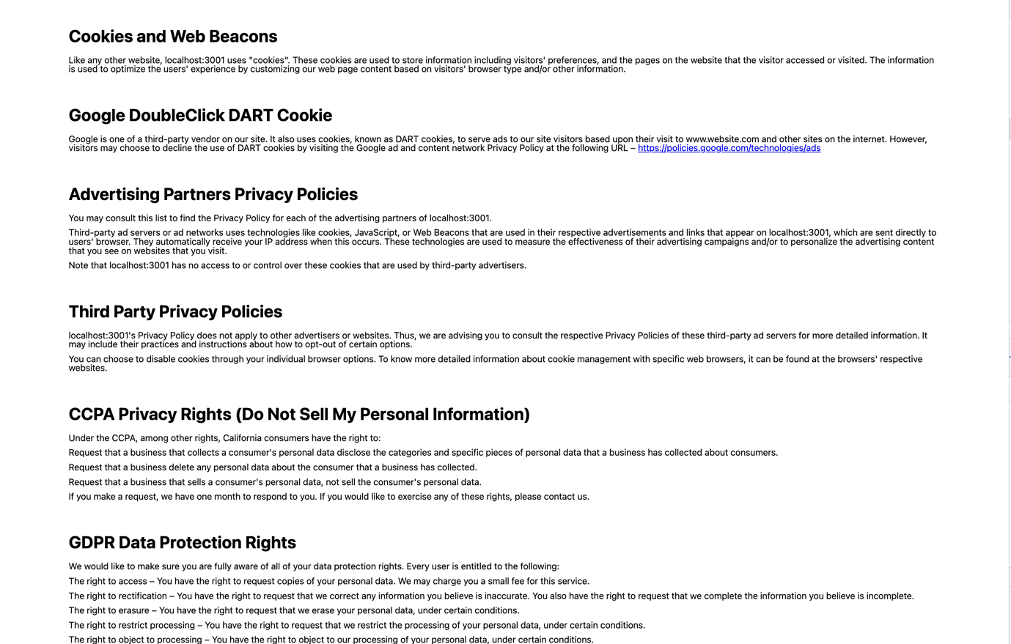

Figure privacy policy page 2 in Chrome Browser

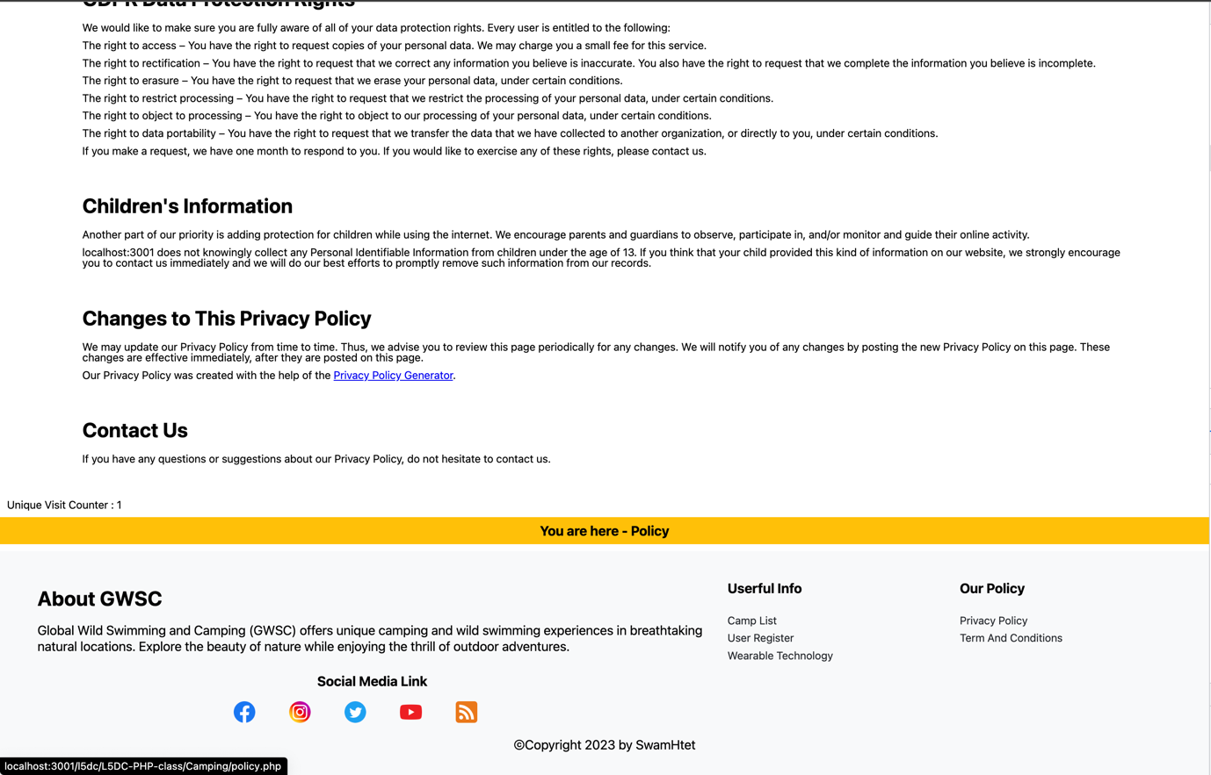

Figure privacy policy page 3 in Chrome Browser



Figure Privacy Policy Page 1 in Firefox Browser

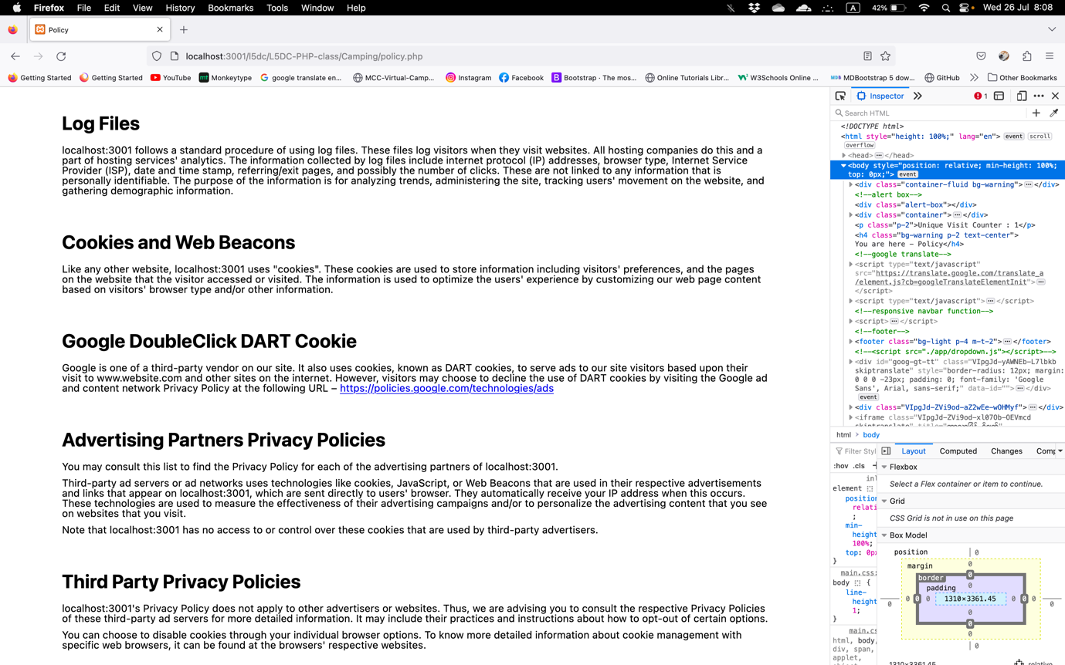

Figure Privacy Policy Page 2 in Firefox Browser

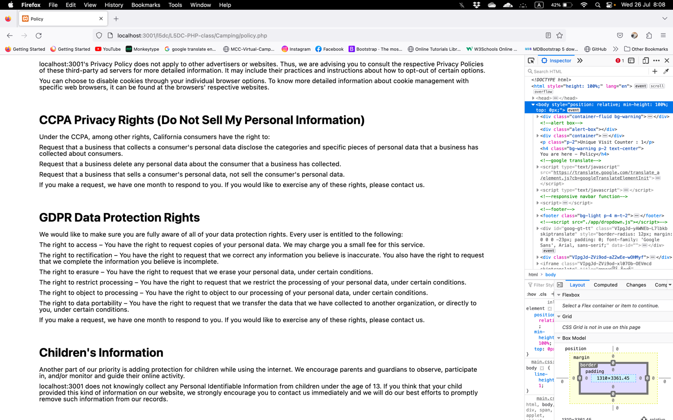

Figure Privacy Policy Page 3 in Firefox Browser

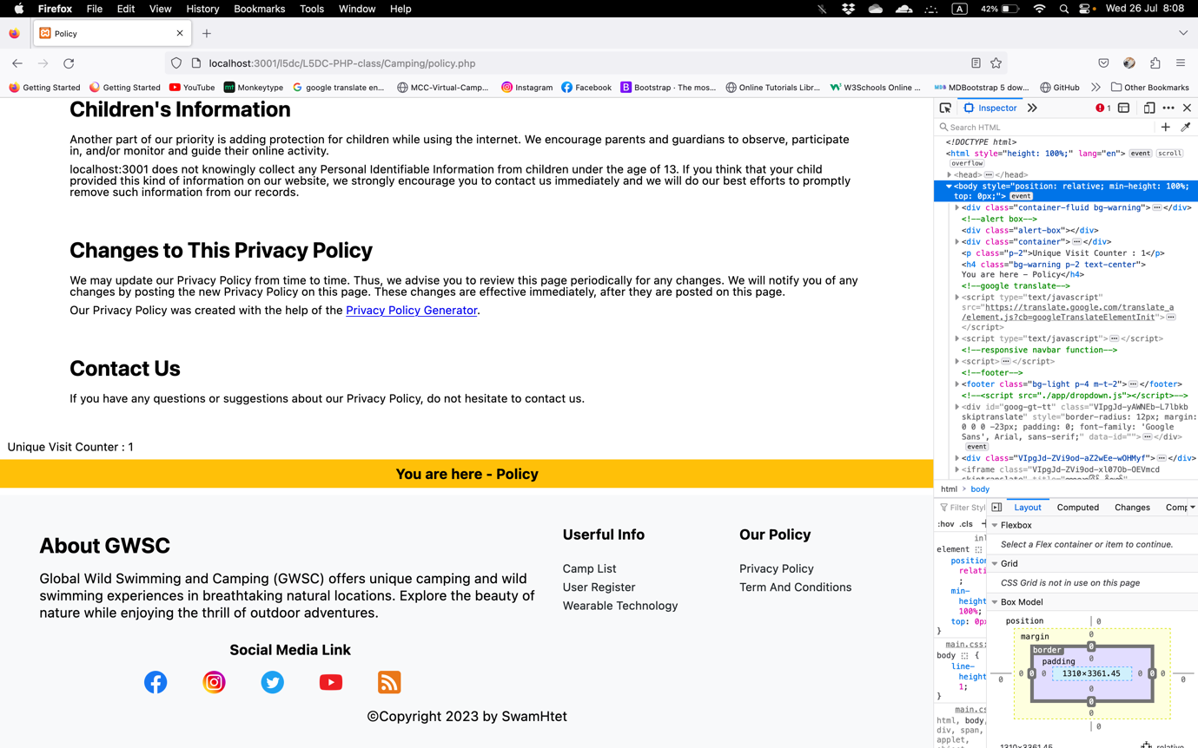

Figure Privacy Policy Page 4 in Firefox Browser

### Rss(rss.php)

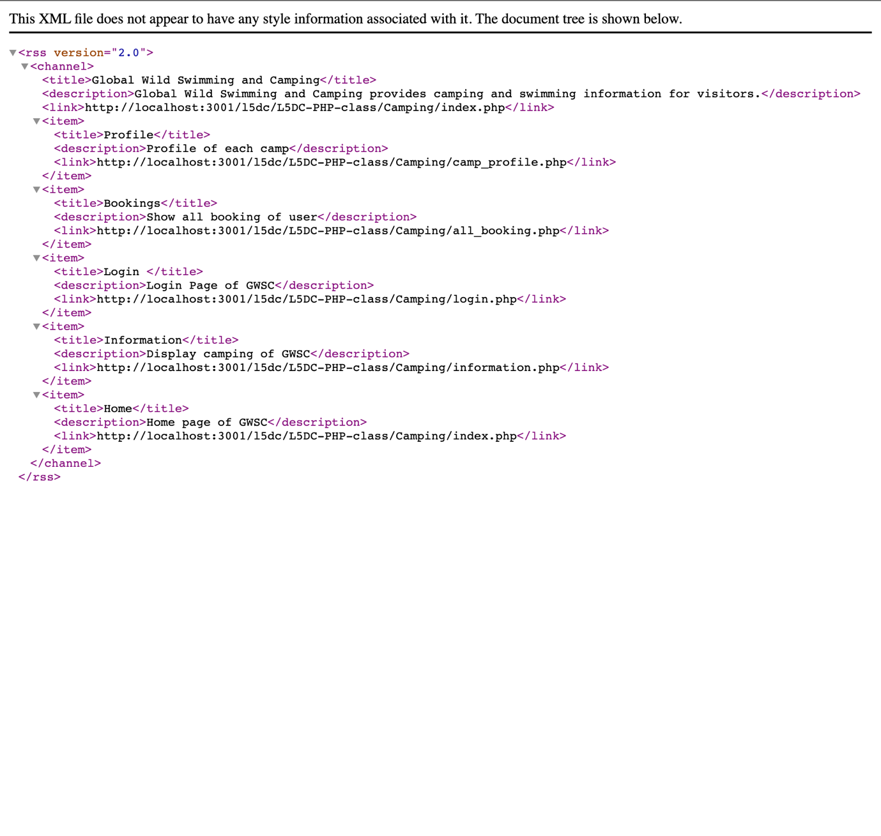

Figure rss.php

# Task 2

### External CSS File

|  |
| --- |
| /* reset.css */  html,  body,  div,  span,  applet,  object,  iframe,  h1,  h2,  h3,  h4,  h5,  h6,  p,  blockquote,  pre,  a,  abbr,  acronym,  address,  big,  cite,  code,  del,  dfn,  em,  img,  ins,  kbd,  q,  s,  samp,  small,  strike,  strong,  sub,  sup,  tt,  var,  b,  u,  i,  center,  dl,  dt,  dd,  ol,  ul,  li,  fieldset,  form,  label,  legend,  table,  caption,  tbody,  tfoot,  thead,  tr,  th,  td,  article,  aside,  canvas,  details,  embed,  figure,  figcaption,  footer,  header,  hgroup,  menu,  nav,  output,  ruby,  section,  summary,  time,  mark,  audio,  video  {  margin: 0;  padding: 0;  border: 0;  font-size: 100%;  font: inherit;  vertical-align: baseline;  }  /* HTML5 display-role reset for older browsers */  article,  aside,  details,  figcaption,  figure,  footer,  header,  hgroup,  menu,  nav,  section  {  display: block;  }  body  {  line-height: 1;  }  ol,  ul  {  list-style: none;  }  blockquote,  q  {  quotes: none;  }  blockquote*:before*,  blockquote*:after*,  q*:before*,  q*:after*  {  content: '';  content: none;  }  table  {  border-collapse: collapse;  border-spacing: 0;  }  *:root*  {  --one: 5px;  --two: 10px;  --three: 20px;  --four: 30px;  --five: 50px;  --six: 70px;  --primary: #0d6efd;  --secondary: #6c757d;  --success: #198754;  --info: #0dcaf0;  --warning: #ffc107;  --danger: #dc3545;  --light: #f8f9fa;  --dark: #212529;  --alert-primary: #cfe2ff;  --alert-secondary: #e2e3e5;  --alert-success: #d1e7dd;  --alert-info: #cff4fc;  --alert-warning: #fff3cd;  --alert-danger: #f8d7da;  --alert-light-: #fcfcfd;  --alert-dark: #ced4da;  --font-family: system-ui,  -apple-system,  "Segoe UI",  Roboto,  "Helvetica Neue",  "Noto Sans",  "Liberation Sans",  Arial,  sans-serif,  "Apple Color Emoji",  "Segoe UI Emoji",  "Segoe UI Symbol",  "Noto Color Emoji";  }  /* navbar */  *.topnav*  {  overflow: hidden;  }  *.topnav* li  {  float: left;  display: block;  padding: 14px 16px;  background-color: var(--warning);  }  *.topnav* li a  {  counter-reset: var(--light);  text-align: center;  text-decoration: none;  font-size: 17px;  }  *.topnav* li a*:hover*  {  color: var(--light);  }  *.topnav* li a*.active*  {  color: var(--light);  }  nav *.row*  {  display: flex;  justify-content: space-around;  }  *.topnav* *.icon*  {  display: none;  }  @media screen and (max-width: 1750px)  {  *.topnav*  {  display: block;  }  *.topnav* li*:not*(*:last-child*)  {  display: none;  }  *.topnav* li a*.icon*  {  float: right;  display: block;  }  *.topnav.responsive*  {  position: relative;  }  *.topnav.responsive* *.icon*  {  position: absolute;  right: 0;  top: 0;  }  *.topnav.responsive* li  {  float: none;  display: block;  text-align: left;  }  }  /* font family */  html  {  font-family: var(--font-family);  }  /* layout */  /* row */  *.row*  {  display: flex;  flex-wrap: wrap;  }  *.d-block*  {  display: block;  }  /* container */  *.container*  {  width: 90%;  margin: 0 auto;  }  *.container-fulid*  {  width: 100%;  }  /* column */  *.col*  {  box-sizing: border-box;  width: 10%;  }  *.col-2*  {  box-sizing: border-box;  width: 20%;  }  *.col-3*  {  box-sizing: border-box;  width: 30%;  }  *.col-4*  {  box-sizing: border-box;  width: 40%;  }  *.col-5*  {  box-sizing: border-box;  width: 50%;  }  *.col-6*  {  box-sizing: border-box;  width: 60%;  }  *.col-7*  {  box-sizing: border-box;  width: 70%;  }  *.col-8*  {  box-sizing: border-box;  width: 80%;  }  *.col-9*  {  box-sizing: border-box;  width: 90%;  }  *.col-10*  {  box-sizing: border-box;  width: 100%;  }  /* list */  *.list*  {  list-style: disc;  }  @media screen and (max-width: 820px)  {  *.col-7*  {  width: 100%;  }  *.col-6*  {  width: 100%;  }  *.col-5*  {  width: 100%;  }  *.col-4*  {  width: 100%;  }  *.col-3*  {  width: 80%;  }  *.col-2*  {  width: 50%;  }  *.col*  {  width: 25%;  }  }  /* margin */  /* all side */  *.m-1*  {  margin: var(--one);  }  *.m-2*  {  margin: var(--two);  }  *.m-3*  {  margin: var(--three);  }  *.m-4*  {  margin: var(--four);  }  *.m-5*  {  margin: var(--five);  }  /* margin end */  *.m-e-1*  {  margin-right: var(--one);  }  *.m-e-2*  {  margin-right: var(--two);  }  *.m-e-3*  {  margin-right: var(--three);  }  *.m-e-4*  {  margin-right: var(--four);  }  *.m-e-5*  {  margin-right: var(--five);  }  /* margin start */  *.m-s-1*  {  margin-left: var(--one);  }  *.m-s-2*  {  margin-left: var(--two);  }  *.m-s-3*  {  margin-left: var(--three);  }  *.m-s-4*  {  margin-left: var(--four);  }  *.m-s-5*  {  margin-left: var(--five);  }    /* margin top */  *.m-t-1*  {  margin-top: var(--one);  }  *.m-t-2*  {  margin-top: var(--two);  }  *.m-t-3*  {  margin-top: var(--three);  }  *.m-t-4*  {  margin-top: var(--four);  }  *.m-t-5*  {  margin-top: var(--five);  }  /* margin button */  *.m-b-1*  {  margin-bottom: var(--one);  }  *.m-b-2*  {  margin-bottom: var(--two);  }  *.m-b-3*  {  margin-bottom: var(--three);  }  *.m-b-4*  {  margin-bottom: var(--four);  }  *.m-b-5*  {  margin-bottom: var(--five);  }  /* padding */  /* all side */  *.p-1*  {  padding: var(--one);  }  *.p-2*  {  padding: var(--two);  }  *.p-3*  {  padding: var(--three);  }  *.p-4*  {  padding: var(--four);  }  *.p-5*  {  padding: var(--five);  }  /* padding end */  *.p-e-1*  {  padding-right: var(--one);  }  *.p-e-2*  {  padding-right: var(--two);  }  *.p-e-3*  {  padding-right: var(--three);  }  *.p-e-4*  {  padding-right: var(--four);  }  *.p-e-5*  {  padding-right: var(--five);  }  /* padding start */  *.p-s-1*  {  padding-left: var(--one);  }  *.p-s-2*  {  padding-left: var(--two);  }  *.p-s-3*  {  padding-left: var(--three);  }  *.p-s-4*  {  padding-left: var(--four);  }  *.p-s-5*  {  padding-left: var(--five);  }    /* padding top */  *.p-t-1*  {  padding-top: var(--one);  }  *.p-t-2*  {  padding-top: var(--two);  }  *.p-t-3*  {  padding-top: var(--three);  }  *.p-t-4*  {  padding-top: var(--four);  }  *.p-t-5*  {  padding-top: var(--five);  }  /* padding button */  *.p-b-1*  {  padding-bottom: var(--one);  }  *.p-b-2*  {  padding-bottom: var(--two);  }  *.p-b-3*  {  padding-bottom: var(--three);  }  *.p-b-4*  {  padding-bottom: var(--four);  }  *.p-b-5*  {  padding-bottom: var(--five);  }  /* background */  /* background color */  *.bg-primary*  {  background-color: var(--primary);  }  *.bg-danger*  {  background-color: var(--danger);  }  *.bg-warning*  {  background-color: var(--warning);  }  *.bg-success*  {  background-color: var(--success);  }  *.bg-secondary*  {  background-color: var(--secondary);  }  *.bg-dark*  {  background-color: var(--dark);  }  *.bg-info*  {  background-color: var(--info);  }  *.bg-light*  {  background-color: var(--light);  }  /* font */  /* font size */  *.fs-smaller*  {  font-size: smaller;  }  *.fs-small*  {  font-size: small;  }  *.fs-medium*  {  font-size: medium;  }  *.fs-large*  {  font-size: large;  }  *.fs-larger*  {  font-size: larger;  }  /* font color */  *.f-primary*  {  color: var(--primary);  }  *.f-secondary*  {  color: var(--secondary);  }  *.f-warning*  {  color: var(--warning);  }  *.f-danger*  {  color: var(--danger);  }  *.f-success*  {  color: var(--success);  }  *.f-info*  {  color: var(--info);  }  *.f-dark*  {  color: var(--dark);  }  *.f-light*  {  color: var(--light);  }  /* text style*/  *.text-center*  {  text-align: center;  }  /* navbar */  *.navbar*  {  height: auto;  display: flex;  justify-content: space-between;  align-items: center;  }  *.navbar-brand*  {  text-decoration: none;  font-size: 200%;  color: var(--dark);  }  /* .navbar-item */  *.navbar-link*  {  text-decoration: none;  font-size: larger;  color: black;  }  /* footer */  *.footer-text*  {  line-height: 1.5rem;  }  *.footer-list*  {  list-style: none;  }  /* .footer-list-item {} */  *.footer-list-item* *.item-link*  {  text-decoration: none;  color: var(--dark);  }    /* header */  h1,  *.h1*  {  font-size: var(--six);  font-weight: bold;  }  h2,  *.h2*  {  font-size: var(--five);  font-weight: bold;  }  h3,  *.h3*  {  font-size: var(--four);  font-weight: bold;  }  h4,  *.h4*  {  font-size: var(--three);  font-weight: bold;  }  h5,  *.h5*  {  font-size: var(--two);  font-weight: bold;  }  h6,  *.h6*  {  font-size: var(--one);  font-weight: bold;  }  /* social list */  *.social-list*  {  justify-content: center;  align-items: center;  }  *.social-link*  {  text-decoration: none;  }  *.social-icon*  {  width: 2rem;  }  /* alert */  *.alert*  {  padding: 2rem;  border-radius: 1rem;  margin: 1rem;  }  *.alert-danger*  {  background-color: var(--alert-danger);  }  *.alert-warning*  {  background-color: var(--alert-warning);  }  *.alert-info*  {  background-color: var(--alert-info);  }  *.alert-success*  {  background-color: var(--alert-success);  }  *.alert-primary*  {  background-color: var(--alert-primary);  }  /* card */  *.card*  {  border-radius: 1rem;  padding: 1rem;  margin: 1rem;  box-sizing: border-box;  }  *.card-img*  {  width: 100px;  }  *.card-header*  {  margin: var(--two) 0px;  }  *.card-body* img  {  width: 100%;  margin: var(--two) 0px;  }  *.card-footer*  {  margin: var(--two) 0px;  }  /* button */  *.btn*  {  margin: var(--three);  padding: var(--two) var(--four);  font-size: var(--three);  width: auto;  text-decoration: none;  color: #fff;  border-radius: var(--one);  border: 1px solid transparent;  transition: 0.5s;  }  *.btn:hover*  {  transition: 0.5s;  box-shadow: 0 0 0 5px rgba(149, 149, 174, 0.5);  }  *.btn:focus*  {  box-shadow: 0 0 0 5px rgba(149, 149, 174, 0.5);  }  /* background color */  *.btn-primary*  {  background-color: var(--primary);  }  *.btn-secondary*  {  background-color: var(--secondary);  }  *.btn-success*  {  background-color: var(--success);  }  *.btn-warning*  {  background-color: var(--warning);  }  *.btn-info*  {  background-color: var(--info);  }  *.btn-danger*  {  background-color: var(--danger);  }  /* dropdown */  *.dropdown-box*  {  display: none;  }  *.show*  {  display: block;  }  /* form */  *.form-text*  {  font-size: 1rem;  display: block;  color: var(--dark);  }  *.form-control*  {  display: block;  width: 100%;  padding: 0.375rem 0.75rem;  font-size: 1rem;  font-weight: 400;  line-height: 1.5;  color: var(--dark);  background-color: #fff;  background-clip: padding-box;  border: 1px solid #ced4da;  border-radius: 0.375rem;  transition: border-color 0.15s ease-in-out, box-shadow 0.15s ease-in-out;  }  *.form-control* *:focus*  {  box-shadow: 0 0 0 5px rgba(149, 149, 174, 0.5);  }  /* carousel */  *.hidden*  {  display: none;  }  *.visible*  {  display: block;  }  /* .carousel-cards {  position: relative;  } */  *.carousel-card* img  {  width: 100%;  /* height: fit-content; */  }  /* width and height */  *.w-100*  {  width: 100%;  }  *.w-80*  {  width: 80%;  }  *.w-50*  {  width: 50%;  }  *.w-30*  {  width: 30%;  }  *.h-100*  {  height: 100px;  }  *.h-80*  {  height: 80px;  }  *.h-50*  {  height: 50px;  }  *.h-30*  {  height: 30px;  }  *#carousel-display*  {  position: relative;  }  *.display-prev*  {  position: absolute;  top: 40%;  left: 0%;  }  *.display-next*  {  position: absolute;  top: 40%;  right: 0%;  } |

### Databases

#### Camp Table

create table camp (

id integer primary key auto_increment,

name varchar(255) not null,

address varchar(255) not null,

location text not null,

phone varchar(255) not null,

no_premium integer not null,

no_improved integer not null,

no_standard integer not null,

features text,

country varchar(255) not null,

slideShow varchar(255) not null,

profile varchar(255) not null

);

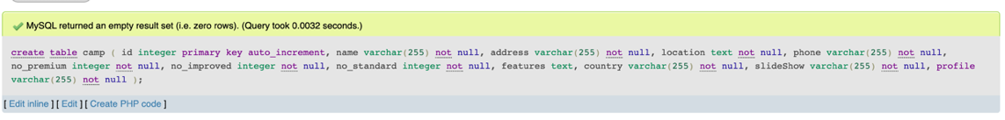

Figure Success output after creating Camp Table

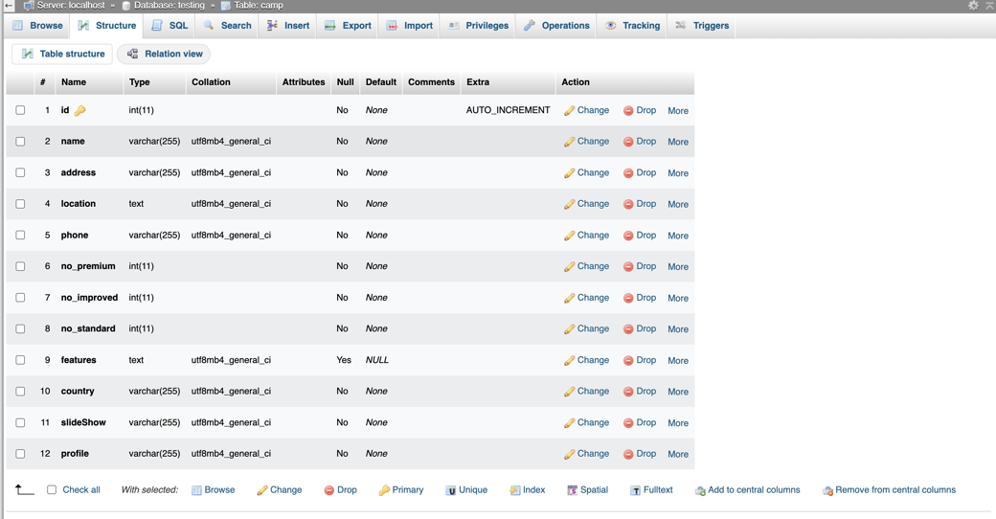

Figure Structure of the Camp Table

#### User Table

CREATE TABLE `User` (

`Id` int(11) NOT NULL,

`firstName` varchar(255) NOT NULL,

`lastName` varchar(255) NOT NULL,

`email` varchar(255) NOT NULL,

`password` varchar(255) NOT NULL,

`phoneNumber` varchar(255) NOT NULL

) ENGINE=InnoDB DEFAULT CHARSET=utf8mb4 COLLATE=utf8mb4_general_ci;

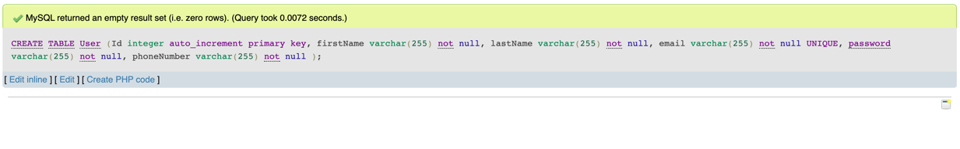

Figure Success output after creating User table

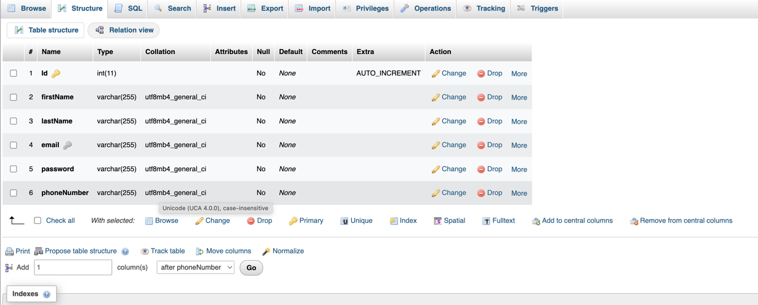

Figure Structure of the user table

#### Local Attraction Table

Query –

CREATE TABLE localAttraction (

id INT PRIMARY KEY AUTO_INCREMENT,

name VARCHAR(255) NOT NULL,

location VARCHAR(255) NOT NULL,

photo VARCHAR(255),

description TEXT,

camp_id INT NOT NULL,

FOREIGN KEY (camp_id) REFERENCES camp(id) on DELETE CASCADE

);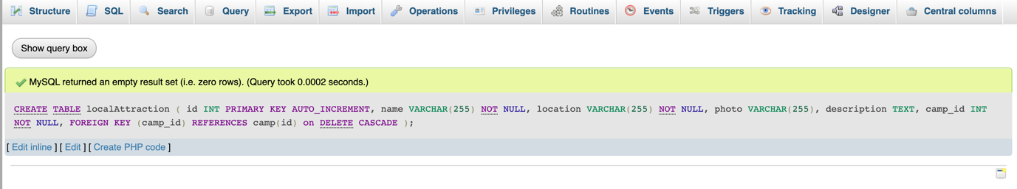

Figure Success output after creating Local Attraction Table

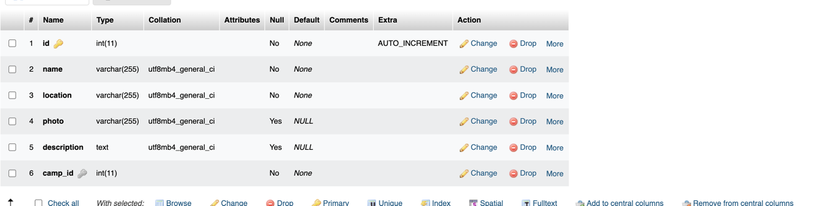

Figure Structure of the Local Attraction table

#### Feature Table

Query –

CREATE TABLE Features (

id INT PRIMARY KEY,

feature_name VARCHAR(50),

description VARCHAR(200)

);

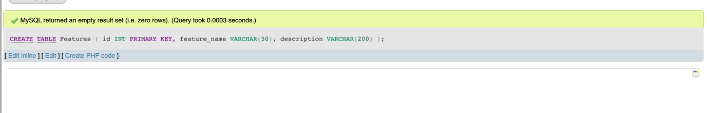

Figure Success output after creating Feature Table

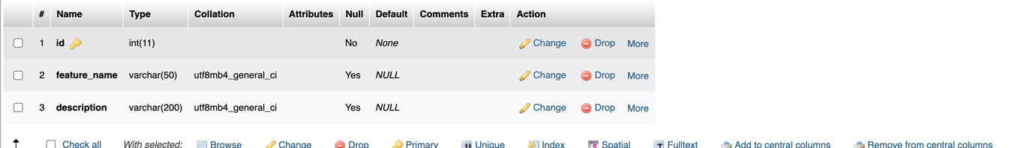

Figure Structure of the Feature Table

#### Booking Table

Query –

CREATE TABLE `booking` (

`id` int(11) NOT NULL,

`no_premium` int(11) NOT NULL,

`no_improved` int(11) NOT NULL,

`no_standard` int(11) NOT NULL,

`date` varchar(255) NOT NULL,

`no_day` int(11) NOT NULL,

`user_id` int(11) DEFAULT NULL,

`camp_id` int(11) DEFAULT NULL

) ENGINE=InnoDB DEFAULT CHARSET=utf8mb4 COLLATE=utf8mb4_general_ci;

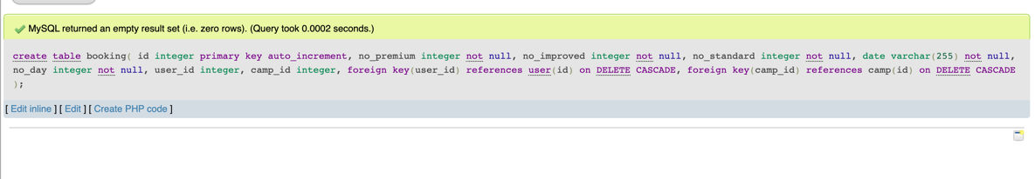

Figure Success output after creating Booking Table

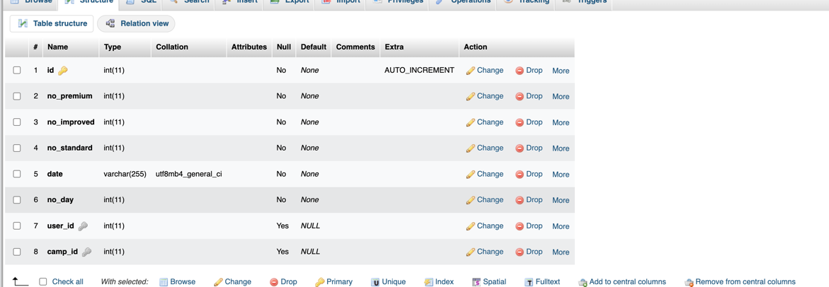

Figure Structure of the Booking Table

#### Review Table

Query -

CREATE TABLE review

(id integer auto_increment primary key,

comment text not null,

point integer,

user_id integer,

camp_id integer,

foreign key(user_id) references user(id) ON DELETE CASCADE,

foreign key(camp_id) references camp(id) ON DELETE CASCADE);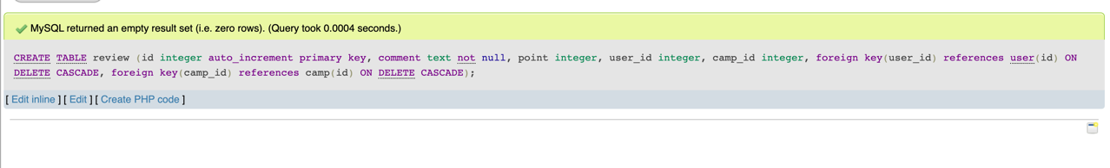

Figure Success output after creating Review Table

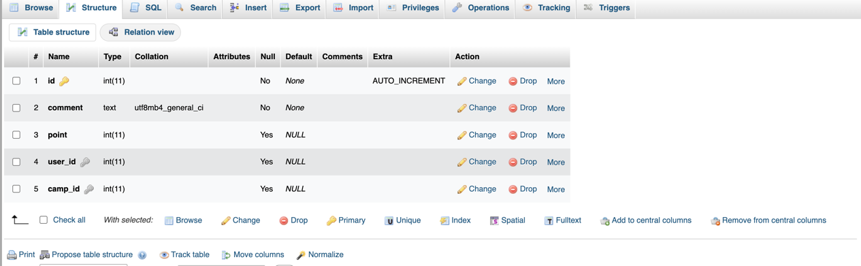

Figure Structure of the Review Table

#### Contact Table

Query –

CREATE TABLE `contact` (

`id` int(11) NOT NULL,

`message` text NOT NULL,

`user_id` int(11) DEFAULT NULL

) ENGINE=InnoDB DEFAULT CHARSET=utf8mb4 COLLATE=utf8mb4_general_ci;



Figure Success output after creating Contact Table

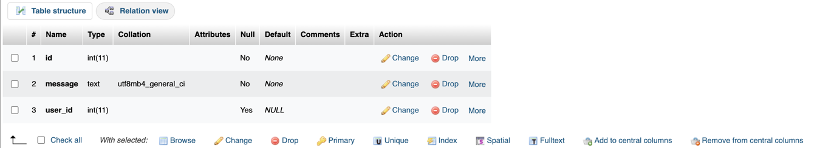

Figure Structure of the Contact Table

#### Counter Table

CREATE TABLE `counter` (

`count` int(255) NOT NULL,

`id` int(255) NOT NULL

) ENGINE=InnoDB DEFAULT CHARSET=latin1;

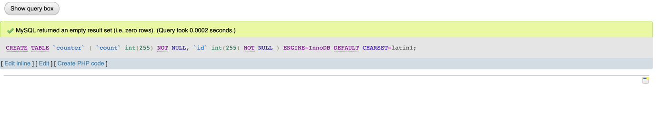

Figure Success output after creating Counter Table

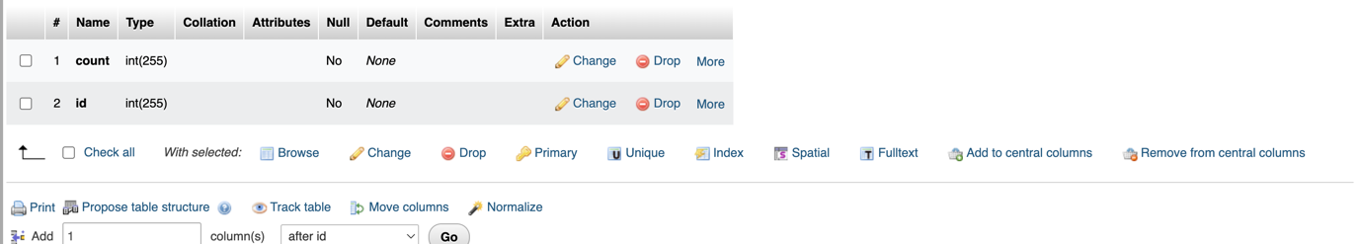

Figure Structure of the Counter Table

#### Visitedip Table

Query –

CREATE TABLE `visitedip` (

`ip` text NOT NULL,

`id` int(11) NOT NULL PRIMARY KEY AUTO_INCREMENT

) ENGINE=InnoDB DEFAULT CHARSET=latin1;

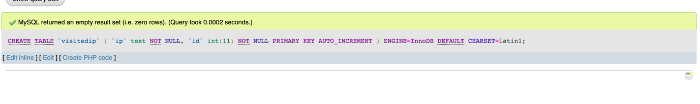

Figure Success output after creating Visitedip Table

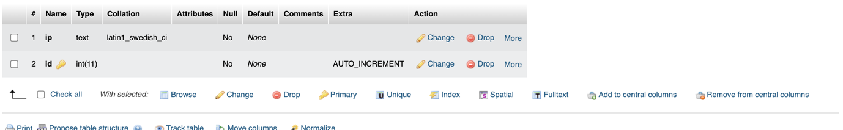

Figure Structure of the Visitedip Table

#### Rssfeed Table

Query –

CREATE TABLE rssfeed ( id int(11) PRIMARY KEY AUTO_INCREMENT NOT NULL, title varchar(100) NOT NULL, description text NOT NULL, link varchar(100) NOT NULL ) ENGINE=InnoDB DEFAULT CHARSET=utf8mb4;

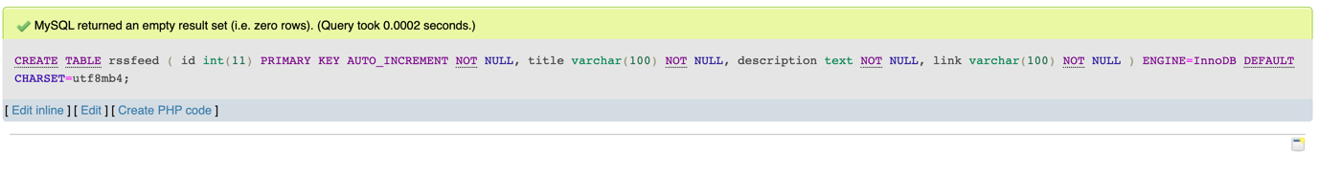

Figure Success output after creating Rssfeed Table

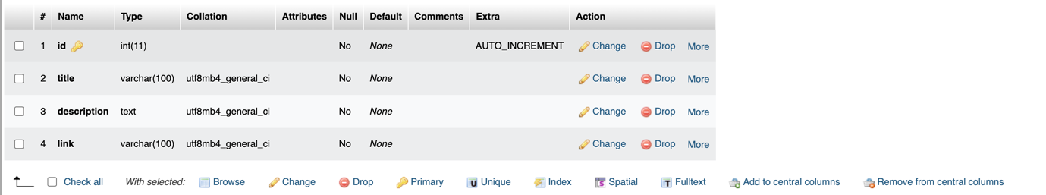

Figure Structure of the RssFeed Table

10 Minutes wait after login failure

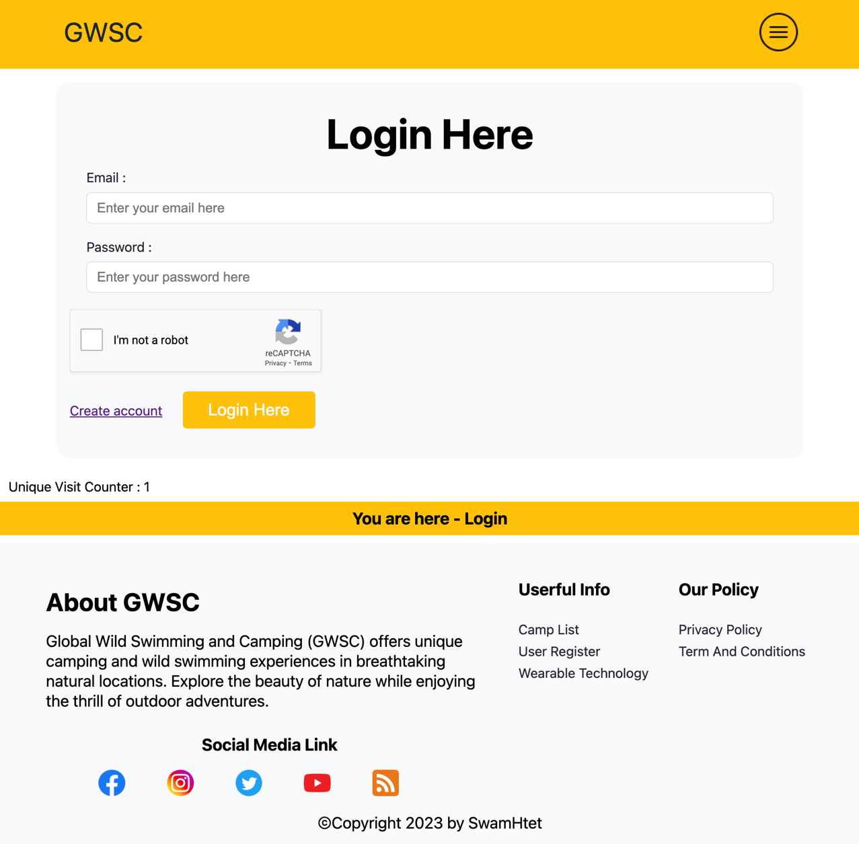

Figure Login Page

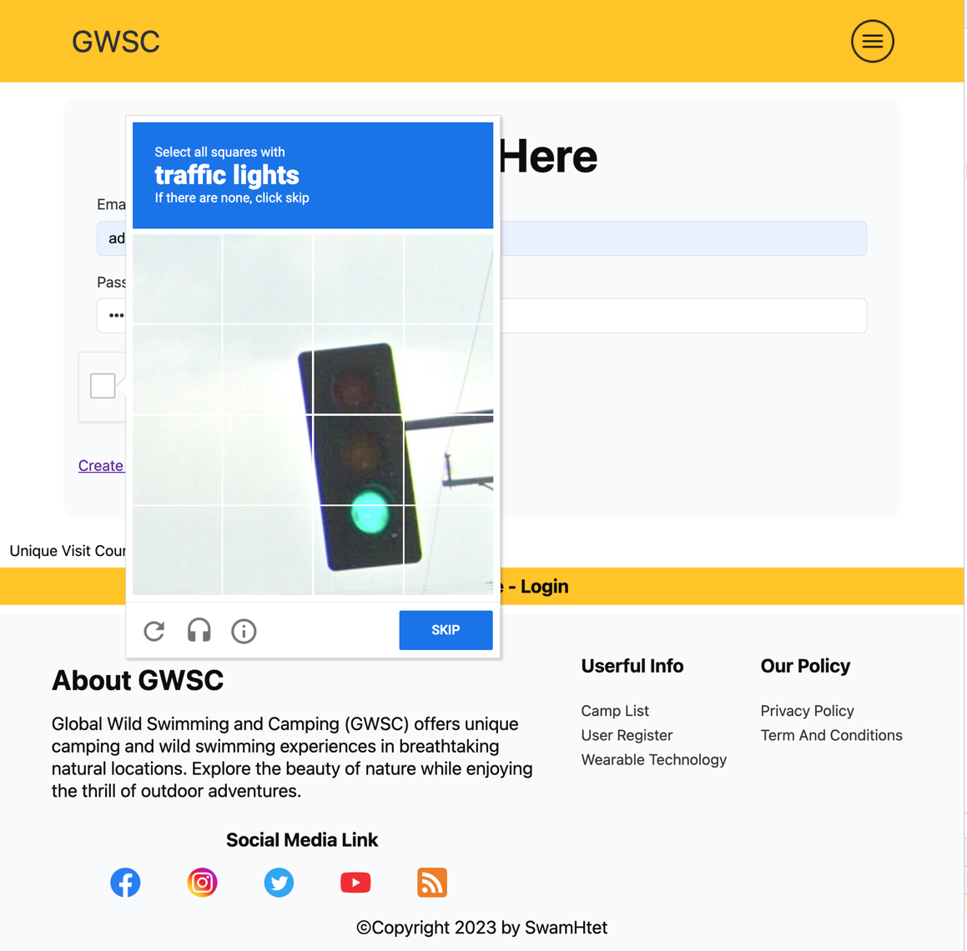

Figure Google reCAPTCHA Checking in login form

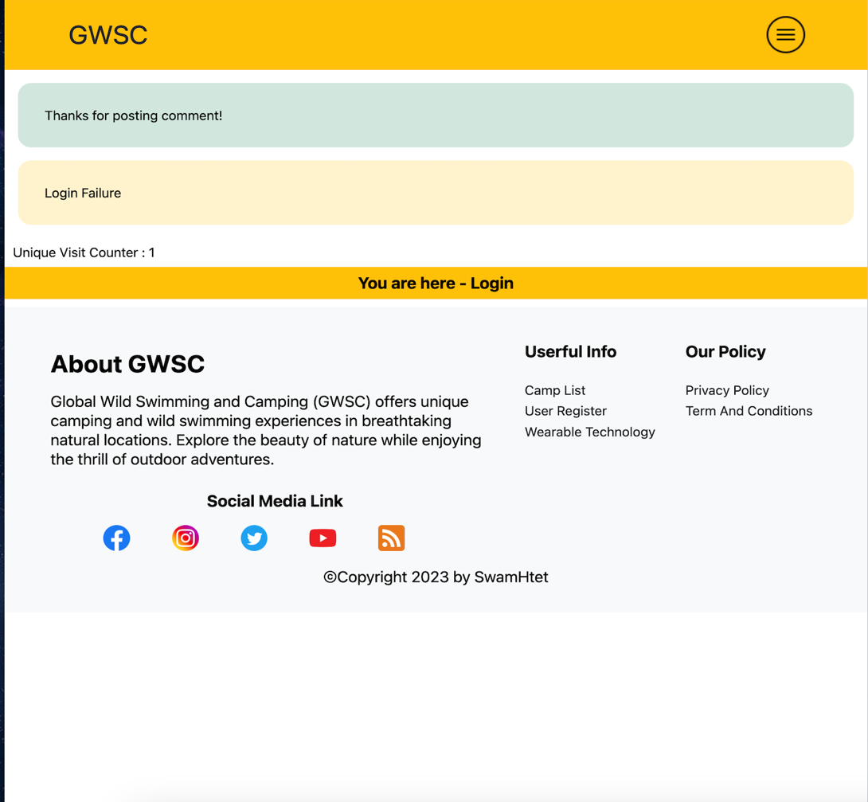

Figure Login Fail Situation

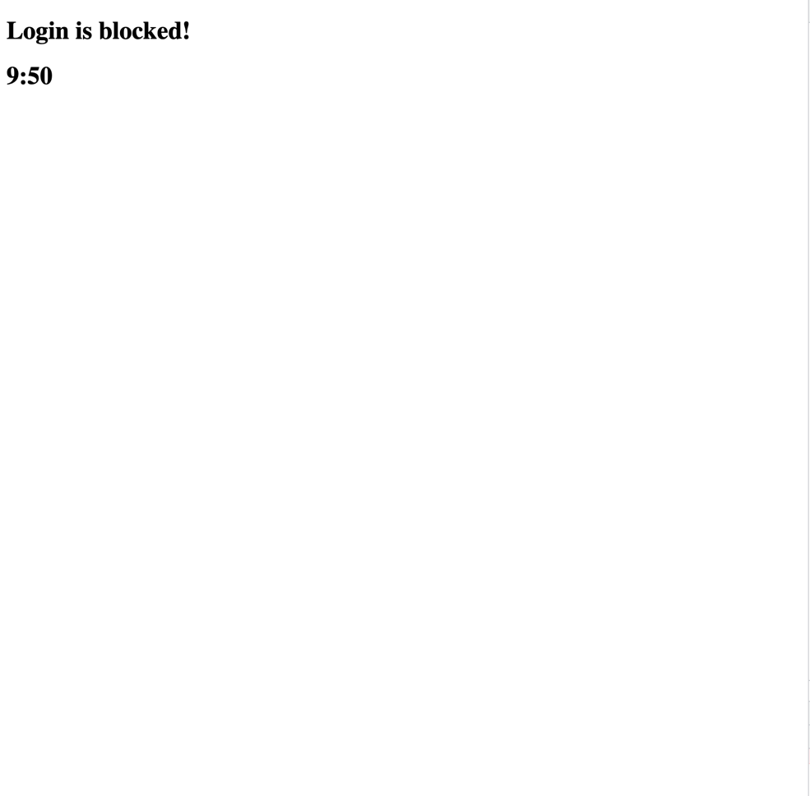

Figure Login Fail Timer after 3 times login fail

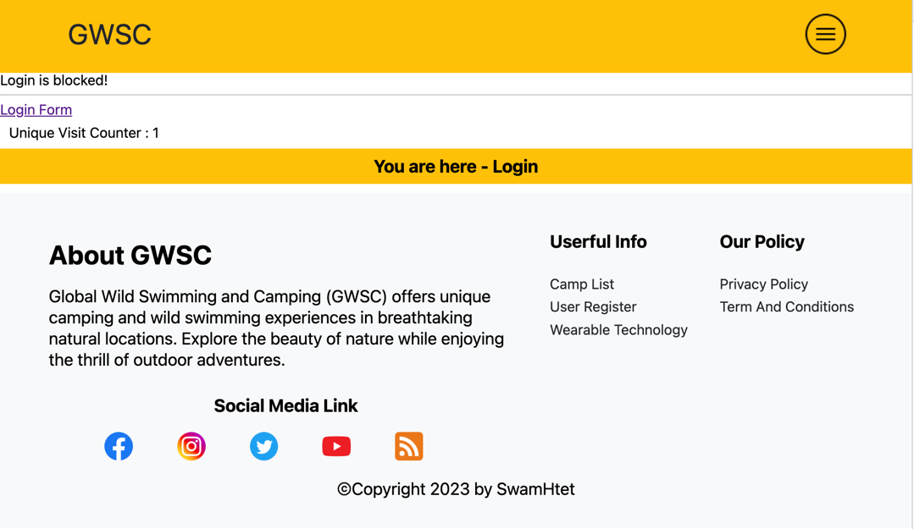

Figure Block Login Form during timer is working

# Task 3

### Critical Evaluation

According to the scenario of the assignment, developed the web application for GWSC (Global Wild Swimming and Camping). By using the application to help in promoting in camping activities and give them other functionalities.

This application’s main functionality is to help the user to display the collection of information about camping activates, types and availabilities. And provided the functionality for booking processes and to be useable for various devices.

By using the application, can be achieved the key advantages like -

* accessibility for user with any devices with internet connection,
* convenience for customer not to do anything for camping activities. The customer needs to do just use the web application and find the favorite camp with required available features,
* can be accessed wide range of services and functionalities within only one application like giving the review and feedback after the camping activities, booking, checking available features, and so on, and
* gain the global reach for the services not only local. It is possible for different countries, regions, and time zones.

### Functionality to the website

The application provides these functionalities –

* to view the advantages of camping, and available wearable technologies,
* user login with 3-time login failure and create user account,
* to search the camp with country and name of the camp,
* to view the available camp sites in difference courtiers,
* to view detail including email, phone number, google map of each camp,
* to send the message the GWSC application from users,
* to give reviews to each camp,
* to check the available local attractions near each camp,
* to do the booking, and
* to check the view counter of the application.

At the home page, display the available wearable technology list, google map of GWSC, YouTube video guide of camping, and search bar for camp searching with camp name and country. At the footer, provide the functionality to help the user which tab are the customer is using some details about GWSC, group of social media links, link to privacy policy page and copyright tag.

For user login process, provide a security feature to allow the login failure just only 3 times. After 3 time, need to wait 10 mins to try the login process again. If the visitor wants to create new user account, it also provided to create new user with first name, last name. email, phone number and password. In the account register process, also add the functionality to check the duplicated user before the account register process to the database.

In the display page, display the available camp on the GWSC web application. Depending on the user rights, control the access of the application. For visitor, only allow to check the list of the camps, for application user allow to check the detail of each camp, and for administrator allow to delete the selected camp from the camp list.

In the detail page, provided available features list, about the camp, available room in that camp, google map location, to check the review of that camp and review message box to that camp, local attraction near that camp and provide booking function. For admin user, provide features to add local attraction of each camp.

For user, also provide the feature to send the contact message to the GWSC admin team. For user provide features to read all the contact message that sent from the application users.

At the footer, use the functionality to check the total count of user depending on the user IP address, store the information in the database and display the count at the footer.

### HTML

It is the backbone of the web. I mainly used HTML 5 for this development. It provides the structure and semantic meaning to the content displaying on web pages. During the HTML learning process need to learn about difference HTML element, kinds of attributes in each tag, how to structure the component with HTML element, how to clean code and to organize the code. It is also important no to abuse the overuse of <div> tag in development. During the development how to structure a web page with clean structure of HTML and try to add clean and user-friendly UI interface like Bootstrap UI library.

(anonymous, n.d.)

### CSS

CSS is a fundamental technology used to development the web application and it provide various kind of functionality for –

* styling the application for appearance,
* layout of the web application,
* responsive designs for various devices, and
* animation and transitions.

For the project, mainly use user-friendly colors by declaring CSS custom properties, For the layout to display the camp display and other layouts, mainly use display flex property. To be available the responsive for different devices by using media query select depending on the width of the devices. In this application, don’t use any animation and transitions CSS properties.

(anonymous, n.d.)

### Evaluation the GWSC website

During the development of GWSC, mainly use two web technologies, google translate and Google reCaptcha Verification (V2).

Using Google Translate offers the benefits of multilingual support, simple implementation, cost effectiveness, real-time translation, accurate translations, regular updates, developer community, scalability, user-friendly, and accessibility, promoting inclusivity and business growth.

In web development, Google reCAPTCHA Verification (V2) offers improved security against spam, bots, and automated attacks, user-friendly integration, accessibility, cutting-edge machine learning, customization, versatility, and cost-effectiveness for compliance and user trust. It offers improved compliance and user trust through user-friendly integration, accessibility, advanced machine learning, customization, versatility, and cost-effectiveness against spam, bots, and automated attacks.

# Task 4

### Process of the website development

During the development, need to learn about web development techniques like – HTML, CSS. PHP, JS, basic imperative programming paradigm. It takes 3 or 4 months to development this website.

I mainly focus on learning PHP language. On the other side I learned how to develop a website with clean and reusable HTML frame. learned how to style a website with CSS. For styling reference, made my own small CSS library like Bootstrap.

### Tools

The first tool that I used for this development is code editor. Sublime Text, it is a popular text editor, it known for lightweight, speed, easy to install and other features.

The second tool that I used is web browsers. I used Google Chrome Browser, Safari, and Mozilla Firefox, to test the responsive of the application by using developer tools of each browser.

(anonymous, n.d.)

### Lesson Learnt (Learning Experience)

During the development, I make this application to be responsive for majority devices like monitor, tablet, and mobile phone.

On the other side, I need more time to learn about CSS to be more responsive and PHP to be available more functionalities.

As I mention, I learned various kinds of web developing techniques within the assignment duration. I also learn how to develop a project depending on the user requirements, how to add functionalities within the fixed time.

After the assignment, I gained the knowledge about web development and know exactly what kinds of web development that I want to learn in the future.

### Future (Improvements/Different Process)

If I have a chance to do the similar task like this, I want to development more responsive, more user-friendly, and more interactive web application.

# References:

Apple, 2022. *Safari.* [Online]   
Available at: https://www.apple.com/safari/  
[Accessed 20 April 2022].

Pedamkar, P., 2022. *What is Mozilla Firefox?.* [Online]   
Available at: https://www.educba.com/what-is-mozilla-firefox/  
[Accessed 20 April 2022].

Soffar, H., 2020. *Mozilla Firefox advantages, disadvantages, review & features.* [Online]   
Available at: https://www.online-sciences.com/computer/mozilla-firefox-advantages-and-disadvantages/  
[Accessed 20 April 2022].

Ivankov, A., 2021. *Safari: Advantages and Disadvantages.* [Online]   
Available at: https://www.profolus.com/topics/safari-advantages-and-disadvantages/  
[Accessed 20 April 2022].

developer mozilla, 2020. *@media.* [Online]   
Available at: https://developer.mozilla.org/en-US/docs/Web/CSS/@media  
[Accessed 20 April 2022].

Velocity Consultancy, 2021. *Importance of website: Reasons why your business needs it.* [Online]   
Available at: https://www.velocityconsultancy.com/importance-of-website-reasons-why-your-business-needs-it/  
[Accessed 20 April 2022].

Future Learn, 2022. *What, so what, now what?.* [Online]   
Available at: https://www.futurelearn.com/info/courses/career-smart-sell-yourself/0/steps/25057  
[Accessed 2 April 2022].

anonymous, n.d. *10 uses of HTML.* [Online]   
Available at: https://www.geeksforgeeks.org/uses-of-html/

anonymous, n.d. *Uses of CSS.* [Online]   
Available at: https://www.javatpoint.com/what-are-the-uses-of-css

anonymous, n.d. *Kinsta.* [Online]   
Available at: https://kinsta.com/blog/how-to-use-sublime-text/#:~:text=Sublime%20Text%20is%20one%20of,for%20developing%20plugins%2C%20and%20more.  
[Accessed 16 June 2023].

# Candidate Checklist

Please use the following checklist to ensure that your work is ready for submission.

Have you read the NCC Education documents 'What is Academic Misconduct? Guidance for Candidates' and 'Avoiding Plagiarism and Collusion: Guidance for Candidates' and ensured that you have acknowledge all the sources that you have used in your work?

Have you completed the 'Statement and Confirmation of Own Work' form and attached it to your assignment? **You must do this**.

Have you ensured that your work has not gone over or under the recommended word count by more than 10%?

Have you ensured that your work does not contain viruses and can be run directly?